

Service performance measurement methods over 5G experimental networks
  - White paper – ICT-19 performance KPIs

Table of Contents
Executive summary 5
1 Background and motivation 6
1.1 Business motivation 6
1.2 Service performance 6
2 Methodology for mapping service to network KPIs 8
3 Industry 4.0 9
3.1 Introduction to the vertical industry 9
3.2 Use Cases Overview 9
3.3 Core Network and Service KPIs Overview 11
3.4 Core and Service KPIs Mapping 14
3.5 KPIs Research on definitions 14
3.6 Mapping Analysis of KPIs 16
3.7 Quantitative requirements 20
4 Smart Cities & Utilities 22
4.1 Introduction to the vertical industry 22
4.2 Use Cases Overview 23
4.3 Core and Service KPIs Overview 26
4.4 Core and Service KPIs Mapping 28
4.5 KPIs Research on definitions 29
4.6 Mapping Analysis of KPIs 31
4.6.1 SC_UC1 - Architecture layers and network segments 32
4.7 New definitions for standards 33
5 Transportation 34
5.1 Introduction to the vertical industry 34
5.2 Use Cases Overview 34
5.3 Core Network and Service KPIs Overview 35
5.4 Core and Service KPIs Mapping 38
5.5 Specific KPIs Refinement for the transportation vertical use cases 39
5.6 Analysis and mapping of Vertical Service KPIs 40
6 Automotive 45
6.1 Introduction to the Vertical Industry 45
6.2 Use Cases Overview 45
6.2.1 Advanced Driving 46
6.2.2 Platooning 49
6.2.3 Extended Sensors 50
6.2.4 Remote Driving 54
6.2.5 Vehicle QoS Support 56
6.3 Core Network KPIs Overview 58
6.4 Vertical/CCAM KPIs 59
6.5 Core and Service KPIs Mapping 61
7 Media & Entertainment 63
7.1 Introduction to the Vertical Industry 63
7.1.1 Business perspective 63
7.1.2 Technology perspective 64
7.1.3 Context – Business Situation & Drivers – Why 5G is required 64
7.2 Use Cases Overview 65
7.3 Service KPIs Overview 66
7.4 Architecture and service provisioning procedures 68
7.4.1 3GPP 68
7.4.2 5G-PPP 71
7.5 Core Network KPIs Overview 73
7.6 Core and Service KPIs Mapping 74
8 Agriculture & Agri-food 75
8.1 Introduction to the vertical Industry 75
8.2 Aquaculture Use Case: Remote Monitoring of Water and Fish Quality 75
8.3 Core Network KPIs Overview 77
8.4 KPI: Data/Video transmission 78
8.4.1 Definition 78
8.4.2 Mapping 78
8.4.3 Measurement 78
8.5 KPI: Fast response (Low Latency) 79
8.5.1 Definition 79
8.5.2 Mapping 80
8.5.3 Measurement 80
8.6 KPI: Space/area dependent interactivity 80
8.6.1 Definition 80
8.6.2 Mapping 81
8.6.3 Measurement 81
8.7 Vertical KPI definitions 82
8.7.1 Sensory data monitoring 82
8.7.2 Camera data monitoring 82
8.7.3 Live monitoring, automation and actuation functionalities 82
8.7.4 Common 82
8.8 Core and Service KPIs Mapping 83
9 Smart (Air)ports 85
9.1 Introduction to the Vertical Industry 85
9.2 Use Cases Overview 85
9.3 Service KPI Overview 88
9.4 Core Network KPI Research on Definitions 90
9.5 Core and Service KPIs Mapping 91
10 E-health & Wellness 93
10.1 Introduction to the Vertical Indusrty 93
10.2 Use Cases Overview 93
10.3 Service KPIs Overview 94
10.4 Core Network KPIs Overview 95
10.5 Core and Service KPIs Mapping 95
11 Conclusions 98
Abbreviations and Acronyms 99
Contributing 5GPPP Projects 101
List of authors 102
References 103

Executive summary
This white paper aims at analysing vertical use cases of various domains for their performance KPIs and their mapping to 5G network KPIs. The scope is to identify (based on architectural elements analysis, information flow, etc.) the potential impact on the service performance and user perceived quality.
The challenge is to understand the relative influence of 5G network performance indicators to the vertical services.
The KPIs mapping methodology is illustrated in the following process diagram:
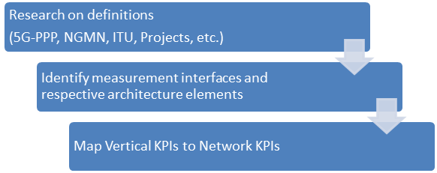
Figure 1 KPI mapping process
Input to the process is information derived from the respective 5G-PPP projects, standardisation bodies and respective alliances e.g. NGMN, ITU, etc.
Starting for the 5G-PPP project the respective use cases are defined.
A subsequent step is to identify relevant key service KPIs and their definitions that are of importance to the respective industry.
Respective end to end architectures and possibly information flow diagrams addressing the need of the specific use case are analysed in order to identify the service provision process.
Lastly the selected services KPI is mapped on the respective network KPIs that impact the operation of the architectural elements that participate in the service provision process. The KPIs’ targets are identified as well.

Background and motivation
This section should provide some background about the role of the KPIs for the developments of the verticals industry services over 5G experimental networks.
NB: The term “Service” does not relate to network service, but to vertical industry application.
It is important that it provides a clear distinction between network and service KPIs.

Business motivation
The scope of this document is to provide a detailed analysis of the mapping of performance KPIs to 5G network KPIs, the conditions under the analysis is performed and the target KPIs that will set the benchmarking for the actual measurements.
The first important step is the definition of the methodology, followed by the performance evaluation, the identification of the use cases, the architectures and the relative KPIs. This white paper defines in a clear and solid way the KPIs mapping and their target values in order to prove and validate that the 5G technology can provide prominent industry verticals with ubiquitous access to a wide range of forward-looking services with orders of magnitude of improvement over 4G.
The white paper analyses use cases in the following industry domains:
- Industry 4.0 (IN)
- Smart Cities & Utilities (SC)
- Transportation (TR)
- Automotive (AU)
- Media & Entertainment (ME)
- Agriculture & Agri-food (AG)
- Smart (Air)ports (SP)
- Energy (EN)
- E-health & Wellness (HW)
Vertical industries address their connectivity and communication requirements with dedicated specific solutions. 5G technologies, slicing and virtualization will provide a common base that delivers an open, cost-efficient and interoperable eco-system enabling a solution platform for the different verticals. 5G must also cater in an economical way the diverse requirements and business needs of a multitude of verticals. In addition, 5G infrastructure and architecture will integrate heterogeneous technologies and enable network slicing, so that the multiple concurrent execution of vertical operational services is performed regardless of their diverse requirements.

Service performance
5G System is expected to quickly address a multiplicity and diversity of services coming from various vertical sectors. 3GPP and ITU have mapped in a similar way the vertical industries to large service categories called service classes by ITU-T [1], allowing for the design of a more 5G user-centric platform dictated by service types for specific uses cases with optimised networks with different characteristics and behaviours determined by key performance requirements.
The concept of a “Service” as well as some additional terminologies around it used throughout the paper relate to the verticals.
First the “vertical domain” or sector (see 3GPPP and ITU mapping above), is an industry or group of enterprises in which similar products or services are developed, produced, and provided [2].
As for the “vertical”: the stakeholder belonging to an industrial sector and consuming services.
A “vertical service” then, from a business perspective, is a service focused on a specific industry or group of customers with specialized needs (e.g., automotive services, entertainment services, e-health services, industry 4.0).
In this context, service performance shall refer to the evaluation of the overall behaviour of the high layer service with the targeted values of the relevant key performance indicators dictated by the actual service provided to the end user (could also be referred to as application level KPIs) and not only by the network performance results. it is also important to note that when it comes to the measurements of such service KPIs, it may not be directly measurable hence the need for an analysis on possible aggregation/correlation between different KPI levels.

With this in mind, the mapping between vertical KPIs and network KPIs should include any contributor other than the ones that constitute the end-to-end network service: network infrastructures or functions. For instance, it may need to consider the physical properties of the system that the application interacts with as well as the computation or caching required.

Methodology for mapping service to network KPIs
Service/Vertical and network/core KPIs might have a relationship that can be different from a one-to-one mapping. Indeed, a service might imply the elaboration of information that is not only handled by network functions only but also by instruments (e.g., hypervisors) that are virtualising resources. In particular, if network functions are virtualised the end-to-end delay is impacted by the data packet propagation time but also by the load of the computing resource where the functions elaborating the packet are virtualised. In addition, Service KPIs might not be directly measurable, and this is the reason why a mapping between Network/Core 5G KPIs and Service/Vertical KPIs is needed. In this way, combining different Core 5G KPIs (completely transparent for the verticals), specific Service KPIs can be obtained, which allow verticals to determine whether the use cases deployed using the 5G technology and the utilized resource fulfill the expected performance and functional requirements.
A possible method for mapping the service KPI to the network KPIs adopted in 5Growth project is the one represented in Figure 2. In this figure Core KPIs are referring to network KPIs. For all the considered Proof of Concept (PoC) Core KPIs and Service KPIs are defined independently. Then a mapping is performed between Core KPIs and Service KPIs. Although this mapping is independent of the specific PoC, the experience gained in PoC use cases can help in performing the mapping.
Figure 2 Procedure for mapping service KPIs to network KPIs.
Then, for each PoC use case the Functional requirements (FR) and the use case service KPIs (UC SKPIs) are defined. Then, the use case function requirements are mapped in to use case services KPIs. Use case service KPIs are finally mapped into the service KPIs generally defined. In this way, a relationship is established between use case functional requirements and Core KPIs.

Industry 4.0

Introduction to the vertical industry
Industry 4.0 is signalling a change in the traditional manufacturing landscape. Also known as the Fourth Industrial Revolution, Industry 4.0 encompasses three technological trends driving this transformation: connectivity, intelligence and flexible automation. Industry 4.0 use cases by COMAU and INNOVALIA are in the category of smart factories. The Industry 4.0 use cases by COMAU are related to remote support and time-critical process control in the factories. The use cases are to demonstrate the performance of a 5G communication network serving industrial applications where strict requirements of reliability and latency are mandatory to keep the connection stable and to avoid emergency stops and safety issues. In the INNOVALIA’s industry 4.0 first use case, Connected Worker Remote Operation of Quality Equipment, it is explored how 5G technologies can be used to enable remote access to M3BOX, an edge device used to control the Coordinate Measuring Machine (CMM), to perform setup and configuration operations that nowadays require an expert to travel to the customer’s premises. The second use case, Connected Worker Augmented Zero Defect Manufacturing Decision Support System, will involve the development of a Machine to Machine (M2M) collaboration system using 5G technologies that will improve the flexibility and productivity of the CMM.

Use Cases Overview
One of the COMAU Pilot use case (identified as IN_UC1) is the Digital Twin use case depicted in Figure 3. The Digital Twin is essentially a virtual representation of something which exists in the real world as physical assets, processes, people, places, systems and devices connected in real-time thanks to continuous data streaming.

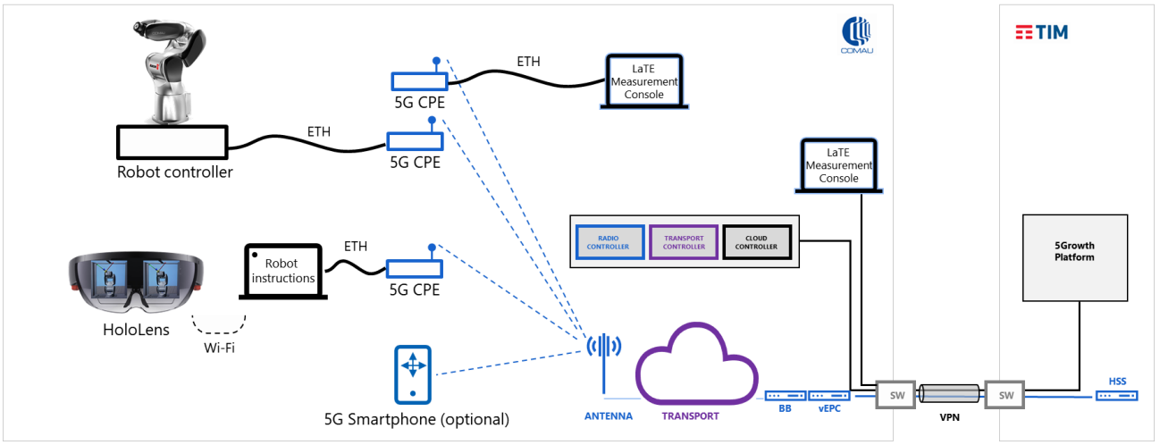
Figure 3 IN_UC1 COMAU Digital Twin use case
Another COMAU use case (identified as IN_UC2) is the Telemetry/Monitoring Apps depicted in Figure 4. In this use case an extensive sensor deployment is in place to monitor and prevent failures of machineries and equipment through massive data collection (i.e., vibration, pressure, temperature, and so on).
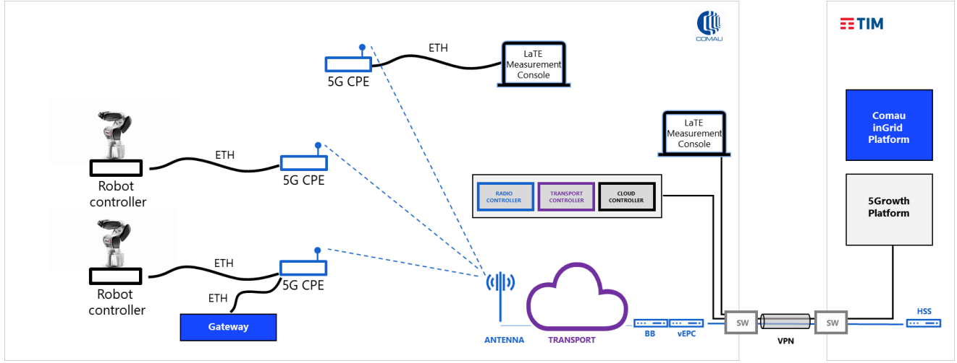
Figure 4 IN_UC2 Telemetry/Monitoring Apps COMAU use case
The third use case (identified as IN_UC3) considered in the COMAU Pilot is the “Digital Tutorial and Remote Support” depicted in Figure 5. This use case aims at providing technicians and maintenance staff with digital tutorials and remote support by means of high-definition videos and live connections to remote technical offices.
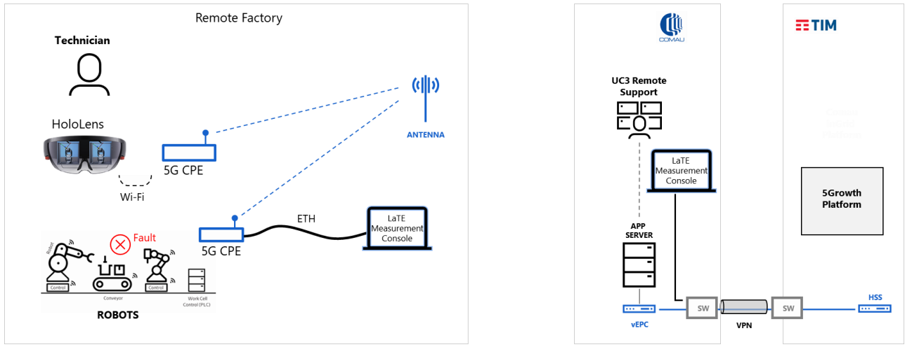
Figure 5 IN_UC3 Digital Tutorial and Remote Support COMAU use case
The first INNOVALIA use case (identified as IN_UC4) is the Connected Worker Remote Operation of Quality Equipment. This use case involves the remote operation of an industrial machine, called Coordinate-Measuring Machine (CMM). More specifically, as depicted in Figure 6, an expert from INNOVALIA located at the headquarter controls the movement of the CMM in a remote location using a virtual joystick, while receiving visual information through low-latency video stream. Together with the CMM, an edge device that runs its software controller that translates the movement commands and the video equipment to record, compress and stream the images are deployed in the remote location.
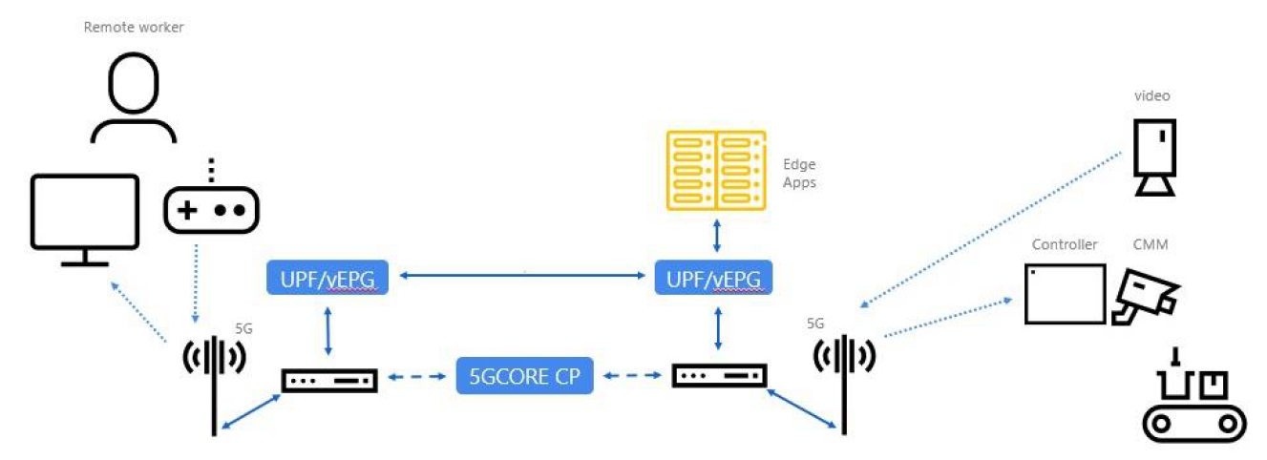
Figure 6 IN_UC4 INNOVALIA Connected Worker Remote Operation of Quality Equipment
The second Innovalia use case (identified IN_UC5) “Connected Worker: Augmented Zero Defect Manufacturing (ZDM) Decision Support System (DSS)”, depicted in Figure 7, aims at semi-automatizing the different stages during the quality control process.
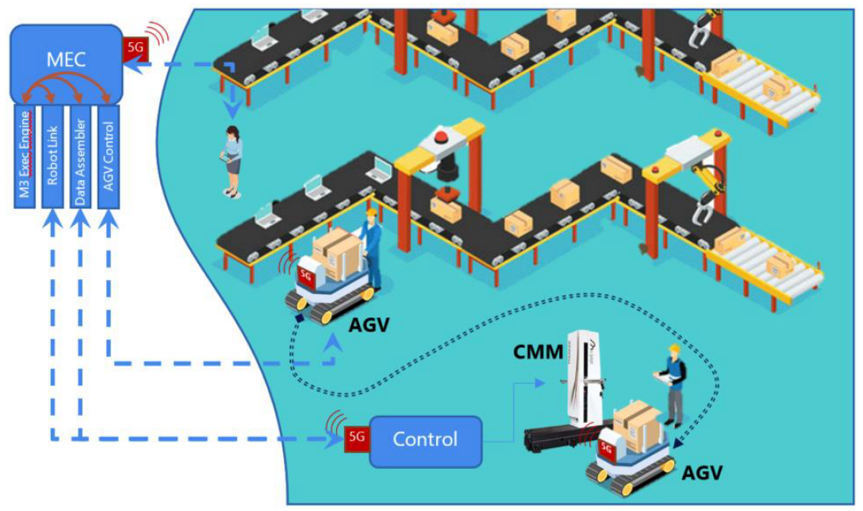
Figure 7 IN_UC5 INNOVALIA second use case Connected Worker: Augmented Zero Defect Manufacturing (ZDM) Decision Support System (DSS)

Core Network and Service KPIs Overview
Within the project two sets of KPIs have been defined: core KPIs and vertical KPIs. Core 5G KPIs are performance parameters related to the network and system components of the communications infrastructure that constitutes the industrial pilots. The core KPIs, reported in Table 1, are the KPIs that contribute to the service KPIs and that are mainly measured at the network level. The core KPI definitions are based on 5GPPP-TMV WG definitions and on different standard document definitions.
Table 1 Core KPIs in Industry4.0 Vertical Use Cases
CKPI Id | CKPI Name | CKPI Description | Units
CKPI-1 | End-to-end Latency | Aggregation of one-way time delays measured between specific components of the logical architecture of the use case. | ms
CKPI-2 | Packet Loss | The number of packets that fail to reach their destination, measured in specific interfaces of the use case logical architecture. | %
CKPI-3 | Guaranteed Data Rate | The data rate is the number of bits per unit of time sent over a specific interface of the use case logical architecture. The guaranteed data rate is the minimum expected data ratefor the overall use case to function correctly. | Mbits/s
CKPI-4 | Coverage | Radio access coverage area on the pilot premises. | m²
CKPI-5 | Availability | Percentage of time during which a specific component of the use case (application, server, network function, etc.) is responding to the requests received with the expected QoS requirements. That is, it is the ratio between the up-time of a specific component over the total time the component has been deployed. | %
CKPI-6 | Slice Creation/adaption Time | Time elapsed since the creation/reconfiguration of a slice is triggered until the slice is fully operational. | ms
CKPI-7 | Connection Density | The number of users/devices that can be connected simultaneously to the use case network infrastructure without degrading the performance of the users/devices that are already connected. | 1/m²
CKPI-8 | Data Volume | The total quantity of information transferred over a given interface during specific use case operations, measured in bits. | Gbits
CKPI-9 | Jitter | Variation of the end-to-end latency forthe communications between specific components of the use case. This core KPI is useful to correlate QoE KPIs for the different video visualizations performed in the use cases. | ms
CKPI-10 | Received Radio Signal Quality | The quality of the received signal, as an abstract value compounding multiple low-level signal properties (e.g., power, SNR, synchronization). | %
CKPI-11 | Buffer occupancy | The amount of user-data pending transmission (i.e., submitted by applications and waiting in transmission buffers). | bytes
Service KPIs (SPKIs) gather the services’ needs. The provided list of SKPIs that not only describes the KPIs of those services tackled in 5Growth, but the KPIs encountered by any service using the 5G technology is reported in Table 2.

Table 2 Service KPIs in Industry4.0 Vertical Use Cases
SKPI Id | SKPI Name | SKPI Description
IN-SKPI-1 | Service Setup Time | Time elapsed since the vertical requests a specific service until the service is completely operational. This time comprises the provisioning and configuration of the resources needed for the use case.
IN-SKPI-2 | Synchronization between Communication Components | Synchronization between components evaluates the ordered and timely execution of operations requested among components. Out-of-order operation requests must be near zero in real-time communications among the involved components.
IN-SKPI-3 | Device Mobility | Capacity of the mobile devices of a given use case to move within the area of applicability of the service without degrading its performance, independently of the devices speed.
IN-SKPI-4 | High-resolution Real-time Video Quality | Specific use cases are supported by a real-time video streaming service whose high quality resolution is critical for the correct operation of the vertical service. This SKPI evaluates the QoE of the users consuming the video feed that supports a given use case. E.g., in a I4.0 context, the high-resolution video service is needed to perform accurate measurements of industrial pieces remotely and in real-time.
IN-SKPI-5 | Radius of Operation | Geographical area of the service applicability. That is, this SKPI determines wether the service implementation is able to deliver a correct operation within a city, a country, a continent or worldwide. All the requirements of a specific use case are fulfilled for any device connecting in the area of applicability specified by the deployed service.
IN-SKPI-6 | Integrated Multitype Communications | Integration of multiple types of communication and protocols (e.g., video, voice, control, etc.) with different performance requirements. This SKPI evaluates that their interoperability does not degrade the overall service performance and meets the same requirements as met when operating independently.
IN-SKPI-7 | Extensive Network Coverage in Vertical Premises | Capability of the elements and actors of a use case located at different places of the vertical premises to access the 5G network from anywhere without altering the performance of the service. This SKPI evaluates whether the 5G network access is provided in the complete vertical premises guaranteeing the minimum expected performance of each specific service.
IN-SKPI-8 | Service Operation Time | The service operation time is the minimum time needed to perform one iteration of the complete service workflow. E.g., in an industry 4.0 context, the time that it takes to scan an industrial piece, process the information and display the results to a QA operator.
IN-SKPI-9 | Service Operation Capacity | Number of iterations of the service workflow that are being performed simultaneously at a specific instant of time.
IN-SKPI-10 | Service Availability | Percentage of time during which the overall vertical service is working correctly and meeting the expected vertical requirements.
IN-SKPI-11 | Service Reaction Time | Time required by the service to react to changes or external events. This time comprises any possible run-time reconfigurations of the service.

Core and Service KPIs Mapping
Within the project the adopted mapping procedure is the one described in section 3.1 of this document. In particular, the mapping between CKPI and SKPI is depicted in Table 3. For example, IN-SKPI-1 (Service Setup Time) is impacted, thus mapped, into CKPI-5 (Availability) and CKPI-6 (Slice Creation/adaption Time).
Table 3 Mapping between Service KPIs and Core KPIs in Industry4.0 Vertical Use Cases
IN-SKPIs |  |  |  | Core 5G KPIs
 | CKPI-1 | CKPI-2 | CKPI-3 | CKPI-4 | CKPI-5 | CKPI-6 | CKPI-7 | CKPI-8 | CKPI-9 | CKPI-10 | CKPI-11
IN-SKPI-1 |  |  |  |  | X | X
IN-SKPI-2 | X | X
IN-SKPI-3 |  |  |  | X | X |  |  |  |  | X | X
IN-SKPI-4 |  | X | X |  |  |  |  | X | X
IN-SKPI-5 | X |  |  |  | X
IN-SKPI-6 |  | X | X |  | X
IN-SKPI-7 | X | X | X | X | X |  | X
IN-SKPI-8 |  | X | X
IN-SKPI-9 | X |  | X |  | X
IN-SKPI-10 |  |  |  |  | X
IN-SKPI-11 | X

KPIs Research on definitions
In the context of network layer packet transmissions, the reliability is defined [3GPP TS 22.261 V17.2.0 (2020-03)] as the percentage value of the amount of sent network layer packets successfully delivered to a given system entity within the time constraint required by the targeted service, divided by the total number of sent network layer packets. Relevant use cases, service types, specifications from 3GPP TS 22.261 V17.2.0 (2020-03) are:
- wireless road-side infrastructure backhaul, requirement 99,999%
- AR/VR Cloud/Edge/Split Rendering, requirement 99.99% in uplink and 99.9% in downlink
- Gaming or Interactive Data Exchanging, requirement 99.99%
- Consume VR content via tethered VR headset, requirement 99,99%
As defined in [3GPP TS 22.261 V17.2.0 (2020-03)] communication service availability is the percentage value of the amount of time the end-to-end communication service is delivered according to an agreed QoS, divided by the amount of time the system is expected to deliver the end-to-end service according to the specification in a specific area.
Relevant use cases, service types, specifications from 3GPP TS 22.261 V17.2.0 (2020-03) are:
- wireless road-side infrastructure backhaul, requirement 99,99%
- Medical monitoring, requirement >99,9999%
As defined in [3GPP TS 22.071 V16.0.0 (2020-07)] the location estimate is the geographic location of a UE and/or a valid Mobile Equipment (ME), expressed in latitude and longitude data. The Location Estimate shall be represented in a well-defined universal format. Translation from this universal format to another geographic location system may be supported, although the details are considered outside the scope of the primitive services.
Relevant use cases, service types, specifications from [3GPP TS 22.071 V16.0.0 (2020-07)] are:
- Location-independent Most existing cellular services, Stock prices, sports reports
- PLMN or country Services that are restricted to one country or one PLMN
- Regional (up to 200km) Weather reports, localized weather warnings, traffic information (pre-trip)
- District (up to 20km) Local news, traffic reports
- Up to 1 km Vehicle asset management, targeted congestion avoidance advice
- 500m to 1km Rural and suburban emergency services, manpower planning, information services (where are?)
- 100m (67%)
- 300m (95%) U.S. FCC mandate (99-245) for wireless emergency calls using network-based positioning methods
- 75m-125m Urban SOS, localized advertising, home zone pricing, network maintenance, network demand monitoring, asset tracking, information services (where is the nearest?)
- 50m (80%)
- U.S. FCC mandate and for wireless emergency calls
- 10m-50m Asset Location, route guidance, navigation Mapping of KPIs on end-to-end architectural elements including network, UEs, computing elements e.g. edge, cloud, etc.
- Mapping of KPIs on end-to-end architectural elements including network, UEs, computing elements e.g. edge, cloud, etc.
Throughput might have different definitions. For example, in [TMVwhitepaper] Minimum Expected Upstream Throughput, Minimum Expected Downstream Throughput, UL Peak Throughput, DL Peak Throughput are defined as UE transmitting IP packets to the N6 interface, the UE receiving IP packets from the N6 interface, a single UE transmitting IP packets to the N6 interface, and a Single UE receiving IP packets from the N6 interface.
In [TMVwhitepaper] the Maximum Expected Latency is defined as the RTT of UE IP packets transmitted to the N6 interface.

Mapping Analysis of KPIs
For each PoC use case the Functional requirements (FR) and the use case service KPIs (UC SKPIs) are defined. Then, the use case functional requirements are mapped onto use case services KPIs. Use case service KPIs are finally mapped into the service KPIs generally defined.
For what concerns the considered COMAU use cases Table 4 summarizes the mapping. For example, functional requirement related to cellular indoor coverage eventually is impacted by (i.e., maps onto) several core KPIs, such as end-to-end latency, packet loss, guaranteed data rate, coverage and availability because the use case service KPI, to which the functional requirement is mapped, is related to having stable connection to all the connected stations in the plant.

Table 4 COMAU use case mappings
UC | FR | UC SKPIs | SKPI | CKPI
IN_UC1 | Cellular indoor coverage of up to 800m² for office and double in open factory” | “Extensive Plant coverage”.  A steady connection must be ensured to all connected stations in the plant. | “IN-SKPI-7 Extensive Network Coverage in Vertical Premises”. | CKPI-1 End-to-end Latency
 |  |  |  | CKPI-2 Packet Loss
 |  |  |  | CKPI-3 Guaranteed Data Rate
 |  |  |  | CKPI-4 Coverage
 |  |  |  | CKPI-5 Availability
 |  |  |  | CKPI-7 Connection Density
IN_UC2 | Cellular indoor coverage of up to 800 m² for office and double in open factory | Extensive coverage for high density networks | “IN-SKPI-7 Extensive Network Coverage in Vertical Premises” | CKPI-1 End-to-end Latency
 |  |  |  | CKPI-2 Packet Loss
IN_UC2 | Guarantee updated information with no delays | Extensive coverage for high density networks | “IN-SKPI-7 Extensive Network Coverage in Vertical Premises” | CKPI-3 Guaranteed Data Rate
 |  |  |  | CKPI-4 Coverage
IN_UC2 | Enable 5G connectivity on as much machineries as possible | Extensive coverage for high density networks | “IN-SKPI-7 Extensive Network Coverage in Vertical Premises” | CKPI-5 Availability
 |  |  |  | CKPI-7 Connection Density
IN_UC3 | Cellular indoor coverage of up to 800 m² for office and double in open factory | Network Support for Device Mobility | IN-SKPI-3 Device Mobility defined as “Capacity of the mobile devices of a given use case to move within the area of applicability of the service without degrading its performance, independently of the devices speed” | CKPI-4 Coverage
 |  |  |  | CKPI-5 Availability
 |  |  |  | CKPI-10 Radio Signal Quality
 |  |  |  | CKPI-11 Buffer Occupancy
IN_UC3 |  | Network Support for Device Mobility | IN-SKPI-7 Extensive Network Coverage in Vertical Premises | CKPI-1 End-to-end Latency
 |  |  |  | CKPI-2 Packet Loss
 |  |  |  | CKPI-3 Guaranteed Data Rate
 |  |  |  | CKPI-4 Coverage
 |  |  |  | CKPI-5 Availability
 |  |  |  | CKPI-7 Connection Density

A similar mapping is performed for INNOVALIA use case and it is reported in Table 5.
Table 5 INNOVALIA use case mappings
UC | FR | UC SKPIs | IN-SKPI | CKPI
IN_UC4 | Radius of action – From Bilbao to Europe | Radius of Operation: the maximum end-to-end distance of applicability of the vertical service | IN-SKPI-5 Radius of Operation | CKPI-1 End-to-end Latency
 |  |  |  | CKPI-5 Availability
IN_UC4 | The solution must guarantee proper levels of isolation (in the form of network slice) | Integrated Multitype Communications | IN-SKPI-6 Integrated Multitype Communications | CKPI-2 Packet loss
 |  |  |  | CKPI-3 Guaranteed data rate
IN_UC4 | Simultaneous support of integrated communications (voice, data, etc)” | Integrated Multitype Communications | IN-SKPI-6 Integrated Multitype Communications | CKPI-5 Availability
IN_UC4 | Enable 5G connectivity to the M3Box edge device | Extensive Network Coverage in the Factory Premises | IN-SKPI-7 Extensive Network Coverage in Vertical Premises | CKPI-1 End-to-end latency
 |  |  |  | CKPI-2 Packet loss
 |  |  |  | CKPI-3 Guaranteed data rate
 |  |  |  | CKPI-4 Coverage
 |  |  |  | CKPI-5 availability
IN_UC4 | The solution must guarantee proper levels of isolation (in the form of network slice | Integrated Multitype Communications | IN-SKPI-6 Integrated Multitype Communications | CKPI-2 Packet loss
IN_UC4 | Simultaneous support of integrated communications (voice, data, etc) | Integrated Multitype Communications | IN-SKPI-6 Integrated Multitype Communications | CKPI-3 Guaranteed data rate
 |  |  |  | CKPI-5 Availability
IN_UC4 | Enable 5G connectivity to the M3Box edge device | Extensive Network Coverage in the Factory Premises | IN-SKPI-7 Extensive Network Coverage in Vertical Premises | CKPI-1 End-to-end latency
 |  |  |  | CKPI-2 Packet loss
 |  |  |  | CKPI-3 Guaranteed data rate
 |  |  |  | CKPI-4 Coverage
 |  |  |  | CKPI-5 availability
IN_UC5 | Externalization of the Edge Computing system |  | IN-SKPI-7 Extensive Network Coverage in Vertical Premises | CKPI-1 End-to-end latency
IN_UC5 | M3 software deployed in the manager device (laptop, tablet) |  | IN-SKPI-7 Extensive Network Coverage in Vertical Premises | CKPI-3 Guaranteed data rate
IN_UC5 | Deployment of Robotlink, Data Assembler and AGV control services on a Cloud Edge System |  | IN-SKPI-7 Extensive Network Coverage in Vertical Premises | CKPI-5 Availability
IN_UC5 | Externalization of the Edge Computing system | Service Operation Capacity | IN-SKPI-9 Service Operation Capacity | CKPI-1 End-to-end latency
 |  |  |  | CKPI-3 Guaranteed data rate
 |  |  |  | CKPI-5 Availability
IN_UC5 | M3 software deployed in the manager device (laptop, tablet)” | Service Creation Time | IN-SKPI-1 Service Setup Time | CKPI-5 Availability
IN_UC5 | Deployment of Robotlink, Data Assembler and AGV control services on a Cloud Edge System | Service Creation Time | IN-SKPI-1 Service Setup Time | CKPI-6 Slice Creation/Adaptation Time
IN_UC5 | CMM-AGV communication protocol working over 5G connection | Network support for user mobility | IN-SKPI-3 Device mobility | CKPI-5 availability
IN_UC5 | Enable 5G connectivity on the AGV | Network support for user mobility | IN-SKPI-3 Device mobility | CKPI-4 coverage
IN_UC5 | Enable 5G connectivity on the manager device | Network support for user mobility | IN-SKPI-3 Device mobility | CKPI-10 radio signal quality
 |  |  |  | CKPI-11 buffer occupancy

Quantitative requirements
An initial set of quantitative target values has been specified for the considered use cases as represented in Table 6 for the COMAU use cased and in Table 7 for the INNOVALIA use cases.
Table 6 reports a subset of the technical
Table 6 Core KPI target values for COMAU use cases
IN_UC1
KPI |  | Units |  | Expected values
E2E One Way Delay/Latency (OWD) |  | ms |  | < 15 (all end devices at same location)
Availability/Reliability |  | % |  | 99.999%
Packet Loss |  | % |  | < 0.1
Jitter |  | us |  | 100
IN_UC2
E2E One Way Delay/Latency (OWD) | ms |  | < 30 (all end devices at same location)
Availability/Reliability | % |  | 99.999%
Packet Loss | % |  | < 0.1
IN_UC3
E2E One Way Delay/Latency (OWD) | ms |  | < 50 (all end devices at same location)
Availability/Reliability | % |  | 99.999%
Bandwidth (in total) | Mbps |  | > 500

Table 7 Core KPI target values for INNOVLIA use cases
IN_UC4
KPI |  | Units |  | Expected values
End-to-end Latency |  | ms |  | <100 (all end devices at same location)
Guaranteed Data Rate |  | Mbps |  | 70-100
Packet Loss |  | % |  | < 0.1
Jitter |  | us |  | 100
IN_UC5
End-to-end Latency | ms |  | 5 (all end devices at same location)
Service Availability | % |  | 99.99%
Packet Loss | % |  | < 0.1
Jitter | us |  | 100

Smart Cities & Utilities

Introduction to the vertical industry
In Europe, cities account for 75% of the population consuming 80% of the EU’s energy. On one hand, this influx of people can create new opportunities for cities but on the other hand it poses major economic, environmental, social and safety challenges as well, since many cities were built on infrastructure designed for smaller, less active population. Therefore, the need for innovative solutions facing the rising demands and different challenges, is growing. The vision of a smart city “incorporates the six “s”, i.e. a shared, secure and scalable infrastructure that enables human possibilities in a manner that is smart, safe and sustainable. This vision is achieved by a smart network connecting sensors, machines and citizens to cloud based internet of things (IoT) applications”.
The Use Cases selected for this white paper are being validated as part the 5G-SOLUTIONS [3] project, below is a brief summary of their objectives (see next section for detailed descriptions) along with an illustration of an architecture combining both UCs covered showing that real-time images from a camera mounted on a pole (can be street light):
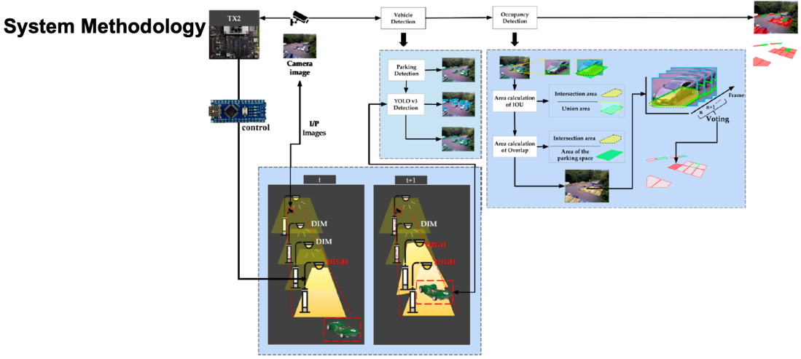
Figure 8: Smart Parking - Intelligent Street Lighting System

Use Case 3.1: Intelligent street lighting
The primary objective is to accelerate the use of intelligent lighting in smart cities and increase the environmental, financial, safety and security benefits that societies can have.
Use Case 3.2: Smart parking
The primary objective is to allow drivers to look for inter-city parking spaces so as to easily spot the most convenient and available parking places.

Use Cases Overview
Use Case SC_UC1: Intelligent street lighting
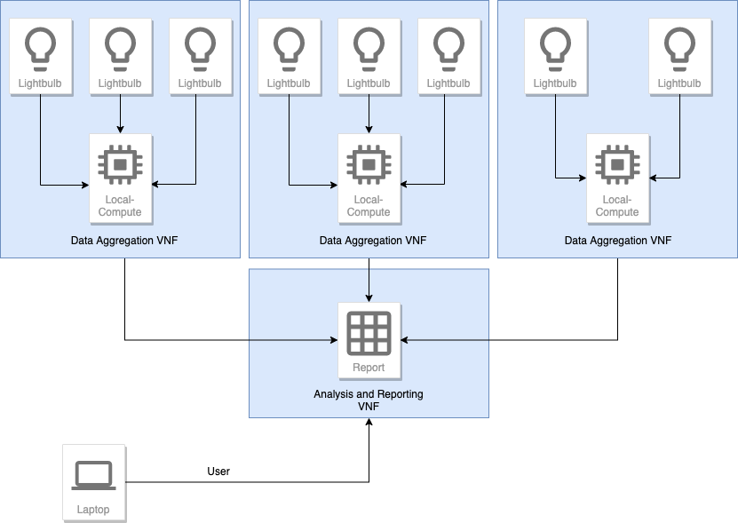
With intelligent street lighting over 60% of power can be saved, and light pollution can be significantly decreased. By dynamically adjusting street lighting based on traffic conditions (pedestrians or vehicular) both security as well as safety of the inhabitants can be improved. In addition, road safety is maximised, whereas the operational costs are minimised.
Figure 9: SC_UC1 HL Architecture

“Intelligent street lights” is an IoT solution that is developed for cities with the goal of reducing the energy consumption by street lights. To do so, the street lights would be fitted with a sensor that can send movement data to the system and this system then determines the state in which the particular street light should be in, such as switch on, switched off or dimmed. To showcase the use case in the city, the tests have to be designed so that they can ensure 100% reliability on the data being collected and performance data.

To do so we are running a virtual City in our Realtime Application which simulates the sensors triggered by the simulated traffic and then send out their data to the Grid Aggregation AFs (Application Functions). These AFs send all their data to the cloud AF, which controls the whole environment. The simulation produces a visualization of the traffic movement in a virtual city built using the Unity3D game engine.

From their reactions based on the calculated data from the Grid Aggregation, AFs will be sent back to the (virtual) Sensors that are in the Street Lights. The Simulation will not only trigger the sensors, but also display the reactions and instructions from the cloud AF. The cloud AF is also going to be responsible for calculating the energy usage in the city and can determine the difference between scenarios when the sensors are not available and with the sensors, to determine the effect Intelligent Street lights will have on the energy consumption.
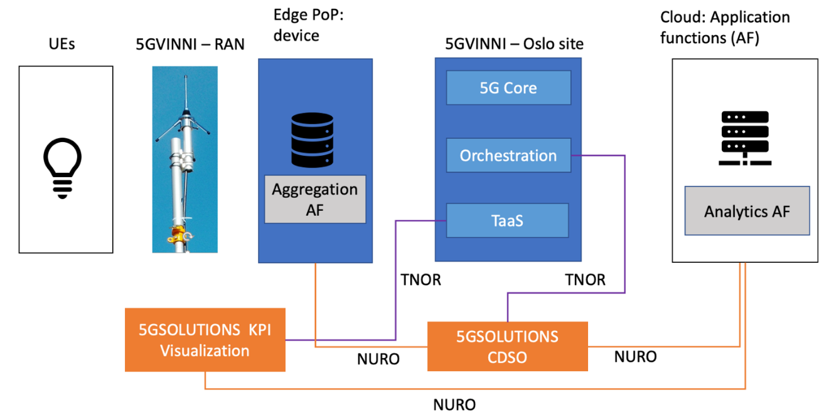
Figure 10: SC_UC1 HL Architecture Management
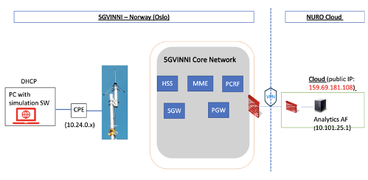
Figure 11: SC_UC1 HL Architecture - SW Simulation

Use Case SC_UC2: Smart parking
Smart parking solutions aim to reduce congestion, emissions and improve traffic safety allowing at the same time higher quality of life for the residents. A smart parking system can benefit not only the drivers and the operators but the city councils as well. Smart parking saves time and costs for the drivers, whereas municipalities are able to provide a more efficient traffic guidance increasing their profits while complying with relevant emissions requirements.
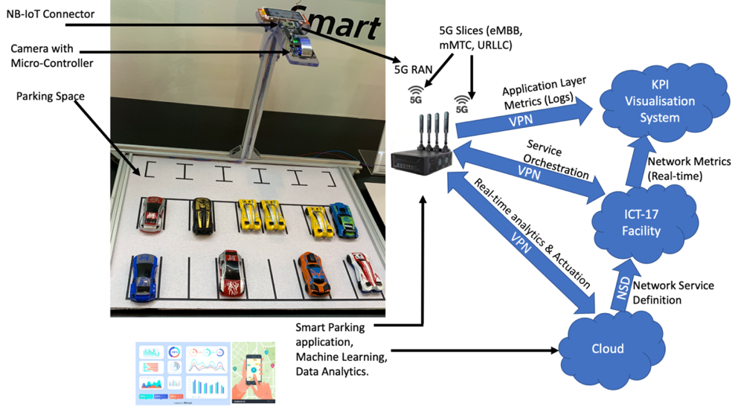
A simulated version of the use case is depicted which includes a 4K camera installed over the parking spot for monitoring the parking space in real-time and is connected with micro-controller as edge computer to analyse the situation and provide the information to the 5G network via NB-IoT. Via a GIS enabled application that syncs with the GPS location of a customer’s mobile device, it informs the citizens of available parking slots in their vicinity.
Figure 12: SC_UC2 HL Architecture
VNFs will be deployed on the 5G-VINNI test bed at Norway facility.

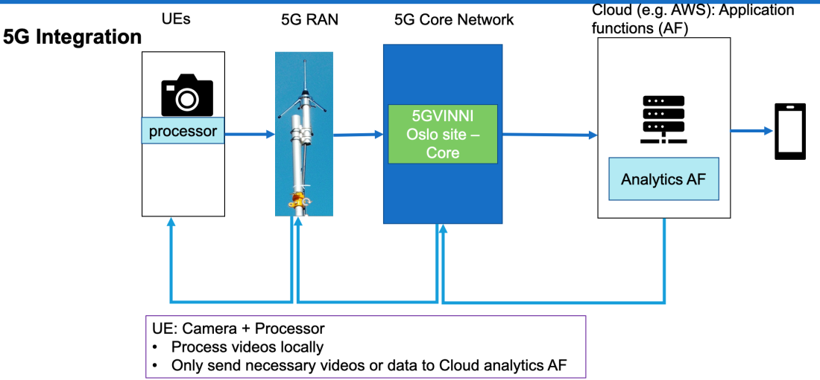
Figure 13: SC_UC2 HL Architecture Management

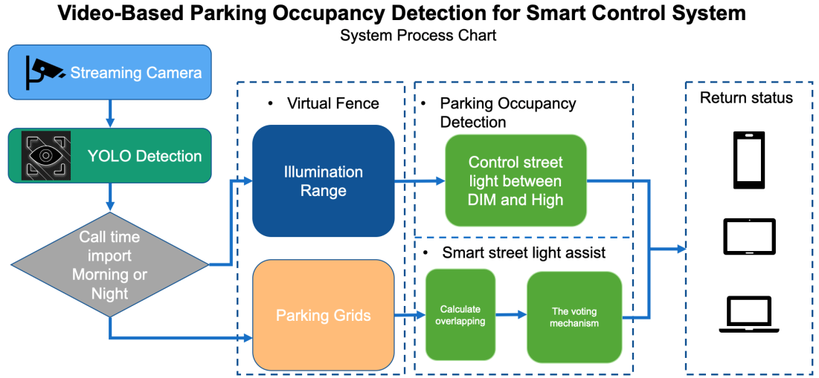
Figure 14: SC_UC.2 Proposed Smart Control System

Core and Service KPIs Overview

Table 8: Intelligent Street Lighting - Service KPIs
SKPI Id | SKPI Name | SKPI Description | Additional Information
ISL-SKPI-1 | Total number of Active lights | Checking the number of active sensors. | This would help in the definition of streetlights turned on and consuming energy.
ISL-SKPI-2 | Total number of active movements | Checking the movement in the city. | This would help in the predictive analysis.
ISL-SKPI-3 | Total Average illuminance | Calculating the luminance from the lights and number of active lights. | This would help in making sure a safe environment is possible for the citizens.
ISL-SKPI-4 | Total Active time | The total active time will be calculated by determining the time for each light | This would help in making sure the most efficient way to organise the lights
ISL-SKPI-5 | Total Power consumption | Will be based on the consumption of each light and the time it was turned on for. | The main aim will be to decrease the energy consumption and make sure each light work as efficiently as possible.
ISL-SKPI-6 | Light response time | Latency to each light

Table 9: Smart Parking - Service KPIs
SKPI Id | SKPI Name | SKPI Description | Additional Information
SP-SKPI-1 | Parking traffic (flow) | How many vehicles entered & exit from the parking lot.
SP-SKPI-2 | Parking availability | What is the current parking availability.
SP-SKPI-3 | Parking occupancy | How many vehicles in the parking lot.
SP-SKPI-4 | Vehicle detection processing time | Time consumed to detect vehicle.
SP-SKPI-5 | Vehicle detection response time | Latency to each vehicle detection.

Table 10: Intelligent Street Lighting - Core KPIs
CKPI Id | CKPI Name | Target Value | CKPI Description | Additional Information
CKPI-1 | Edge-to-edge Latency | <100ms | Compare the network latency to the edge server running the emulations from the simulation server | The time needed to send signal from streetlights to the servers to calculate the lights being switch on and off.
CKPI-2 | Reliability | >99% | % of data delivered without data corruption. | To make sure that all the data is sent so that the most amount of reliability is provided to the citizens.
CKPI-3 | Coverage | >99% | Data reception success rate when devices in different locations. | We need to be certain that the entire city can be covered by the use case.
CKPI-4 | Device Density | 1dev/m² | Device density of streetlights and the number of sensors required. | The streets lights can be placed in both urban and rural areas with more density than normal.

Table 11: Smart Parking - Core KPIs
CKPI Id | CKPI Name | Target Value | CKPI Description | Additional Information
CKPI-1 | Positioning accuracy | <1ms | Compare calculated position with actual location. | After parking the car citizen need to get the accurate location of parking once coming back for pickup, this will decrease the time of finding the car.
CKPI-2 | Reliability | >99.9% | % of data delivered without data corruption. | Wireless networks must reliably transmit large amounts of data at very high speed to ensure no degradation in quality of videos.
CKPI-3 | Coverage | >99.9% | Data reception success rate when device in different locations. | Prevent service disruption if the cameras are deployed at different locations covered by the cell.
CKPI-4 | Data rate | >100Mbps (per cell) | Throughput measurement at device. | Average uplink rate per camera is 25 Mbps, and for 4 cameras, it yields 100 Mbps

Core and Service KPIs Mapping

Table 12: Intelligent Street Light - Service-Core KPIs Mapping Proposal
SKPIs | CKPIs
SKPIs | CKPI-1 | CKPI-2 | CKPI-3 | CKPI-4
ISL-SKPI-1 | x | x | x | x
ISL-SKPI-2 | x | x | x | x
ISL-SKPI-3 | x | x | x | x
ISL-SKPI-4 | x | x | x | x
ISL-SKPI-5
ISL-SKPI-6 | x

Table 13: Smart Parking - Service-Core KPIs Mapping Proposal
SKPIs | CKPIs
SKPIs | CKPI-1 | CKPI-2 | CKPI-3 | CKPI-4
SP-SKPI-1 |  | x | x | x
SP-SKPI-2 |  | x | x | x
SP-SKPI-3 |  | x | x | x
SP-SKPI-4 | x | x | x | x
SP-SKPI-5 | x | x | x | x

KPIs Mapping justification:
- The Network energy efficiency KPI (energy consumption directly from IoT devices) from the battery powered devices, sensors, is mapped to some application level KPIs, which are:
- Reduction of the number of maintenance rounds related to battery replacement or recharging on the IoT devices.
- Service availability improvement from reduced interruptions related to maintenance and/or hardware faults related to batteries.

KPIs Research on definitions
E2E Latency (User experienced):
Many definitions exist with different names and from different bodies such as:
- End-to-end latency of 5G network from ETSI (3GPP) TS 128 554 V15.4.0 (2019-10) [4].
- High latency communication from 3GPP TS 23.501 V16.4.0 (2020-03) [5].
- End-to-end latency, User plane Latency from NGMN 5G White_Paper [6].
The proposed definition in the context of the Smart Cities Use Cases is as followed:
An End-to-end round-trip time (RTT) traversing all the nodes (inside and outside the 5G system) measured as a duration between UE and Application Server required for a user to receive a response back from the time the request is sent.
Reliability:
From ETSI TS 122 261 V15.5.0 (2018-07) [7]: In the context of network layer packet transmissions, percentage value of the amount of sent network layer packets successfully delivered to a given system entity within the time constraint required by the targeted service, divided by the total number of sent network layer packets.
In addition, from NGMN 5G White paper [6]:
Note that the reliability rate is evaluated only when the network is available. The reliability rate depends on the service and use case. The 5G technology should allow high reliability rates of 99.999%, or higher for the use cases that demand it, in particular those under the ultra-high reliability and ultra-low latency use cases category. For use cases for which reliability may be less an issue, e.g., some non-delay critical MTC use cases, the reliability rate may be 99% or even lower depending on the associated trade-off needs.
Coverage:
Area for which the application should function correctly.

Device Density:
From NGMN 5G White paper [6]: Traffic Density measured in bit/s/m2 is defined as the total amount of traffic exchanged by all devices over the considered area. The KPI requirement on the minimum Traffic Volume Density / Areal Capacity for a given use case is given by the product: [required user experienced data rate] x [required connection density]. For the sake of defining this KPI, a single operator is considered in the considered area.
Also, from ITU-R M.2410-0(11/2017) Report [8]: Connection density is the total number of devices fulfilling a specific quality of service (QoS) per unit area (per km2). Connection density should be achieved for a limited bandwidth and number of TRxPs. The target QoS is to support delivery of a message of a certain size within a certain time and with a certain success probability, as specified in Report ITU-R M.2412-0. This requirement is defined for the purpose of evaluation in the mMTC usage scenario. The minimum requirement for connection density is 1 000 000 devices per km2.

Data Rate:
From NGMN 5G White paper [6]: Data rate requirements are expressed in terms of user experienced data rate, measured in bit/s at the application layer. The required user experienced data rate should be available in at least 95% of the locations (including at the cell-edge) for at least 95% of the time within the considered environment. The user experienced data rate requirement depends on the targeted application/use case. It is set as the minimum user experienced data rate required for the user to get a quality experience of the targeted application/use case. Use case specific user experienced data rates up to 1 Gb/s should be supported in some specific environments, like indoor offices, while at least 50 Mb/s shall be available everywhere cost-effectively.
Also, from ITU-R M.2410-0(11/2017) Report [8]: user experienced data rate is the minimum data rate required to achieve a sufficient quality experience, with the exception of scenario for broadcast like services where the given value is the maximum that is needed.

Mobility:
ITU-R M.2410-0(11/2017) Report [8] defines mobility as the maximum mobile station speed at which a defined QoS can be achieved (in km/h) while considering different classes of mobility based on a speed range (i.e., Stationary: 0 km/h or Vehicular: 10 km/h to 120 km/h). It also provides a reference to traffic channel link data rates for several test environments in the context of evaluating the eMBB usage scenario (i.e., Dense Urban: 1.12 bits/Hz, 30 km/h).

NGMN 5G White paper [7] also provides a definition based on the system’s ability to provide seamless service experience to users that are moving with the introduction of “mobility on demand” to support the large segment of static and nomadic users/devices.
NGM expresses the mobility requirements in terms of the relative speed between the user and the network edge, at which "consistent user experience" should be ensured (i.e. Mobile broadband in vehicles (cars, trains) Use Case category requires: DL: 50 Mbps, UL: 25 Mbps, E2E Latency: 10ms and Mobility: On demand, up to 500 km/h).

Network Energy efficiency:
ITU-R M.2410-0(11/2017) Report [8] defines Network energy efficiency as the capability of a RIT/SRIT to minimize the radio access network energy consumption in relation to the traffic capacity provided. Device energy efficiency is the capability of the RIT/SRIT to minimize the power consumed by the device modem in relation to the traffic characteristics.
Energy efficiency of the network and the device can relate to the support for the following two aspects:
a) Efficient data transmission in a loaded case.
b) Low energy consumption when there is no data.
Efficient data transmission in a loaded case is demonstrated by the average spectral efficiency (see § 4.5).
Low energy consumption when there is no data can be estimated by the sleep ratio. The sleep ratio is the fraction of unoccupied time resources (for the network) or sleeping time (for the device) in a period of time corresponding to the cycle of the control signalling (for the network) or the cycle of discontinuous reception (for the device) when no user data transfer takes place. Furthermore, the sleep duration, i.e., the continuous period of time with no transmission (for network and device) and reception (for the device), should be sufficiently long.
This requirement is defined for the purpose of evaluation in the eMBB usage scenario. The RIT/SRIT shall have the capability to support a high sleep ratio and long sleep duration. Proponents are encouraged to describe other mechanisms of the RIT/SRIT that improve the support of energy efficient operation for both network and device.
Another interesting KPI that could be used here in Smart Cities, from ETSI TS 132 425 V13.5.0 (2016-08) is Number of active UEs.

Mapping Analysis of KPIs
- Mapping of KPIs on end-to-end architectural elements including network, UEs, computing elements e.g., edge, cloud, etc.
- Combine the behavioural, communication, computation and caching KPIs.
- Provide target values for the E2E KPIs and for each segment/architectural element.

SC_UC1 - Architecture layers and network segments
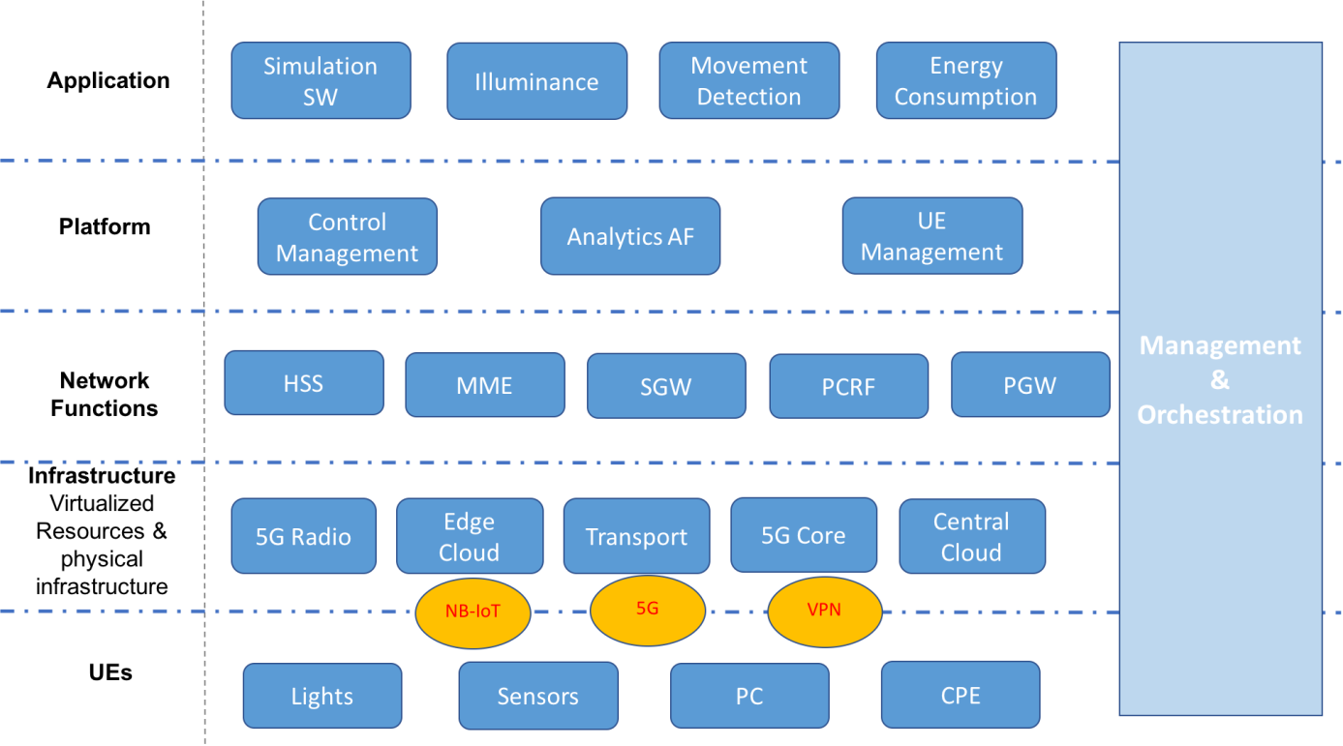
Figure 15: Intelligent Street lighting architecture layers
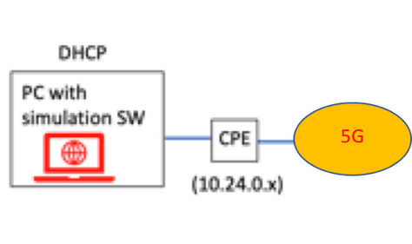
Figure 16: Simulated Light Infrastructure

Table 14: UE Component - Simulated Environment
Name | Component Description | Communication Type (From/To)
PC Browser | Simulated SW accessed from User Device. | Public internet
CPE | Huawei 5G CPE Pro2 router to connect the system with 5G-RAN. | WIFI, ETH

Light response time KPI Analysis and Mapping:
At the UEs layer, there are a number of possible delays that could occur and be caused by different components:
For instance, the actuator delay generated by the light controller to action the commands received.
At the sensor there could be delays in sensing (processing time) and there could also be a configuration/calibration for “time taken to sense” hence an additional delay.
At the communication interface, delays could be due to transmission time (NB-IoT).
Also, for an optimal fitting for “the position and location of the sensor” that may help to reduce delays in detecting movement and the distance between lights should also be considered.
At the Infrastructure layer, delays in network transmission time may occur in the RAN, backhaul and Core (including queuing and propagation time).
As for the Network functions layer, delays in processing time could occur within the RAN, Edge and Core.
And at the Application layer: delays in response time could come from client or server (Edge and Core).

New definitions for standards
- Provide revised KPIs definition (e.g., formal definition), method of measurement and potential gap to standards.
  - KPI name, Descriptive definition, KPI measurement points, proposed reference values.
  - Proposals for KPI Definition for standards.

Transportation

Introduction to the vertical industry
In modern railway transportation facilities, there is a demand for a broad range of novel on-board applications for passengers including advanced guiding services, real time travel information, infotainment services, etc., usually referred to as “business services”, along with services addressing stakeholders/ users engaged in the railway vertical domain such as train control, railway emergency voice communication services (between driver and controller(s)/ operations centre/dispatcher) etc., usually denoted as “critical services”, as well as train telemetry and maintenance services, non-critical real-time video (e.g. surveillance) services etc., usually referred to as “performance services”. More information on the railway environment requirements and vertical applications can be found in [24] and [22].
The existing telecommunications infrastructure of the railway industry includes several versatile telecommunication technologies to provide the aforementioned versatile services. In practice, different communications services are provided by different network deployments (e.g. “business services” are provided by public telecom service providers, while “critical services” mainly train automation related services are provided by private GSM-R networks, and so on). These practices, are pushing existing networks deployed in the railway environment to their limits, making it difficult to guarantee extensive coverage for all services along the railway tracks extending over thousands of Km, and are also leading to slow service deployment, low performance for premium services, and high Total Cost of Ownership (TCO) for all stakeholders.
The telecommunications system(s) to address the current networks’ inefficiencies and meet the requirements of the aforementioned services is commonly denoted as FRMCS –Future Railway Mobile Communication System (FRMCS) [21]; the future worldwide telecommunication standard and GSM-R successor, as well as key enabler for rail transport digitalisation. It reflects the technology neutrality and network services’ logic of 3GPPP 4G/5G standards, tailored to the specific services requirements and deployment challenges of the railway environment. FRMCS and 3GPP collaboration in specification series ([27]-[30]) prove the expectations of both worlds.
To this end, a number of projects (EU, national funded, equipment vendor supported, etc.) are focusing on the technical realization of the FRMCS concepts and principles, by delivering 5G deployment paradigms and evaluating FRMCS services thereover.
.

Use Cases Overview
In this landscape, the provisioning of FRMCS services to various end-users and stakeholders engaged in the railway industry, over a single, technology neutral, 5G network deployment is the use case examined for the railway vertical domain in this section. For this purpose, services that represent all FRMCS categories are analysed on the basis of representative vertical applications as in [25] namely::
- “Business services”, that is, services supporting the railway business operation in general that are usually provided to passengers requiring communication services and broadband connectivity when embarking, travelling and disembarking from the trains daily. Wireless internet/data, Infotainment services, streaming video services (of eMBB type) are used as an example.
- “Performance services”, that is, non-critical services related to train operation. In general, these can be sub-grouped into four main categories: i) passenger information services, ii) advisory services, iii) telemetry services and iv) infrastructure monitoring and maintenance services; the use case will focus on CCTV services for supervision of the rail tracks quality and provision maintenance when needed. Cameras mounted on the front and rear part of the train capturing images that are forwarded in real time to the Operations Center (of the railway facilities) are used indicatively.
- “Critical services”, related to train operation/movement, railway automation systems (Automatic Train Control - ATC, Automatic Train Operation (ATO)), trackside maintenance, emergency and safety services, and so on. Information generated in this type of services must be shared between different stakeholders, e.g. infrastructure operators and several railway operators. Mission Critical Push to Talk (e.g. between the controller(s) of the train/ operations centre and the driver/ on-train staff etc.) is used as indicative application of this type.
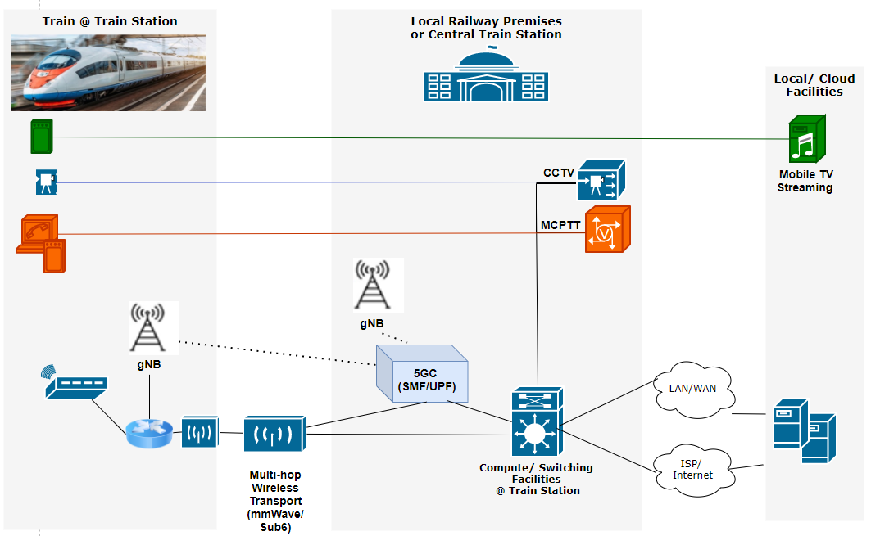

Figure 18 Business & Performance Services over 5G infrastructure at Railway Facilities

5.3 Core Network and Service KPIs Overview
In line with the analysis defined in previous vertical cases, the following core KPIs and 5G Service KPIs are defined as relevant to these use cases; their association being that the Core 5G KPIs constitute the very technical performance parameters related to the network and system components, which contribute to the 5G service KPIs.
Table 18 Core KPIs in the Transportation Vertical use cases
CKPI Id | CKPI Name | CKPI Description | Units
CKPI-1 | End-to-end Latency | Aggregation of one-way time delays measured between specific components of the logical architecture of the use case. | Ms
CKPI-2 | Packet Loss | The number of packets that fail to reach their destination, measured in specific interfaces of the use case logical architecture. | %
CKPI-3 | Guaranteed Data Rate | The data rate is the number of bits per unit of time sent over a specific interface of the use case logical architecture. The guaranteed data rate is the minimum expected data ratefor the overall use case to function correctly. | Mbits/s
CKPI-4 | Coverage | Radio access coverage area on the pilot premises. | M²
CKPI-5 | Availability | Percentage of time during which and locations in which a specific component of the use case (application, server, network function, etc.) is responding to the requests received with the expected QoS requirements. That is, it is the ratio between the up-time of a specific component over the total time the component has been deployed. | % of time
CKPI-6 | Slice Creation Time | Time elapsed since the creation of a slice is triggered until the slice is fully operational. | Ms
CKPI-7 | Connection Density | The number of users/devices that can be connected simultaneously to the use case network infrastructure without degrading the performance of the users/devices that are already connected. | 1/m²
CKPI-8 | Data Volume | The total quantity of information transferred over a given interface during specific use case operations, measured in bits. | Gbits
CKPI-9 | Jitter | Variation of the end-to-end latency forthe communications between specific components of the use case. This core KPI is useful to correlate QoE KPIs for the different video visualizations performed in the use cases. | Ms
CKPI-12 | Area Network Capacity | Total network capacity that is provided over a specifically defined geographic area. | Gbps
CKPI-13 | Mobility / Speed | The network capability to provide connectivity to end user devices moving at various speeds. | Km/h
CKPI-14 | Handover time | Time between the moment that a change to another access node is triggered up to the time that the session is transferred to the other access node and served. | Ms
CKPI – 15 | Reliability | Percentage of times in which a specific component of the use case (application, server, network function, etc.) is responding to the requests received with the expected QoS requirements given the availability of the service. That is, it is the ratio between the up-time of a specific component over the total time the component has been deployed for the time that the service is supposed to be available. | % of times (frequency metric)

Table 19 5G Service KPIs in the Transportation Vertical use cases
SKPI Id | SKPI Name | SKPI Description
TR-SKPI-1 | Service Setup Time | Time elapsed since the vertical requests a specific service until the service is completely operational. This time comprises the provisioning and configuration of the resources needed for the use case.
TR-SKPI-3 | Device Mobility | Capacity of the mobile devices of a given use case to move within the area of applicability of the service without degrading its performance, independently of the devices speed.
TR-SKPI-4 | High-resolution Real-time Video/Audio Quality | Specific use cases are supported by a real-time video/audio service whose high quality resolution is critical for the correct operation of the vertical service. This SKPI evaluates the QoE of the users consuming the video feed that supports a given use case.
TR-SKPI-5 | Service Area | Geographical area of the service applicability. This SKPI determines the area in which a network service needs to be provided.
TR-SKPI-6 | Integrated Multitype Communications | Integration of multiple types of communication and protocols (e.g., video, voice, control, etc.) with different performance requirements. Similtaneous operation of multiple types of communications does not degrade the overall service performance and meets the same requirements as met when operating independently.
TR-SKPI-7 | Extensive Network Coverage in Vertical Premises | Capability of the elements and actors of a use case located at different places of the vertical premises to access the 5G network from anywhere without altering the performance of the service. This SKPI evaluates whether the 5G network access is provided in the complete vertical premises guaranteeing the minimum expected performance of each specific service.
TR-SKPI-10 | Service Availability | Percentage of time during which the overall vertical service is available.
TR -SKPI-12 | Area Traffic Density | Total traffic throughput that can be served over a specifically defined geographic area.
TR-SKPI-13 | Service Reliability | Percentage of time during which the overall vertical service is available and it is working correctly meeting the expected vertical requirements.

Core and Service KPIs Mapping
Following the mapping proposal paradigm, we come up with the KPIs correlation matrix presented in the table below.

Table 20 Mapping between Service KPIs and Core KPIs in transportation vertical use case
TR-SKPIs |  |  |  |  |  |  |  |  |  |  |  | Core 5G KPIs
 | CKPI-1 | CKPI-2 | CKPI-3 | CKPI-4 | CKPI-5 |  | CKPI-6 |  | CKPI-7 |  | CKPI-8 |  | CKPI-9 | CKPI-10 | CKPI-11 | CKPI-12 | CKPI-13 | CKPI-14 | CKPI-15
TR-SKPI-1 |  |  |  |  | X |  | X
TR-SKPI-2
TR-SKPI-3 |  |  |  | X | X |  |  |  |  |  |  |  |  | X | (X) |  | X | X
TR-SKPI-4 |  | X | X |  |  |  |  |  |  |  |  |  | X
TR-SKPI-5 |  | (X) | (X) | X | X |  |  |  |  |  |  |  |  | (X) |  |  |  |  | (X)
TR-SKPI-6 |  | X | X |  | X |  |  |  |  |  |  |  |  |  |  |  |  |  | (X)
TR-SKPI-7 |  | X | X | X | X |  |  |  | X |  | (X) |  |  | (X)
TR-SKPI-8
TR-SKPI-9
TR-SKPI-10 |  | X | X | X | X |  |  |  |  |  |  |  |  | (X)
TR-SKPI-11 | X
TR-SKPI-12 |  |  |  |  | x |  |  |  | (X) |  |  |  |  |  |  | X
TR-SKPI-13 |  |  |  |  | x |  |  |  |  |  |  |  |  |  |  |  |  |  | X

In particular, availability is a prerequisite for achieving almost all TR-SKPIs. Besides that, the relational mapping between the TR-SKPIs and CKPIs is inherent in the SKPIs definitions. For instance, in the definitions of the Service Area, the Integrated Multitype Communications, the Network Coverage in Vertical premises and the Service Availability TR-SKPIs, needs to be defined also the performance achieved in terms of packet loss, guaranteed data rates, Received Radio Signal Quality and of course coverage and service availability. Similarly, the specification of TR-SKPI Device Mobility, comes with the definition of CKPIs of Mobility/ Speed, Handover time, Received Radio Signal Quality for the handover to be triggered, of course under network coverage and given the network availability. In other cases, a direct mapping between core and service KPIs is revealed. For instance, given the network availability, Reliability is mapped on service reliability, service setup time is mapped to Slice Creation/adaptation, and Service Reaction time is predominantly dependent on to end-to-end latency.

Specific KPIs Refinement for the transportation vertical use cases
In view of the railway transportation vertical use cases, it has emerged the necessity to further refine specific KPI definitions. More specifically, as far as the Core KPIs are concerned we focus on the “Connection Density”, and the “Area Traffic Density”.
Connection Density:
A number of definitions have been provided by standandardisation organisations as follows:
- ITU-R M.2410-0 Report (2017) Definition (https://www.itu.int/dms_pub/itu-r/opb/rep/R-REP-M.2410-2017-MSW-E.docx): Connection density is the total number of devices fulfilling a specific quality of service (QoS) per unit area (per km2). Target QoS to be defined as delivery of a message of a certain size within a certain time and with a certain success probability. The target value of this KPI for 5G networks is 1 000 000 devices per km^2.
- NGMN Recommendations (2016) Definition (https://www.ngmn.org/wp-content/uploads/Publications/2016/160603_Annex_NGMN_Liaison_to_3GPP_RAN_72_v1_0.pdf): Same definition as ITU, with the remarks that QoS definition should take into account the amount of data generated within a time t_gen that can be sent or received within a given time, t_sendrx, with x% probability.
Typically this KPI implies measuring: Number of Devices/Connections at Radio Access Network that are capable of receiving specific network service with specific QoS characteristics.
At the same time, as aforeanalysed, this KPI is associated with a number of network service KPIs as components contributing to the achievement of this KPI.
In a 5G deployment the achievement of the Connection/Device Density KPI – as posed by a Vertical/ Vertical service – is associated with a number of more specific Network KPIs, or even on a number of Nerwork KPI components such as the following:
- Connection/Device Density (required/ supported at 5G Access Network), measured for the specific area definitions, i.e. on-board a train and at the trains’ boarding platform, for Ues at various states
- Connection / Device Density (required/ supported at 5G Access Network), measured for the specific area definitions, i.e. on-board a train and at the trains’ boarding platform, for a specific number of (media/ broadband internet/ MCPTT) services (with specific QoS) defined by the vertical; and as a subset for a specific media service defined by the vertical.
- Number of Connections of specific services (e.g. CCTV, media services etc.) required/ supported at Edge Network node(s) –used for the specific services provisioning to the specific geographical area (i.e. the boarding platform).
- Number of Connections of specific services defined (e.g. CCTV, media services etc.) required/ supported at Core Network nodes.
Area Traffic Capacity OR Traffic Density:
A number of definitions have been provided by standandardisation organisations as follows:
- ITU-R M.2410-0 Report (2017) Definition (https://www.itu.int/dms_pub/itu-r/opb/rep/R-REP-M.2410-2017-MSW-E.docx ): Area traffic capacity is the total traffic throughput served per geographic area (in Mbit/s/m²). The throughput is the number of correctly received bits, i.e. the number of bits contained in the SDUs delivered to Layer 3, over a certain period of time.
This can be derived for a particular use case (or deployment scenario) of one frequency band and one TRxP layer, based on the achievable average spectral efficiency, network deployment (e.g. TRxP (site) density) and bandwidth. Let W denote the channel bandwidth and $ρ$ the TRxP density (TRxP/m²). The area traffic capacity C_{area} is related to average spectral efficiency SE_{avg} through equation (6).
C_{area} = ρ × W × SE_{avg} (6)
In case bandwidth is aggregated across multiple bands, the area traffic capacity will be summed over the bands.
This requirement is defined for the purpose of evaluation in the related eMBB test environment. The conditions for evaluation including supportable bandwidth are described in Report ITU-R M.2412-0 for the test environment.
- NGMN Recommendations (2016) Definition (https://www.ngmn.org/wp-content/uploads/Publications/2016/160603_Annex_NGMN_Liaison_to_3GPP_RAN_72_v1_0.pdf): NGMN, defines this KPI similarly with ITU, but details two different conditions:
  - Full buffer: Total traffic throughput served per geographic area (in Mbit/s/m2). The computation of this metric is based on full buffer traffic.
  - Non full buffer: Total traffic throughput served per geographic area (in Mbit/s/m2). Both the user experienced data rate and the area traffic capacity need to be evaluated at the same time using the same traffic model.
In a 5G deployment the achievement of the Traffic Density KPI – as posed by a Vertical/ Vertical service – is associated with a number of more specific Network KPIs, or even on a number of Nerwork KPI components such as the following:
- Traffic Density and Capacity offered at 5G Access Network, measured for the specific area, i.e. on-board a train carriage and at the railway station/ platforms.
- Capacity provided at various transport network segments between the 5G Access and Edge or Core Network nodes – that are used for a specific services provisioning (with specific QoS), to the specific geographical area.

Analysis and mapping of Vertical Service KPIs
Following the afore-described methodology, for each vertical service the requirements and the related KPIs are defined, and associated with network service and core KPIs.
To this end the following KPIs have been identified as common to all services of the railway transportations vertical:
- “Service Availability on board the train wherever it resides along the tracks (at station platforms and at railway lines)”, reflects the generic deployment requirement for network coverage at the vertical premises. It actually narrows down the scope of 5GR-SKPI-7 to the locations of interest of the railway transportation vertical. The exact Service Availability levels / target values though depend on the services and range between low availability requirement for business services to very high levels for critical services.
- “Seamless service provisioning to train wagons moving with high speeds”, reflects the vertical specific requirement for mobility at trains velocity (reaching 100Km/h and in cases 250Km/h), for all services provided on-board the train wagons.
Table 21: Vertical Environment – related Requirements and KPIs mapping
Environment Requirements & KPIs | TR-SKPI | CKPI
“Service Availability on board the train wherever it resides along the tracks (at station platforms and at railway lines)”. | “TR-SKPI-7 Extensive Network Coverage in Vertical Premises”. | CKPI-1 End-to-end Latency
 | “TR-SKPI-7 Extensive Network Coverage in Vertical Premises”. | CKPI-2 Packet Loss
 | “TR-SKPI-7 Extensive Network Coverage in Vertical Premises”. | CKPI-3 Guaranteed Data Rate
 | “TR-SKPI-7 Extensive Network Coverage in Vertical Premises”. | CKPI-4 Coverage
 | “TR-SKPI-7 Extensive Network Coverage in Vertical Premises”. | CKPI-5 Availability
 | “TR-SKPI-7 Extensive Network Coverage in Vertical Premises”. | CKPI-7 Connection Density
“Seamless service provisioning to train wagons moving with high speeds” | “TR-SKPI-3 Device Mobility” | CKPI-4 Coverage
 | “TR-SKPI-3 Device Mobility” | CKPI-5 Availability
 | “TR-SKPI-3 Device Mobility” | CKPI-10 Received Radio Signal Quality
 | “TR-SKPI-3 Device Mobility” | CKPI-13 Mobility / Speed
 | “TR-SKPI-3 Device Mobility” | CKPI-14 Handover time

Business services-specific KPIs reflecting the application requirements for the Video Streaming or High Data Rate internet services have been also identified as follows (advised also by [22]):
- “High-resolution Real-time Video Quality of video/ TV streaming channels/content”, reflects the mobile TV services’ requirement for provisioning: user data rates of~5-10Mbps, available along the railway tracks.
- “Channel/ Stream Switching time”, corresponds to the time between the moment that channel switching is triggered on the device up to the moment that the new channel is presented on device screen.
- “Total Wagon Traffic Density”, corresponds to the total traffic offered, thus the access network capacity required in a highly occupied wagon or train (e.g. of 2-3 smaller wagons).
Table 22: Business Services – Video Streaming Service Requirements and KPIs mapping
Business Services Requirements KPIs mapping | TR-SKPI | CKPI | Target
“High-resolution Real-time Video Quality of video/ TV streaming channels/content” | TR-SKPI-4 High-resolution Real-time Video/Audio Quality | CKPI-2 Packet Loss | <1%
 | TR-SKPI-4 High-resolution Real-time Video/Audio Quality | CKPI-3 Guaranteed Data Rate | 5-10Mbps
 | TR-SKPI-4 High-resolution Real-time Video/Audio Quality | CKPI-9 Jitter | <40ms
 | TR-SKPI-7 Extensive Network Coverage in Vertical Premises | CKPI-1 End-to-end Latency | 100ms- not critical
 | TR-SKPI-7 Extensive Network Coverage in Vertical Premises | CKPI-2 Packet Loss | <1%
 | TR-SKPI-7 Extensive Network Coverage in Vertical Premises | CKPI-3 Guaranteed Data Rate | 5-10Mbps
 | TR-SKPI-7 Extensive Network Coverage in Vertical Premises | CKPI-4 Coverage | As in generic vertical service KPIs.
 | TR-SKPI-7 Extensive Network Coverage in Vertical Premises | CKPI-5 Availability | Not critical (99%)
 | TR-SKPI-7 Extensive Network Coverage in Vertical Premises | CKPI-7 Connection Density | ~100-300 users per train for this service
“Channel/ Stream Switching time” | TR-SKPI-1 Service Setup Time | CKPI-1 End-to-end Latency | Not critical:  Latency <150ms  Total channel switching delay < 1-2 sec.
“Channel/ Stream Switching time” | TR-SKPI-1 Service Setup Time | CKPI-5 Availability | Not critical (99%)
“Total Wagon Traffic Density” | TR-SKPI-12 Area Traffic Density | CKPI-5 Availability | Not critical (99%)
“Total Wagon Traffic Density” | TR-SKPI-12 Area Traffic Density | CKPI-7 Connection Density | ~100-300 users per train for this service
“Total Wagon Traffic Density” | TR-SKPI-12 Area Traffic Density | CKPI-12 Area Network Capacity | 1-2Gbps per Train (>1Gbps at railway platforms)

Performance services-specific KPIs reflecting the application requirements for the CCTV or other infrastructure monitoring services have been identified as follows (based also on [22],[23]):
- “High-resolution Real-time Video Quality of CCTV camera stream towards the monitoring center”, reflects the CCTV service requirement for: data rates of ~3-15Mbps (average 6Mbps), available along the railway tracks.
- “Stream setup time”, corresponds to the time between the moment that the CCTV service switching on is triggered on the device up to the moment that it is setup.
- “Total Traffic transferred from trains CCTV cameras to monitoring/ operations’ center”, for the purposes of the use case two cameras facing front and back of the train will be installed, in normal operation, the number of cameras can be two per wagon/door/ etc.
- “Bulk transfer of infrastructure monitoring data (e.g. CCTV archives, engine performance measurement archives etc.), collected over time” it depends on the scheduling of the transfer, and the availability of the network, but it may amount a number of GB-TB, bulk transfer datarates of 500Mbps-1Gbps are advised ([22],[23]).
Table 23: Performance Services – CCTV & Monitoring Service Requirements and KPIs mapping
Performance Services Requirements KPIs mapping | TR-SKPI | CKPI | Target
“High-resolution Real-time Video Quality of CCTV camera stream towards the monitoring center” | TR-SKPI-4 High-resolution Real-time Video/Audio Quality | CKPI-2 Packet Loss | <0.005
 | TR-SKPI-4 High-resolution Real-time Video/Audio Quality | CKPI-3 Guaranteed Data Rate | 3-15Mbps
 | TR-SKPI-4 High-resolution Real-time Video/Audio Quality | CKPI-9 Jitter | <40ms
 | TR-SKPI-7 Extensive Network Coverage in Vertical Premises | CKPI-1 End-to-end Latency | 150ms- not critical
 | TR-SKPI-7 Extensive Network Coverage in Vertical Premises | CKPI-2 Packet Loss | <0.005
 | TR-SKPI-7 Extensive Network Coverage in Vertical Premises | CKPI-3 Guaranteed Data Rate | 3-15Mbps
 | TR-SKPI-7 Extensive Network Coverage in Vertical Premises | CKPI-4 Coverage | As in generic vertical service KPIs.
 | TR-SKPI-7 Extensive Network Coverage in Vertical Premises | CKPI-5 Availability | 99.99%
 | TR-SKPI-7 Extensive Network Coverage in Vertical Premises | CKPI-7 Connection Density | Not critical, 2/ wagon
“Stream setup time” | TR-SKPI-1 Service Setup Time | CKPI-1 End-to-end Latency | Not critical:  Latency <150ms  Total stream setup time <1-2 sec.
“Stream setup time” | TR-SKPI-1 Service Setup Time | CKPI-5 Availability | 99.99%
“Total Traffic transferred from trains CCTV cameras to monitoring/ operations’ center” | TR-SKPI-12 Area Traffic Density | CKPI-5 Availability | 99.99%
 | TR-SKPI-12 Area Traffic Density | CKPI-7 Connection Density | Not critical, 2/ wagon, more depending on other monitoring devices
 | TR-SKPI-12 Area Traffic Density | CKPI-12 Area Network Capacity | Low
“Bulk transfer of infrastructure monitoring data (e.g. CCTV archives, engine performance measurement archives etc.), collected over time” | TR-SKPI-12 Area Traffic Density | CKPI-4 Coverage | As in generic vertical service KPIs.
 | TR-SKPI-12 Area Traffic Density | CKPI-5 Availability | 99.99%
 | TR-SKPI-12 Area Traffic Density | CKPI-12 Area Network Capacity | It depends on the scheduling of the transfer, and the availability of the network, but it may amount a number of GB-TB, so >500Mbps is desirable.
Critical services -specific KPIs reflecting the application requirements for the MCPTT service have been identified as follows – based also on [23][22] :
- “Voice Quality of MCPTT session” reflects the service requirement for having network quality to perform voice sessions, available along the railway tracks.
- “Setup time of a communication session” corresponds to the time between the communication setup request and the indication of successful communication session establishment. Given the safety related character of the service, this shall be immediate, meaning it shall not exceed 1 sec.
- “Talker assignment time” corresponds to the time between a talker request and the permission to talk applicable to group communication, after the group has been established. This shall be lower than 300ms.

- “Session Loss Rate” corresponds to the number of sessions released due to failure over a specific time window and is practically impacted by network reliability. For MCPRR this shall be lower than 10-2 sessions/h.
- “Service Reliability” reflects the capability to perform a complete MCPTT session with understandable voice quality, given network availability. It reflects the general critical services reliability levels of 99,99% (- 99,9999%), depending on the criticality of use of MCPTT.

Table 24: Critical Services – Mission Critical Push to Talk Service Requirements and KPIs mapping
Critical Services Requirements KPIs mapping | 5G-SKPI | CKPI | Target
“Voice Quality of MCPTT session” | TR-SKPI-4 High-resolution Real-time Video/Audio Quality | CKPI-2 Packet Loss | <10⁻⁶
“Voice Quality of MCPTT session” | TR-SKPI-4 High-resolution Real-time Video/Audio Quality | CKPI-3 Guaranteed Data Rate | 100Kbps
“Voice Quality of MCPTT session” | TR-SKPI-4 High-resolution Real-time Video/Audio Quality | CKPI-9 Jitter | <40ms
“Voice Quality of MCPTT session” | TR-SKPI-7 Extensive Network Coverage in Vertical Premises | CKPI-1 End-to-end Latency | 30ms (60ms RTT)
“Voice Quality of MCPTT session” | TR-SKPI-7 Extensive Network Coverage in Vertical Premises | CKPI-2 Packet Loss | 10⁻⁶
“Voice Quality of MCPTT session” | TR-SKPI-7 Extensive Network Coverage in Vertical Premises | CKPI-3 Guaranteed Data Rate | 100Kbps
“Voice Quality of MCPTT session” | TR-SKPI-7 Extensive Network Coverage in Vertical Premises | CKPI-4 Coverage | As in generic vertical service KPIs.
“Voice Quality of MCPTT session” | TR-SKPI-7 Extensive Network Coverage in Vertical Premises | CKPI-5 Availability | 99,99%
“Setup time of a communication session” | TR-SKPI-1 Service Setup Time | CKPI-1 End-to-end Latency | Duration of immediate communication session establishment < 1 sec.
“Setup time of a communication session” | TR-SKPI-1 Service Setup Time | CKPI-5 Availability | 99,99%
“Talker assignment time” | TR-SKPI-1 Service Setup Time | CKPI-1 End-to-end Latency | <300ms
“Talker assignment time” | TR-SKPI-1 Service Setup Time | CKPI-5 Availability | 99,99%
“Session Loss Rate” | TR-SKPI-10 Service Availability | CKPI-5 Availability | <10⁻²/h
“Session Loss Rate” | TR-SKPI-13 Service Reliability | CKPI-15 Reliability | <10⁻²/h
“Service Reliability” | TR-SKPI-13 Service Reliability | CKPI-15 Reliability | 99,99% (- 99,9999%)

Automotive

Introduction to the Vertical Industry
The vision of cooperative, connected and automated mobility (CCAM) across Europe can only be realized when harmonized solutions that support cross-border traffic exist. The possibility of providing CCAM services along different countries when vehicles drive across various national borders has a huge innovative business potential. However, the seamless provision of connectivity and the uninterrupted delivery of services along borders also poses interesting technical, administrative and regulatory challenges. Such an environment offers exceptional innovation potential given the multi-country, multi-operator, multi-telco-vendor, and multi-car-manufacturer scenario of any cross-border layout.
In this context, the European Commission is partially funding innovation actions, which are working to deploy 5G-enabled CCAM cross-border large scale trials. They are 5GcroCo (5G Cross Border Control), 5G-CARMEN (5G for Connected and Automated Road Mobility in the European tili), and 5G-MOBIX (5G for cooperative & connected automated MOBIility on X-border corridors) and belong to the family of projects under the umbrella of the 5G-PPP (5G public private partnership).
Cross-border means, first of all, a handover from one operator to another. A first challenge concerns the radio handover in which case the data connection has to be handed over from one operator to another. Even if basic CAM QoS requirements can be met with current mobile networks, the challenge is to provide a more detailed service-level agreement (SLA) handover, guaranteeing that SLAs are maintained even while changing countries. SLAs are application specific. Generally speaking, each application has its own 5G slice, which must be handed over from one MNO to another in the way that the minimum requirements are fulfilled. The exact metrics (e.g., min throughput, max latency, etc.) are defined for dedicated CCAM use cases. These metrics have to be communicated in some way during the handover procedure, allowing the visited network operator to make a decision regarding the 5G slice to be established and to instantiate it with minimal delay. There should also exist a network feedback on the success or failure to provide those minimum requirements, allowing the application to react if they cannot be provided (e.g., change from autonomous assisted driving to manual mode, etc.).

Use Cases Overview
The automotive vertical sector presents a wide range of use cases / applications with often diverse performance requirements. 3GPP has defined the following five areas for vehicle-to-everything (V2X) application scenarios [9]:
1. Advanced Driving
2. Platooning
3. Extended Sensors
4. Remote Driving
5. Vehicle quality of service Support
The following subsections provide an overview of key use cases within each area, termed here as Use Case Category (UCC). It must be noted that the presented use cases don’t comprise an exhaustive list of applications, and more applications/use cases (may) exist, but are out of scope of the three EC funded innovation action projects.

Advanced Driving
Table 25: List of Use Cases within the Advanced Driving Use Case Category
UCC1: Advanced Driving
AU_UC1.1: Cooperative collision avoidance using Manoeuvre Coordination Messages (MCM)
AU_UC1.2: Infrastructure-assisted advanced driving
AU_UC1.3: Cloud-assisted advanced driving
AU_UC1.4: Complex manoeuvres in cross-border settings
AU_UC1.6: Automated shuttle: VRU Cooperation

AU_UC1.1: Cooperative collision avoidance using Manoeuvre Coordination Messages (MCM)
The Cooperative Collision Avoidance (see Figure 19) Use Case uses MCM messages to negotiate between connected and automated vehicles which are on a collision course. The MCM messages can contain both a desired trajectory, which the vehicle prefers to take, as well as the planned trajectory, which is a collision-free trajectory. Variations include a scenario with an MCS (Maneuver coordination Service) application in the MEC, which provides advices to the vehicles, as well as a scenario without application in the MEC, in which the vehicles negotiate between each other.
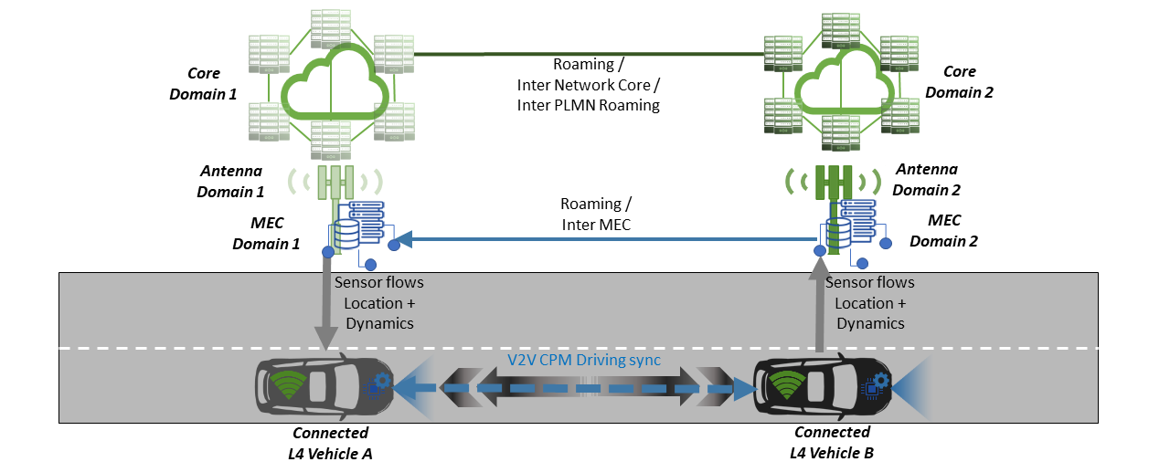
Figure 19 US1.1 Cooperative collision avoidance using MCM
AU_UC1.2: Infrastructure-assisted advanced driving
This Use Case deals with safe lane change manoeuvre dictated from the road operator in a multi-lane highway, with separation signs between the different lanes. The most critical factors of lane change manoeuvres comprise the following: a safe distance to the oncoming separation signs when initiating the lane change operation and a safe gap to the connected vehicle behind coming in the same direction, but on a different lane. An edge node (MEC) receives two types of data: the first one is provided by the road operator’s Traffic Management Centre (TMC) in order to share up to date information about the different types and rules of the toll gates (heavy trucks, CAV, payment methods), while the second data flow is provided by roadside sensors (such as cameras, lidar) in order to be aware of the presence of separation signs between the different lanes on the roads. The received raw data is fused and treated in vicinity of the road entities. After analysing all the input data together with the vehicle related information (location, speed), the MEC takes the lane change decision, calculates the trajectory and guides the vehicle in order to safely change the lane.
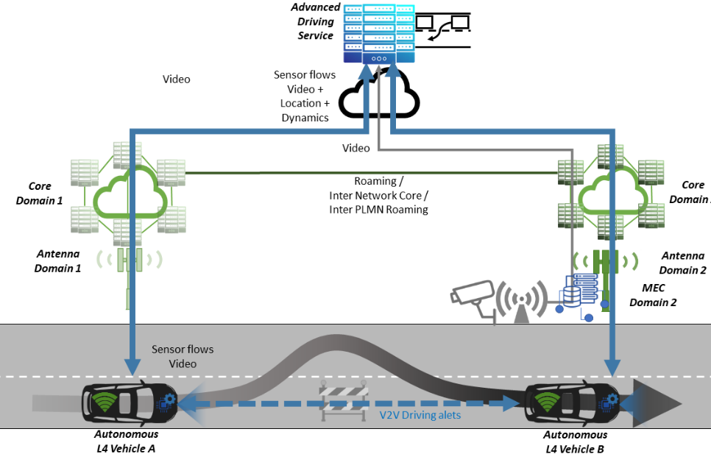
Figure 20 Us1.2 Infrastructure-assisted advanced driving
AU_UC1.3: Cloud-assisted advanced driving
In this Use Case the roadside unit (RSU), remote control centre and cloud server monitor and manage the autonomous vehicles in real time. The remote-control centre (MEC) can issue an overtaking order to a vehicle A through the RSU. After receiving the order, Vehicle A sends the overtaking information to the preceding Vehicle B through V2V communication and receive the real-time information from Vehicle B via V2V again, which includes the position, speed and heading angle of the vehicle. Thus, Vehicle A makes an automatic decision according to the information of Vehicle B. The decision includes the lane change and acceleration. All decisions are communicated between the involved vehicles through V2V communication.
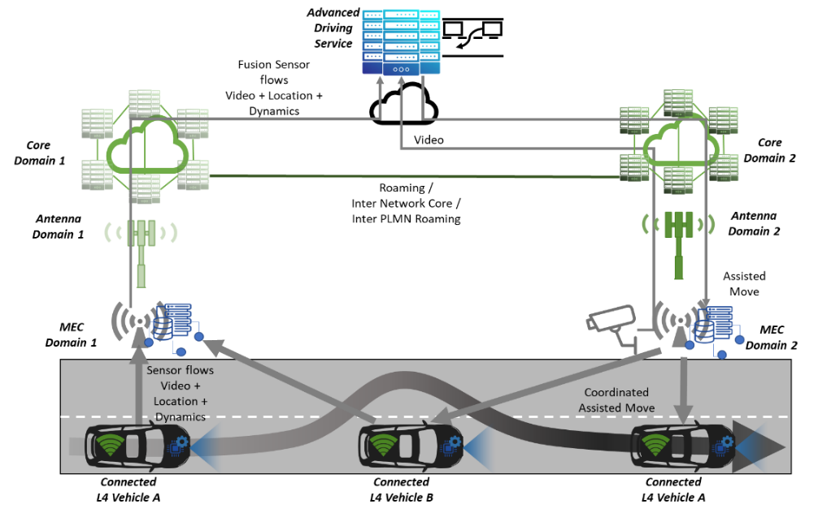
Figure 21 US1.3 Cloud-assisted advanced driving
AU_UC1.4: Complex manoeuvres in cross-border settings
This Use Case focuses on various complex manoeuvres in cross-border corridor environments e.g., national borders. Scenarios include lane merging for automated vehicles, as well as automated overtaking. In the former scenario, vehicles share their vehicle data with the use of a Communication Unit with 5G capabilities and through a MEC Node. Road sensing technologies, such as traffic radars, are also used to detect the presence of vehicles in a lane and to transmit their position and speed to the automated vehicle. Automated vehicles use the Communication Unit to receive the information sent by surrounded vehicles and the road-side infrastructure, and therefore decide on and determine the status of a lane merge and the best way to achieve it. In the latter scenario (automated overtaking), the purpose is to extend the 360º perception layer of the automated vehicle by integrating communication capabilities in the different vehicles of the scenario and additional road sensors (e.g. traffic radars) in the infrastructure. Vehicles are able to share their positions, speeds, sizes, etc., as well as with the road-side infrastructure, which allows automated vehicle to understand current situation and thus take the best decision of how to proceed with the automated overtaking.
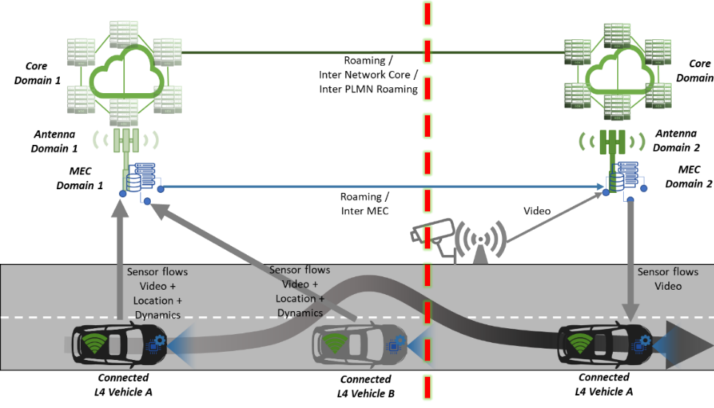
Figure 22 Complex manoeuvres in cross-border settings
AU_UC1.5: Automated shuttle: VRU Cooperation
This Use Case focuses on the cooperative operation of Electric Vehicle (EV) automated shuttle vehicles with VRUs (Vulnerable Road User) in order to increase comfortability and safety of these users, and support the smooth operation of the shuttle service. The operation relies on the collection of VRU and vehicle near-real time position, speed and trajectory (of the vehicle) and the detection of a possible collision, accident. The detection can happen either in a remote control center or at the shuttle itself. The collision avoidance re-action can include either the stopping of the shuttle or the remote handling of the shuttle (where applicable).

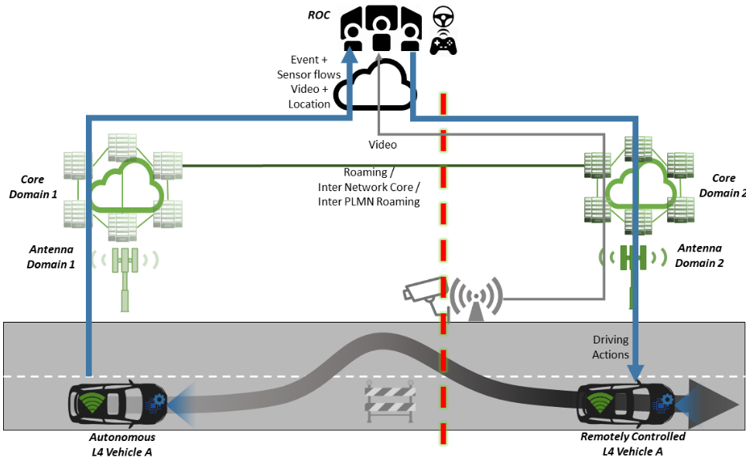
Figure 23 Automated shuttle remote driving across borders

Platooning
Table 26: List of Use Cases within the Platooning Use Case Category
UCC2: Platooning
AU_UC2.1: Platooning
AU_UC2.2: See-What-I-See

AU_UC2.1: Platooning
Two or more vehicles move in a convoy (“platoon”) with seemingly virtual strings attached between each other. The leading vehicle is driven by a human driver, but the followers use the messages transmitted by the leader over either the direct communication links (V2V) or the 5G network (V2N2V), along with the other automated driving functionality that exists in the vehicles, to adjust their manoeuvres. The application can make use of an Edge Dynamic Map (EDM) service provided by the digitized roadside infrastructure i.e., an eRSU (see Figure 24). Within the platooning context, the EDM service can provide assistance to a platoon by broadcasting relevant information perceived from the current traffic situation. This includes information about the other vehicles position, velocity and trajectory which allows the notification of the platoon leader about potential collisions. The eRSU further provides support in the form of detecting potential manoeuvres for the platoon formation.

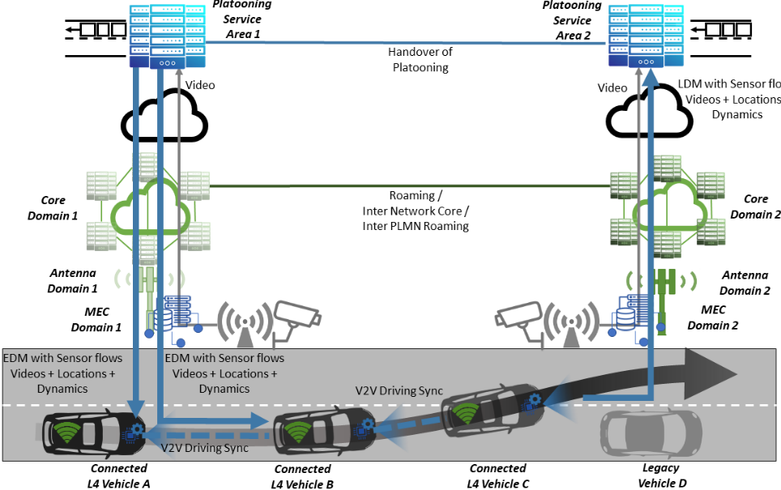
Figure 24 eRSU-assisted platooning
AU_UC2.2: See-What-I-See
In this Use Case, the road view of one of the platooning vehicles, as captured by one or more high quality cameras, is shared with the others in the form of a video stream. The leader truck of the platoon transmits the video to the followers, but the see-what-I-see functionality is independent of whether the vehicles are in a platoon mode or not i.e., it can continue even when the platoon is dissolved at the customs area for further checks.

Extended Sensors
Table 27: List of User Cases within the Extended Sensors Use Case Category
UCC3: Extended Sensors
AU_UC3.1: Assisted Border Crossing
AU_UC3.2: Truck Routing in Customs Area
AU_UC3.3: EDM-enabled ES with surround view generation
AU_UC3.4: Extended sensors with redundant Edge processing
AU_UC3.5: Extended sensors with Collective Perception Messages (CPMs)
AU_UC3.6: Complex manoeuvres in cross-border settings: HDMaps

AU_UC3.1: Assisted Border Crossing
By extending and making use of the sensor data on the vehicle and the other road users, a safe and zero-touch border-crossing is targeted, by this Use Case, for hard borders (customs control required for passing vehicles) like the one that separates Greece and Turkey. Vehicles are checked/monitored remotely by the authority applications, and clearance is provided if no threat is detected. In an adverse situation, the vehicle will not be allowed to pass, and may even be autonomously stopped by the application on the edge.
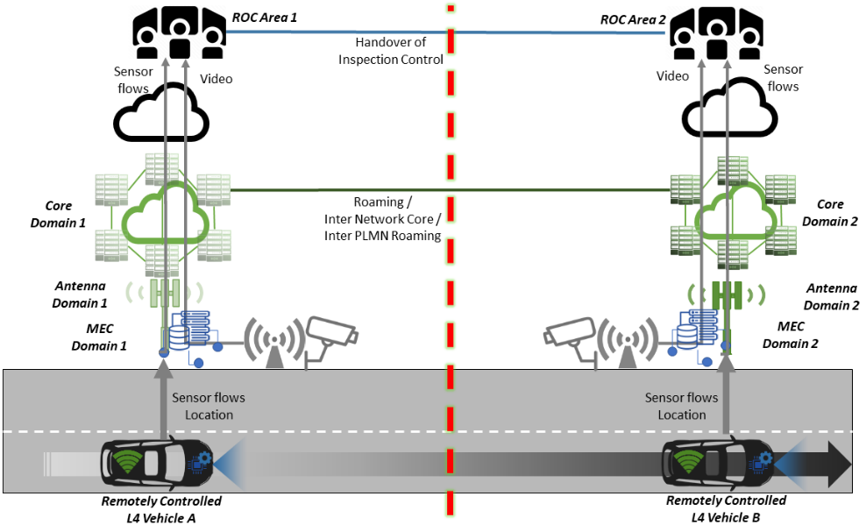
Figure 25 Extended sensors for assisted border-crossing

AU_UC3.2: Truck Routing in Customs Area
In hard borders, the customs zone may require vehicles to go through X-ray checks, which significantly increases the border passing time for drivers, who also need to submit papers and get administrative approvals before continuing to the customs zone at the other side of the borders. In order to perform these two tasks in parallel, the driver leaves the vehicle at the entrance of the customs area to complete paper checks for him/her-self, while the vehicle is autonomously driven by a remote application at the cloud to the X-ray building.
AU_UC3.3: EDM-enabled Extended Sensor with surround view generation
This Use Case deals with situations when the perception obtained by the on-board sensors is not enough and needs to be enhanced by sensor data from other traffic participants. To this end, an Edge Dynamic Map (EDM) service realized at the digitized roadside infrastructure (eRSU), provides vehicles with vehicle discovery functionality and live information, enabling among other sensory data also the transmission of HD video among road users. This can involve several connected vehicles equipped with sensors, as well as roadside infrastructure (eRSU) comprising sensors e.g., cameras. The vehicles and the eRSU using their respective sensor data build their individual situational awareness, identifying objects, lane markings or the road condition to support their prediction and planning functions. However, each individual vehicle’s sensors as well as roadside sensors are limited in the perception in different ways. The sensors view could be obstructed by objects, limited by weather conditions, or not covering a specific area. To mitigate the lack of environment information, vehicles share extracts ROIs (regions of interest) from their Local Dynamic Maps (LDMs) and/or sensor raw data and the eRSU shares its Edged Dynamic Map (EDM).
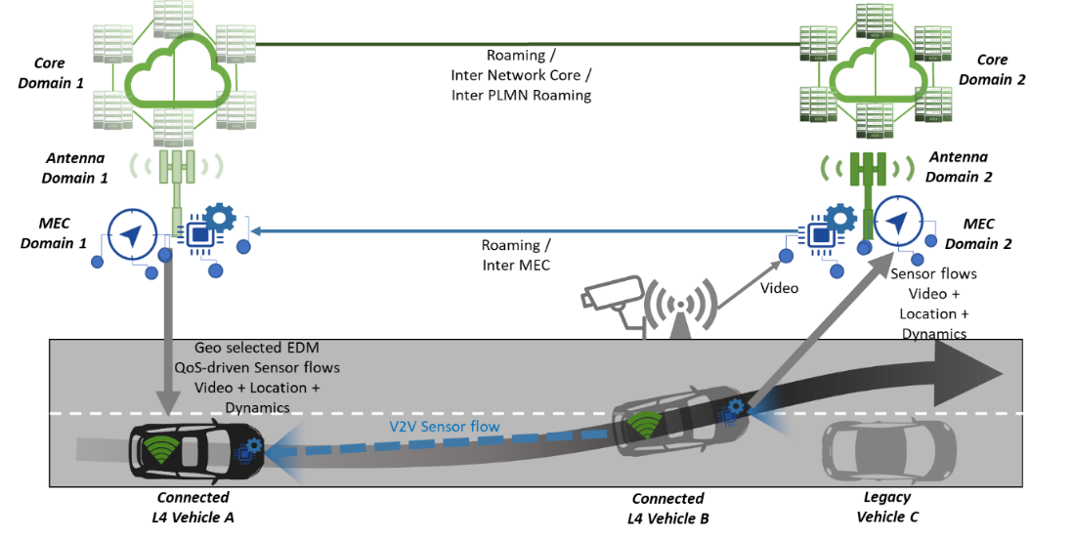
Figure 26 Extended sensors with surround view generation
AU_UC3.4: Extended sensors with redundant Edge processing
This Use Case focuses on video-based cooperative perception for automated vehicles, and especially aspects related to the reliability and performance of networking and edge computing services, especially in cross-border environments. This includes functionalities and performance (e.g. processing delay, migration overhead) of an automated vehicle using edge computing for cooperative perception, including auto discovery of edge nodes, adaptive task allocation, and seamless service migration. When a V2N connection is established, the automated vehicle receives the network address of an edge node connected with the same 5G base station. For redundancy, an automated vehicle is connected simultaneously to two networks (legislation exists towards this end in some countries e.g., Finland), and thus it is connected by default to two edge nodes at the same time. Data generated by the automated vehicle is forwarded to both edge nodes for processing. When the automated vehicle receives the processing results from one edge node already, it can cancel the task on the other edge node. When the automated vehicle is connected to a different network, services also migrate to an edge node connected to the newly connected base station.
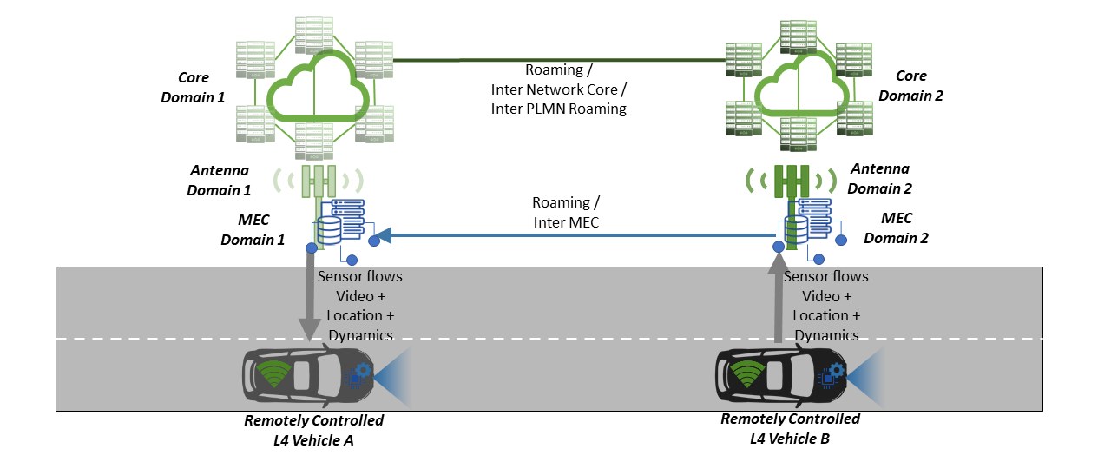
Figure 27 Extended sensors with redundant Edge processing

AU_UC3.5: Extended sensors with CPM messages
This Use Case focuses on enhancing the environmental perception of vehicles by enabling the real-time data exchange between vehicles and road side units (RSUs) using Collective Perception Messages (CPMs). Vehicles with SAE Level 4 capability [10] require predictive information of environment sufficiently ahead in time. Vehicles are equipped with on-board sensors, however, with limited range to detect objects and obstacles. Collective Perception of Environment (CPE) extends this range by providing perception of areas not visible to the vehicle sensors due to curves, corners or obstacles in the roads. Vehicles equipped with 5G technology could share raw sensor data from cameras, LIDAR, etc. or share pre-processed data such as dynamic objects and planned trajectories. Additionally, other driving condition data such as weather situation and traffic information can be shared. gNodeB can act as a hub to relay pre-processed data in low resolution or raw data in high resolution, or (in case of MEC) combined data from different vehicles. Exchanging high resolution perception data in real-time requires high bandwidth and low latency communication as promised by 5G (eMBB, uRLLC).
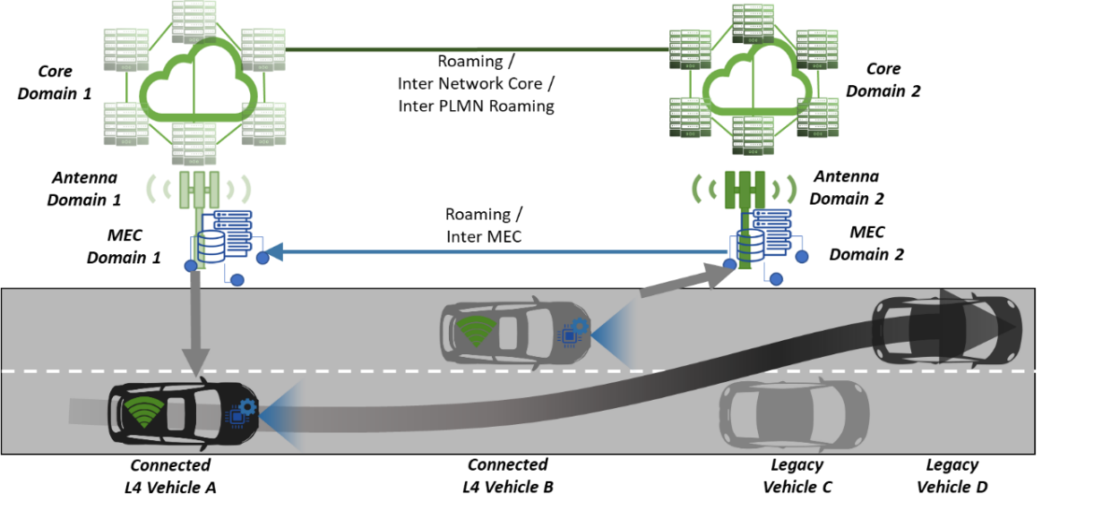
Figure 28 Extended sensors with Collective Perception Messages

AU_UC3.6: Complex manoeuvres in cross-border settings: HDMaps
This Use Case focuses in the capability of automated vehicles and road-side infrastructure to detect changes in the road and the HD-Map used for driving, and in sending these changes to the ITS-Centre in order to centralise and broadcast this information to the other approaching vehicles. Lasers, cameras and traffic radars information can be fused with Differential-GPS and HD-Maps data, in order to determine changes in the stored information. This information can be measured in terms of length of the event, changes in road description (number of lanes, width of the lanes), dangerousness of the situation, etc. Finally, obtained data is shared with the ITS-Centre in order to be stored and shared with other vehicles, ensuring the information reaches all the relevant vehicles.

Remote Driving
Table 28: List of Use Cases within the Remote Driving Use Case Category
UCC4: Remote Driving
AU_UC4.1: Remote driving in a redundant network environment
AU_UC4.2: Remote driving using 5G positioning
AU_UC4.3: Remote driving using mmWave communication

AU_UC4.1: Remote driving in a redundant network environment
The remote driving of an SAE L4 vehicle is enabled by a V2N connection between the vehicular Onboard Unit (OBU) and a remote server hosting V2N applications, in this case the remote driving application is used by the remote human operator. The V2N connection transfers the sensor data feed (high resolution perception data) from the vehicle to the remote human operator (in the uplink direction). The sensor data provides the human operator a “driver’s view” and allows the human operator to send appropriate command messages (e.g. command trajectories) back to the L4 vehicle (in the downlink direction). The remote control/driving of vehicle presents stringent requirements on connection between the vehicle and the Remote Operations Centre (ROC). These requirements include the need to ensure that human operator always maintains connectivity to the vehicle they control, the latency minimized to ensure timeliness of the downlink control messages from the human operator; and the uplink capacity is guaranteed for the transmission of the sensor data feeds from the vehicle. The whole control loop needs to keep tight. The accumulated delay from: sensor reading, sensor data processing, uplink, data visualization, manual control, control signal reading, downlink, and control signal processing to control must be kept low for direct control (depending on speed and dynamics of the vehicle). Furthermore, the vehicle should be aware of any latency issues, so that the operational speed could be adjusted accordingly.
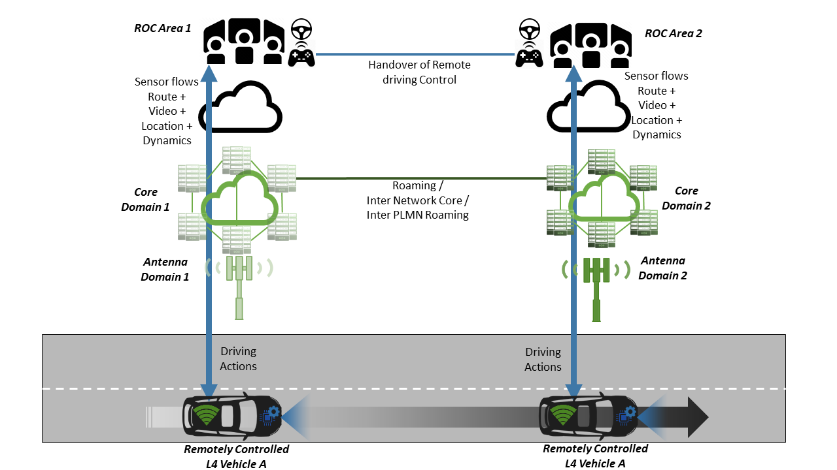
Figure 29 Remote driving in a redundant network environment
AU_UC4.2: Remote driving using 5G positioning
This Use Case focuses on the impact of different modalities of localization in a degradation of sensors, using mmwave localization as one of the options (next to GPS, odometry, visual odometry etc.), all in the context of remote driving services. Within this application environment, particular focus is on using multiple remote stations integrating an environment for virtual remote control, with corresponding (multiple) remote drivers with consoles connected to different MECs taking over control of the vehicles.
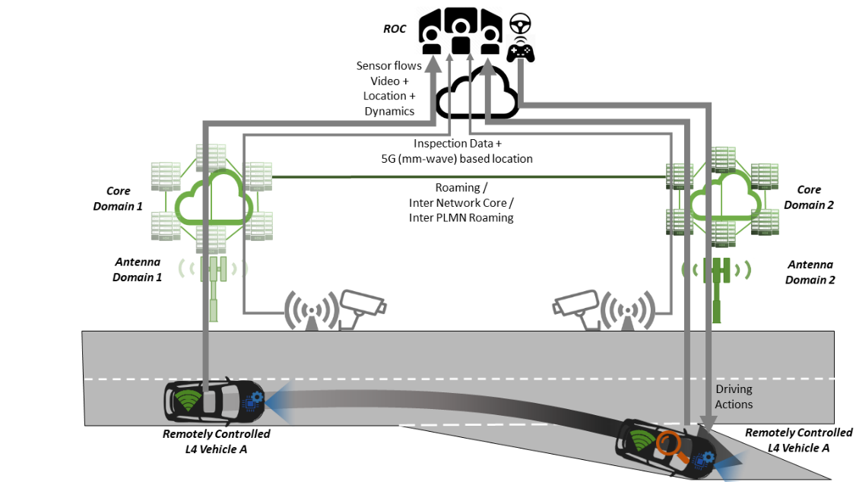
Figure 30 Remote driving using 5G positioning

AU_UC4.3: Remote driving using mmWave communication
Remote driving presents stringent requirements including: ensuring enough field of view and high definition of view for front camera, ultra-low latency to sharing live video stream between vehicle equipped cameras and remote site, and reliable connectivity to control remote driving vehicle in remote site. This Use Case aims to validate feasibility of remote driving system based on mmWave-band V2I communication.
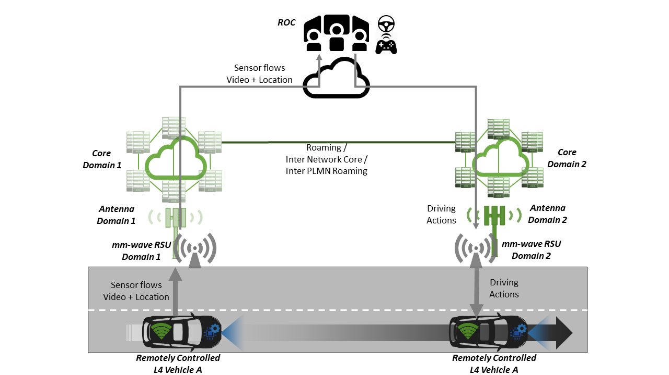
Figure 31 Remote driving using mmWave communication

Vehicle QoS Support
Table 29: List of Use Cases within the Vehicle QoS SupportUse Case Category
UCC5: Vehicle QoS Support
AU_UC5.1: Tethering via Vehicle using mmWave communication
AU_UC5.2: Public transport, HD media services and video surveillance

AU_US5.1: Tethering via Vehicle using mmWave communication
This Use Case enables in-vehicle Ues and pedestrian Ues to access the network with the help of a vehicle relay which is deployed at a vehicle. For in-vehicle Ues, it is possible to avoid high penetration loss occurring from the metallic vehicle surface, thereby achieving more reliable wireless connectivity as well as reduced UE power consumption. The in-vehicle Ues are also benefited from the minimized handover operations. Only the vehicle relays involve in the handover operations. For pedestrian Ues, tethering via Vehicle use case enables more reliable connectivity, increased throughput and reduced UE power consumption since it reduces the communication range of the pedestrian Ues. This Use Case generally supports eMBB-type services such as web surfing, FTP, and video streaming. Hence, it intrinsically requires high data throughput up to several Gbps. In order to satisfy such very high throughput, large bandwidth is necessary which is quite difficult in lower frequency bands below 6 GHz. Therefore, mmWave frequency band should be employed to support such high throughput and to satisfy the Tethering via Vehicle use case.
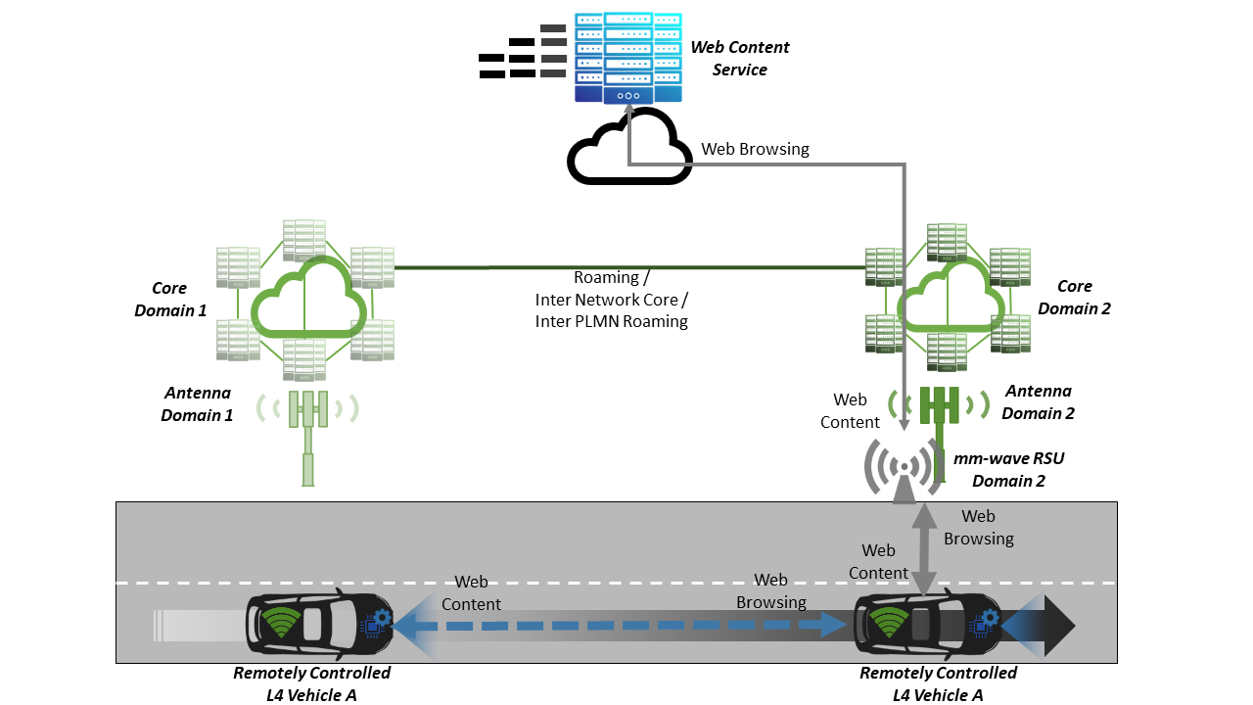
Figure 32 Tethering via vehicle using mmWave communication

AU_UC5.2: Public transport, HD media services and video surveillance
The objective of this Use Case is to provide real time connected services to public transport vehicle fleets. According to this approach, users will be able to enjoy different multimedia services while travelling in the public transport, including high bandwidth data consumption applications as well. On the other hand, public transport vehicles are equipped with a 4K Cameras to provide video streams for Control Centre management and monitoring tasks. Added to this, in vehicle sensor data is also sent to the ITS Centre in order to update the HD maps of other vehicles around, helping to improve the execution of autonomous driving manoeuvres in terms of safety and comfort.
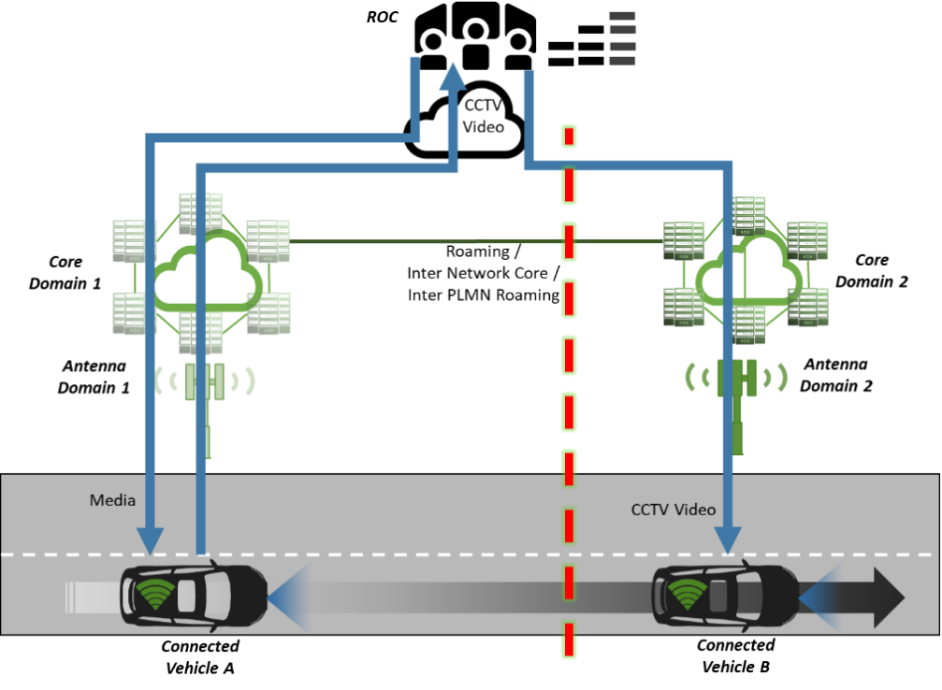
Figure 33 Public transport with HD media services and video surveillance

Core Network KPIs Overview
A series of Network KPIs are defined to guide performance evaluation. Particular attention is devoted to the selection of KPIs aimed to capture aspects related to service continuity and reliability, which is of particular importance in the automotive sector; especially when also further considering the inherent requirement for cross-PLMN (Public Land Mobile Network) service continuity.
Table 30 Network KPIs in the Automotive Vertical Use Cases
CKPI id | Network KPI Name | Network KPI Description
CKPI-1 | User experienced data rate | Data rate as perceived at the application layer. It corresponds to the amount of application data (bits) correctly received within a certain time window (also known as goodput).
CKPI-2 | Throughput | The instantaneous data rate / throughput as perceived at the network layer between two selected end-points. The end points may belong to any segment of the overall network topology. It corresponds to the amount of data (bits) received per time unit.
CKPI-3 | Latency | Elapsed time from the moment a data packet (network Protocol Data Unit) is transmitted by the source node, to the moment it is received by the destination node. It applies to various levels of the protocol stack. Particular attention is paid to the End-to-End Latency defined as the elapsed time from the moment a message is transmitted by the source application to the moment it is received by the destination application instance(s).
CKPI-4 | Control plane Latency | Control plane latency refers to the time to move from a battery efficient state (e.g., IDLE) to start of continuous data transfer (e.g., ACTIVE). This is a KPI aimed to shed further light on the end-to-end latency components i.e., identify the contribution of control plane processes to the overall perceived latency.
CKPI-5 | User plane Latency | Contribution of the radio network to the time from when the source sends a packet to when the destination receives it. It is defined as the one-way time it takes to successfully deliver an application layer packet/message from the radio protocol layer 2/3 SDU ingress point to the radio protocol layer 2/3 SDU egress point of the radio interface in either uplink (UL) or downlink (DL) in the network, assuming the mobile station is in the active state.
CKPI-6 | Reliability | Amount of application layer messages or network layer packets (subject to measurement level i.e., L2 or L1) successfully delivered to a given system node within the time constraint required by the targeted service, divided by the total number of sent messages or packets.
CKPI-7 | Position accuracy | Deviation between RTK-GPS location information and the measured position of a UE via 5G positioning services.
CKPI-8 | NG-RAN Handover Success Rate | Ratio of successfully completed handover events within the NR-RAN regardless if the handover was made due to bad coverage or any other reason.
CKPI-9 | Application Level Handover Success Rate | Applies to scenarios where an active application level session (e.g., communication between application client at UE and the Application Server) needs to be transferred from a source to a destination application instance (e.g., located at MEC hosts at the source and destination networks respectively) as a result of a cross-border mobility event. The KPI describes the ratio of successfully completed application level handovers i.e., where service provisioning is correctly resumed/ continued past the network level handover, from the new application instance.
CKPI-10 | Mobility interruption time | The time duration during which a user terminal cannot exchange user plane packets with any base station (or other user terminal) during transitions. This is messured as the time difference between RRC Connection Reconfiguration and New Data Receive messages.

Vertical/CCAM KPIs
Table 31: Vertical KPIs in the Automotive Vertical Use Cases
UCC | Vertical KPI Name | Vertical KPI Description
Advanced Driving | Local Perception metrics
Advanced Driving | Instantaneous accelerations/decelerations | Number of times the vehicle involved in the overtaking/lane merge manoeuvres needs to accelerate/decelerate instantaneously in order to complete the manoeuvre in a safe way.
Advanced Driving | Object detection capability (True Positive Rate, TPR) | In the object detection capability context, TPR refers to the number of objects correctly identified as objects.
Advanced Driving | Object classification capability (true positive) | In the object classification capability context, TPR refers to the number of objects correctly classified to the right classification.
Advanced Driving | Augmented Perception metrics
Advanced Driving | Object localisation precision | Precision of the object localisation functionality as a comparison of the perception system evaluation against real object location.
Advanced Driving | Object detection capability | Precision of the object detection functionality as a comparison of the perception system evaluation against ground truth/human perception.
Advanced Driving | Recognition of non-communicating object | Evaluates the capacity of the system in correctly recognizing non-communicating objects. This reflects to the capability of data fusion between the output of the local perception and the received CPMs.
Advanced Driving | Recognition of communicating objects | Evaluates the capacity of the system in correctly recognizing communicating objects. This reflects to the capability of data fusion between the received CAMs, CPMs and the output of the local perception.
Advanced Driving | Risk analysis metrics
Advanced Driving | Time to collision | The time remaining before the rear-end accident if the course and speed of vehicles are maintained.
Advanced Driving | Inter-vehicle gap | Headway distance (gap) between vehicles in the same lane
Platooning | Number of Video Stream Failures | Due to various reasons such as lack of throughput or high latency, video streaming from lead vehicle to follower vehicle stalls.
Platooning | Number of Platoon Maneuver Failure | Platoon maneuvers such as maintain platoon is not possible due to high latency or position information is not precise enough, etc.
Platooning | Number of Path Follow Failure | Path is not followed properly during border crossing due to path information is not received in expected time or the application server did not receive (timely) information by sensors and vehicle due to high latency and low throughput capability.
Platooning | Number of CPM Loss | Number of platooning CPM messages that have been lost and cannot be used for platooning control, between eRSU and platoon leader.
Platooning | Number of Platooning Messages Loss | Number of platooning messages that have been lost and cannot be used for platooning control, between platoon leader and other vehicles in the platoon.
Extended Sensors | Speed deviation | Degree of deviation respect to the road speed. Measured as number of events or time spent at deviated speed (along with the amount of deviation).
Extended Sensors | Driving mode | Amount of time the vehicle is in autonomous/manual mode
Extended Sensors | Continuity of Surround View stream | Percentage of time the vehicle is receiving a valid Surround View stream.
Extended Sensors | Target variations | Momentary difference between target points observed by host vehicle and other vehicles
Extended Sensors | Speed variations | Variability in speed profiles during manouevres.
Extended Sensors | Instantaneous accelerations/decelerations | (as defined above)
Remote Driving | Remote driving session outage | The amount of time in which the remote driving session is lost or degraded .
Remote Driving | Vehicle maneouvre delay | Delay in vehicle resuming driving in a new trajectory
Remote Driving | (subjective) experience of remote operator | Observations and descriptions from remote operator of video quality (distance perception).
Remote Driving | Control action delay | Delay between control command message and manouevre execution of remote vehicle
Remote Driving | Instantaneous accelerations/decelerations | (as defined above)
Vehicle QoS Support | Number of Video Stream Failures | (as defined above)
Vehicle QoS Support | Resolution of the video streaming | Captures variations of the quality of the video stream due to variations of the underlying network conditions.

Core and Service KPIs Mapping

UCC | Vertical KPIs vs. Networking KPIs | User experienced data rate | Throughput | Latency | Control plane Latency | User plane Latency | Reliability | Position accuracy | NG-RAN Handover Success Rate | Application Level Handover Success Rate | Mobility interruption time
Advanced Driving | Local Perception metrics
Advanced Driving | Instantaneous accelerations/decelerations | ✓ | ✓ | ✓ | ✓ | ✓ |  |  | ✓ | ✓ | ✓
Advanced Driving | Object detection capability (True Positive Rate, TPR) |  |  | ✓ |  | ✓ | ✓
Advanced Driving | Object classification capability (true positive) |  |  | ✓ |  | ✓ | ✓
Advanced Driving | Augmented Perception metrics
Advanced Driving | Object localisation precision |  |  | ✓ |  | ✓ | ✓
Advanced Driving | Object detection capability |  |  | ✓ |  | ✓ | ✓
Advanced Driving | Recognition of non-communicating object |  |  | ✓ |  | ✓ | ✓
Advanced Driving | Recognition of communicating objects |  |  | ✓ |  | ✓ | ✓
Advanced Driving | Risk analysis metrics
Advanced Driving | Time to collision |  |  | ✓ |  | ✓ | ✓
Advanced Driving | Inter-vehicle gap |  |  | ✓ |  | ✓ | ✓
Platooning | Number of Video Stream Failures | ✓ | ✓ | ✓ |  |  | ✓ | ✓
Platooning | Number of Platoon Maneuver Failure | ✓ | ✓ | ✓ |  |  | ✓ | ✓
Platooning | Number of Path Follow Failure | ✓ | ✓ | ✓ |  |  | ✓ | ✓
Platooning | Number of CPM Loss |  |  | ✓ | ✓ | ✓ |  |  | ✓ | ✓ | ✓
Platooning | Number of Platooning Messages Loss |  |  | ✓ | ✓ | ✓ |  |  | ✓ | ✓ | ✓
Extended Sensors | Speed deviation | ✓ | ✓ |  |  |  | ✓ |  | ✓ | ✓ | ✓
Extended Sensors | Driving mode | ✓ | ✓ |  |  |  | ✓ |  | ✓ | ✓ | ✓
Extended Sensors | Continuity of Surround View stream | ✓ | ✓ | ✓ |  | ✓ | ✓ |  | ✓ | ✓ | ✓
Extended Sensors | Target variations | ✓ |  | ✓ |  |  | ✓ |  |  | ✓
Extended Sensors | Speed variations | ✓ |  | ✓ |  |  | ✓ |  |  | ✓
Remote Driving | Remote driving session outage |  |  | ✓ | ✓ | ✓ | ✓ |  | ✓ | ✓ | ✓
Remote Driving | Vehicle maneouvre delay |  |  | ✓ | ✓ | ✓ | ✓ |  | ✓ | ✓ | ✓
Remote Driving | (subjective) experience of remote operator | ✓ | ✓ | ✓ | ✓ | ✓ | ✓ |  | ✓ | ✓ | ✓
Remote Driving | Control action delay | ✓ | ✓ | ✓ | ✓ | ✓ | ✓ |  | ✓ | ✓ | ✓
Vehicle QoS Support | Number of Video Stream Failures | ✓ | ✓ | ✓ |  | ✓ | ✓ |  | ✓ | ✓ | ✓
Vehicle QoS Support | Resolution of the video streaming | ✓ | ✓ | ✓ |  | ✓ | ✓ |  | ✓ | ✓ | ✓

Media & Entertainment

Introduction to the Vertical Industry
M&E services need to cope with increasing demand in terms of data rates, number of simultaneous users connected and/or more stringent QoS requirements. High quality and high-resolution audio-visual services are important drivers for increased downlink data rates, where 5G promises to provide cost-effective alternatives to today’s Content Delivery Network (CDN) approaches. At the same time, user generated content, as well as the use of cellular technology for professional and semi-professional media production are key drivers for increased uplink data rates. Cellular, especially when used in bonding multiple links, has been replacing the traditional uplink method of satellite trucks transmission and enabled live high-quality transmission to all sorts of media content providers. 5G will enable this viable and immensely growing area of cellular and IP-based live media production as a business to grow further, supporting new business models, such as production in the cloud, at lower costs. 5G will seamlessly integrate services over different network technologies (fixed, wireless), topologies (including e.g. unicast, multicast and broadcast) and capabilities (e.g. caching and multi-link), which may be needed to cover all M&E use cases.

Business perspective
5G networks will catalyse the media industry chain, from production and contribution to distribution. 5G networks’ ability to dynamically respond to such needs will be the key driver for the provision of next generation media services.

Production and contribution business scenarios: In terms of professional media production and contribution operations, 5G will become the cost-affordable companion to be employed, saving space and specialised maintenance of equipment, replaced by smaller and general-purpose communications equipment. New business models include IP media workflows, remote live production, where the video assets are in the cloud and the involved team members are in their homes or offices, as well as enhanced media production services, given that cloud resources and AI/big- data processing solutions can be used in real time with the live high-fidelity video uplink in a 5G network. Further business drivers are described include: increased productivity and revenues by enabling producing and handling more live events simultaneously, significantly reduced costs by reducing size and travel of big production teams and equipment trucks to event sites, reduced costs compared to traditional media contribution over dedicated satellite, reduced costs due to enabling usage of cloud-based production software, increasing viewers engagement by providing more content and at a higher quality and higher overall QoE (such as more fluent and reliable video) content on TV and online including on social networks, using fewer modems and SIM cards in multilink bonded transmission (even from the same 5G operator), using multilink on the same operator for example by using “multi-slice” – a technology of bonding two modems on two different network slices.

Distribution business scenarios: According to Cisco’s Visual Networking Index [11], video content is expected to be responsible for 75% of the mobile data traffic by 2021. At the same time, media companies and content providers are affected by rising CDN costs. 5G is expected to reduce content distribution costs and offer a competitive business advantage to Mobile Network Operators (MNOs) that will be able to provide transparent multicast and broadcast capabilities, at a considerably lower network load. Caching close to the edge provides an interesting commercial opportunity for MNOs.

Technology perspective

Considering that the media traffic is the main traffic type, volume-wise being delivered by the networks, the new 5G networks will play a major role in media distribution. The solution must be transparent in different levels, from the media delivery protocol perspective to be universally adopted, and from the networking efficiency to avoid overheads with extra messaging. This can become a reality by using content delivery analytics to measure the speed and availability of different delivery paths over the network. 5G slicing, Multi-access Edge Computing (MEC), Fog and Mist Computing architectures can make the difference in order to exploit in an isolated and scalable way geo-based network and QoS analytics with almost zero latency. In this regard, SDN over NFV virtualisation technologies bring new possibilities to make an efficient and dynamic setup and provision of the infrastructure. The use of multiple IP-based connections bonded together, enables higher bandwidth, higher reliability and lower delay. An inherent multicast and broadcast mode with support for large cells and a single-frequency mode provides a highly efficient mean for distribution of high-quality and/or immersive content to many concurrent users. Target devices include regular smartphones, VR/AR glasses, TV sets, public displays as well as in-car entertainment systems (which are expected to gain an increasing role in the advent of automated driving).

Context – Business Situation & Drivers – Why 5G is required
To support efficient multi-viewer delivery of live content in such use cases, broadcast and multicast capabilities are needed (e.g. those designed by the 5G-Xcast project). TV and radio are consumed on many different devices and in many different usage scenarios. A traditional, linear service is understood as a curated integrated service, which could be a 24/7 linear live channel but could also be complemented by on-demand elements. For a 5G network iteration there should also be considerations for future types of “linear” such as skipping songs, shows, replacing (parts of) programme items. Linear is downlink only in broadcast mode, i.e. a certain portion of spectrum is permanently consumed by TV/Radio services – independently from the number of viewers. This can then be combined with on-demand elements obtained in unicast mode known as “hybrid applications” (e.g. as is the case with HbbTV).The use of on-demand apps (Video on Demand, Audio on Demand) is by nature an individual affair and requires bi-directional communications and unicast mode. Places such as stadiums, cinemas and hall parks are becoming increasingly connected to the digital world, with the purpose of further engaging their users. Augmented onsite live event experience: this means enhancing the experience of the onsite visitors, for example by means of augmented reality, providing them with additional information relating to the live event. Such information may be previously available or be created in real-time.
Personalised onsite live event experience is of key importance. This use case caters for personalizing the visitors’ experience, for example allowing them to select (additional) camera angles to view, zoom in certain areas of the location which would otherwise be too far away or not visible from their current location, or view replays of the just played content or view related content. On site live events can be classified into scheduled (e.g. sport matches, music concerts, festivals) and unpredictable/unexpected events (e.g. live news, emergency support). Scheduled events are planned by TV organizations employing professional equipment like 360° degree cameras, 4K cameras that are controlled remotely, and UHD video streams. Additionally, video streaming produced for users attending the event could be properly conveyed by professional equipment to enhance media fruition or delivered directly to final users as direct video communications. Unpredictable/unexpected events that cannot be planned in advance and need to be streamed at unpredictable time, from both TVs and users in the area of the event. The fundamental difference between the two kinds of events is related to the time available for infrastructure setup, with the second scenario possibly critical also for environmental aspects. Both cases require setup of the media delivery and the related communication support for a limited period of time, i.e. the duration of the event. Broadcasting and multicasting via eMBMS, 5G broadcast and multicast and seamless transition to unicast, can also enable the delivery of high-quality video to many users without consuming more bandwidth.

Use Cases Overview
Use Case: Ultra-High-Fidelity media
Rapid progress in display and capture technologies is enabling a new, highly immersive production and viewing experience with ultra-crisp, wide-view pictures with deep contrast and multi-channel sound. Both linear and non-linear content will be used for testing the Ultra High-Fidelity Media (UHFM) experience. In order to guarantee a high quality of experience for UHFM, 5G network should be able to support efficient network management, fair resource allocation, high speed transport capabilities and strategies, e.g. by means of local and network caching of content. UC involves media streaming to devices using a variety of applications supported by the partners under different network configurations.
The last few years have been witnessing a quantum shift in the production and commercialization of digital media. High Definition (HD) digital media is now pervasive in every domain. UHD and higher resolution content is a definite trend. Applications range from Digital Cinema Projection through Broadcast TV, corporate messaging and training, science, medical and military. The distribution of UHFM digital media, for these and every other application, has been made possible by the development of highly efficient compression standards that reduce the size of files and bit‐streams significantly while maintaining picture quality to allow storage, cashing and distribution of media on a mass scale, be it to the cinema, digital live broadcast channels, or streaming on demand to home and mobile consumers.
Indeed, film distribution has started moving towards Ultra‐High Definition (UHD) ‐ four times the HD size. Well established companies, such as the BBC, are putting substantial effort in the creation of UHD content considering increases in resolution towards UHD and frame rate towards 100 Hz. Domestic television sets and mobile devices e.g. smartphones, tablets, laptops, etc. have been introduced with UHD resolution screens, and are capable of displaying and capturing even higher resolutions. Undoubtedly, the production and exploitation of UHFM content will dominate the market for years to come.
In the meantime, there have been dramatic changes in the generation, production and use of digital media. Indeed, User Generated Content (UGC) has been inundating the storage cells of smart mobile devices, personal computers and social networks alike. A new wide range of sources of UGC has emerged; originated by the pervasive and increasing impact of connected devices, such as smartphones, tablets and wearable devices, able to capture the news and the event as it unfolds anytime anywhere. Moreover, the latest smart device models are equipped with high‐specification cameras, enabling users to capture videos with professional quality, even in UHD out‐of‐the‐box. Exploiting the mobile social media concept, both the TV broadcasting industry and academia have been continuously building integrated TV and web platforms to engage the users in the broadcasting process. Of course, the pervasiveness of social networks also means that such platforms should not only be used to generate new forms of media and interaction, but should be accessible to all, irrespective of geographical location e.g. mobile consumers or access device.
The realisation of this vision is underpinned by decades of research and advances in video and multi‐view media processing, as well as, other related research fields, meaning that the time is now ripe for integrating research outputs with technologies that support real‐time creation and distribution of more advanced content forms while enabling interaction and crowd‐sourcing among users and professional content creators. Indeed, the community of knowledge creators, developers and commercialisation enterprises in the fields of mobile applications, UHFM broadcasting, or both, is fully aware of the unprecedented growth of related technology and is wholly convinced of the great potential of a UHFM broadcasting to all consumers no matter their status e.g. being at home or mobile.
The challenge broadcasters currently face is the understanding of pros e.g. additional capabilities such as slicing, or limitations that emerging NGA networks (with focus on 5G) offer in order to take advantage and adapt technological infrastructures and business models. Respective efforts over 4G networks demonstrated great capacity, latency and density limitations. To this end, no matter if content mobile distribution services exist over current mobile networks, they cannot guarantee higher quality and eventually support most of the times lower content formats.
One aspect to be proved is the possibility to scale delivery for large audiences. 3GPP has prioritized the work around unicast use cases since the first release of 5G, Rel’15, and hence 5G point-to-multipoint would only be addressed starting from Rel’17. The lack of PTM characteristics may lead to an inefficient service provisioning and utilization of the network and spectrum resources when distributing the same data to multiple users and devices (e.g., live and linear content with very large audiences or mass software updates). However, whether 5G unicast is already able to withstand massive media consumption needs to be investigated.

Service KPIs Overview

According to “5G Trial and Testing Initiative Precommercial Network Trials Framework Definition v2.0” [12] the quality of video services (user experience) is determined by:
Table 32 Service KPIs in media & entertainment vertical use case
SKPI Id | SPKI Name/Description
ME-SKPI-1 | the server accessibility (application accessibility)
ME-SKPI-2 | the waiting time (time to first picture)
ME-SKPI-3 | user defined timeout (emulates the user’s patience) leads to a “fail”
ME-SKPI-4 | very importantly the picture quality (MOS for each 10s interval of a video, and certainly as the average MOS for the whole video)
ME-SKPI-5 | freezing / stalling of the video in %
ME-SKPI-6 | lost streams (constant freezing)
ME-SKPI-7 | jerkiness in % (if frame rate is not high enough, e.g. < 20 fps, the video is not perceived as fluent)
The measurements flow is illustrated in the following figure:
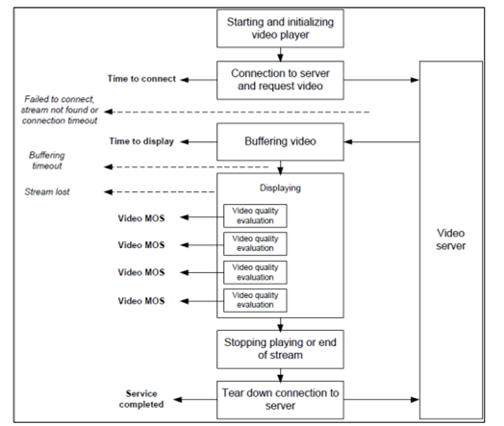
Figure 34 Measurement Flow

The service KPIs and their target values are summarized in tables 33 and 34 [12]:

Table 33 Content Streaming for the ITU-based method
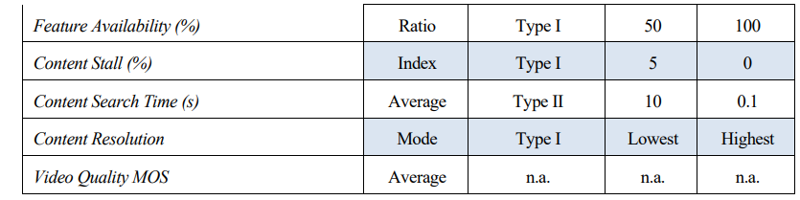

In case of the “generalized method” the second step is how different the KPIs can be interpolated into a Generalized MOS, as shown in table 34.

Table 34 Content Streaming KPIs Interpolation into Generalized MOS
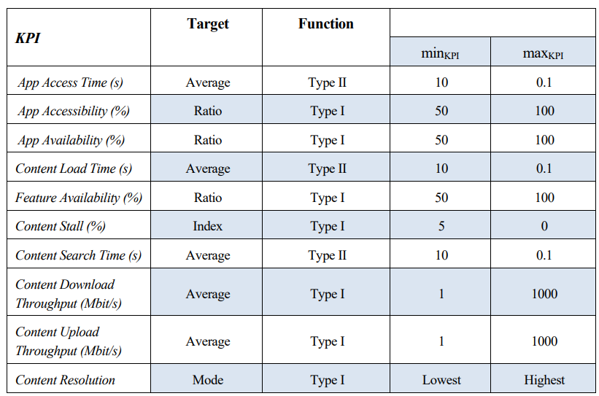

Architecture and service provisioning procedures
Within the broad variety of services 5G networks target, there are use cases that require content delivery to a group of end devices using broadband connectivity over mobile and converged networks. Example of such use cases are live video streaming, mission critical communication, information dissemination in IoT and V2X domains. Live video streaming has been growing for many years due to improvements in network performance which made HTTP streaming a viable solution for delivering live media. Nonetheless, live video streaming creates several challenges when delivered over unicast connections. In particular, demand for network throughput may experience significant, yet short-term, peaks, forcing network operators to overprovision their networks to deal with such peak demands.
5G-PPP and 3GPP architecture definitions targeting media distribution are presented below.

3GPP
Streaming in the context of the specification [13] is defined as the delivery of time-continuous media as the predominant media. Streaming points to the fact that the media is predominantly sent only into a single direction and consumed as it is received. Additionally, the media content may be streamed as it is produced, referred to as live streaming. If content is streamed that is already produced, it is referred to as on-demand streaming.
The overall 5G Media Streaming Architecture is shown in the figure below:
Figure 35 5G Media Streaming within the 5G System

The present clause describes the procedures for downlink streaming.
The downlink streaming procedures follow a general high-level workflow, starting from provisioning and ingest session preparation to the actual content streaming sessions. The ingest session refers to the time interval during which media content is uploaded into the 5GMSd AS. The provisioning session refers to the time interval, during which the 5GMS Client can access the media content and the 5GMSs Application Provider can control and monitor the media content and its delivery. Interactions between the 5GMSd AF and the 5GMS Application Provider may occur at any time, while the Provisioning Session is active.
The 5GMS provisioning API allows selection of media session handling (M5d) and media streaming (M4d) options, including whether the media content is hosted on trusted 5GMSd Ass. The selection is identified by a 5GMSd Application Service Configuration Id. The 5GMSd AF selects the M5d interface features according to the provisioning option. The Media Session Handling interface can be used for core session handling, consumption reporting, QoE reporting, requesting different policy and charging treatments or other network assistance services.
When the content is hosted by trusted Media Ass, then the 5GMSd AF selects and configures the 5GMSd AS. Interactions between a 5GMSd AF and a 5GMSd AS (M3d interactions) take place for 5GMS Ingest (M2d) and Media Streaming (M4d) resource reservations. The 5GMSd AS allocates M2d and M4d resources and communicates resource identifiers back to the 5GMSd AF. The 5GMSd AF provides information about the provisioned resources (in form of resource identifiers) for Media Session Handling (M5d), the 5GMSd Ingest (M2d) and the Media Streaming (M4d), to the 5GMSd Application Provider. The resource identifiers for Media Session Handling and Media Streaming are needed by the 5GMSd Client to access the 5GMSd functions.
When content hosting is provided by a 5GMSd AS in the external DN, then the M3d interface is not used and the 5GMSd AF does not provide 5GMS Ingest (M2d) and Media Streaming (M4d) resource reservations. M3d procedures are not standardized.
5GMSd Clients can (in principle) start the media streaming as soon as the content is ingested by activating its unicast downlink streaming session. However, it may take some time until the media content is available for Media Streaming (via the Media Streaming API) or the distribution availability might be based on a provisioned schedule. The unicast downlink streaming session for a given UE (or “for each UE”) is active from the time, at which the 5GMS Aware Application activates the reception of a streaming service until its termination.
The 5GMSd Aware Application receives application data from the 5GMSd Application Provider before receiving the downlink streaming media. The application data contains service access information, which act as entry point for the 5GMSd Client to start the downlink streaming session. The 5GMSd Client may either receive a reference to that service access information or the full service access information from the 5GMSd Application Provider.
Figure 36 High Level Proceducre for Downlink Streaming

The steps for the service provision are:
1. The 5GMSd Application Provider creates a Provisioning Session and starts provisioning the usage of the 5G Media Streaming System. During the establishment phase, the used features are negotiated and detailed configurations are exchanged. The 5GMSd Application Provider receives service access information for M5d (Media Session Handling) and, when media content hosting is negotiated, service access information for M2d (Ingestion) and M4d (Media Streaming). This information is needed by the 5GMSd Client to access the service. Depending on the provisioning, only a reference to the service access information may be used.
2. When media hosting is provided, then there may be interactions between the 5GMSd AF and 5GMSd AS, e.g. to allocate 5GMSd ingest and Media Distribution resources. The 5GMSd AS provides resource identifiers for the allocated resources to the 5GMSd AF, which then provides the information to the 5GMS Application Provider. The M3d procedures between Media AF and Media AS are not specified.
3. The 5GMS Application Provider starts the Ingest Session by ingesting content. In case of live services, the content is continuously ingested. In case of on-demand streaming services, the content may be uploaded once and then updated later on. Note, a 5GMSd AS in the external Data Network may provide the content hosting.
4. The 5GMS Application Provider provides the service announcement information to the 5GMS Aware Application. The service announcement includes either the whole service access information (i.e. details for Media Session Handling (M5d) and for Media Streaming access (M4d)) or a reference to the service access information or pre-configured information. When a reference is included, the 5GMS Client fetches (in a later step) the services access information when needed.
5. When the 5GMSd Aware Application decides to activate the streaming service reception, the service access information (all or a reference) is provided to the 5GMSd Client. The 5GMSd Client activates the unicast downlink streaming session.
6. When the 5GMSd Client got a reference to the service access information, then it acquires the service access information. Note, pre-caching of service access information may also be supported by the 5GMS Client to speed up the activation of the service.
7. The 5GMSd Client uses the Media Session Handling API towards the 5GMSd AF. The Media Session Handling API is used for consumption, QoE reporting, requesting different policy and charging treatments or other network assistance services. The actual time of API usage depends on the feature and interactions that may be used during the media content reception.
8. The 5GMSd Client activates reception of the Media Content.

5G-PPP
The overall end to end architecture for efficient content delivery over 5G networks [14] is illustrated in figure 37 below below:
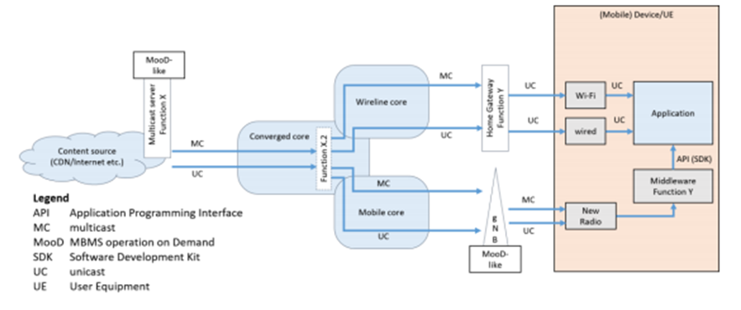
Figure 37 End-to-End Architecture for Content Delivery over 5G

The design principles of the CN for multicast and broadcast are aligned with those of the 5GS. Although the architecture is discussed with the focus on mobile CN, the network design is applicable to a converged network as well. Additional principles related to multicast and broadcast capabilities from a CN architecture perspective are the following:
- Enabling multicast and broadcast capabilities should require a small footprint on top of the existing unicast architecture.
- Wherever possible, treat multicast and broadcast as an internal optimization tool inside the network operator’s domain.
- Consider terrestrial broadcast as a service offered also to Ues without uplink capabilities that can be delivered as a self-containing service by subset of functions of multicast and broadcast architecture.
- Simplify the system setup procedure to keep the system cost marginal. The design aims to develop an efficient system in terms of architecture/protocol simplicity and resource efficiency. Despite simplified procedures, the architecture also should allow flexible session management.
- Focus on the protocols that allows efficient IP multicast.
- Enable caching capabilities inside the network.
The System architecture enhanced for multicast and broadcast is illustrated in figure 38 below:
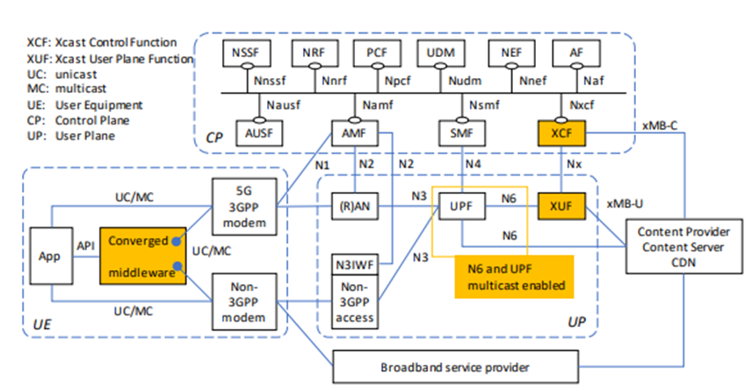
Figure 28 System Architecture for Multicast and Broadcast
The detailed description of the architectural elements is described in the “5G Architecture White Paper” [14], Section 4.2.1.
Please note that the UE is decomposed to an application, a converged middleware, a 5G 3GPP modem and a non-3GPP modem.

Core Network KPIs Overview

The network KPIs are defined in the matrix below:

Table 35 Core KPIs in media & entertainment vertical use case
CKPI Id | CKPI Name | CKPI Description | Units
CKPI-1 | End-to-end Latency | Aggregation of one-way time delays measured between specific components of the logical architecture of the use case. | Ms
CKPI-2 | Packet Loss | The number of packets that fail to reach their destination, measured in specific interfaces of the use case logical architecture. | %
CKPI-3 | Guaranteed Data Rate | The data rate is the number of bits per unit of time sent over a specific interface of the use case logical architecture. The guaranteed data rate is the minimum expected data ratefor the overall use case to function correctly. | Mbits/s
CKPI-4 | Coverage | Radio access coverage area on the pilot premises. | M²
CKPI-5 | Availability | Percentage of time during which and locations in which a specific component of the use case (application, server, network function, etc.) is responding to the requests received with the expected QoS requirements. That is, it is the ratio between the up-time of a specific component over the total time the component has been deployed. | % of time
CKPI-6 | Slice Creation Time | Time elapsed since the creation of a slice is triggered until the slice is fully operational. | Ms
CKPI-7 | Connection Density | The number of users/devices that can be connected simultaneously to the use case network infrastructure without degrading the performance of the users/devices that are already connected. | 1/m²
CKPI-8 | Data Volume | The total quantity of information transferred over a given interface during specific use case operations, measured in bits. | Gbits
CKPI-9 | Jitter | Variation of the end-to-end latency forthe communications between specific components of the use case. This core KPI is useful to correlate QoE KPIs for the different video visualizations performed in the use cases. | Ms
CKPI-12 | Area Network Capacity | Total network capacity that is provided over a specifically defined geographic area. | Gbps
CKPI-13 | Mobility / Speed | The network capability to provide connectivity to end user devices moving at various speeds. | Km/h
CKPI-14 | Handover time | Time between the moment that a change to another access node is triggered up to the time that the session is transferred to the other access node and served. | Ms
CKPI – 15 | Reliability | Percentage of times in which a specific component of the use case (application, server, network function, etc.) is responding to the requests received with the expected QoS requirements given the availability of the service. That is, it is the ratio between the up-time of a specific component over the total time the component has been deployed for the time that the service is supposed to be available. | % of times (frequency metric)

Core and Service KPIs Mapping
Following the aforementioned analysis, we come up with the KPIs correlation matrix presented in the table below.
Table 36 Mapping between Service KPIs and Core KPIs in media & entertainment vertical use case
M&E SKPIs |  |  |  |  |  |  |  |  |  |  |  | Core 5G KPIs
 | CKPI-1 | CKPI-2 | CKPI-3 | CKPI-4 |  | CKPI-5 | CKPI-6 |  | CKPI-7 |  | CKPI-8 |  | CKPI-9 | CKPI-10 | CKPI-11 | CKPI-12 | CKPI-13 | CKPI-14 | CKPI-15
ME-SKPI-1 | v |  |  | V |  | V | V |  | V |  |  |  |  |  |  | v | V | V
ME-SKPI-2 | v |  |  | V |  | V | V |  | V |  |  |  |  |  |  | v | V | V
ME-SKPI-3 | v | v |  | v |  | v | v |  | v |  |  |  |  |  |  | v |  | v | v
ME-SKPI-4 | v | v | v |  |  |  |  |  |  |  | v |  | v |  |  | v | v | v | v
ME-SKPI-5 |  | v |  | v |  | v |  |  | v |  |  |  | v |  |  |  | v | v | v
ME-SKPI-6 |  | v |  | v |  | v |  |  | v |  |  |  | v |  |  |  | v | v | v
ME-SKPI-7 |  | v |  | v |  | v |  |  | v |  |  |  | v |  |  |  | v | v | v

Agriculture & Agri-food

Introduction to the vertical Industry
-

Aquaculture Use Case: Remote Monitoring of Water and Fish Quality
Aquaculture production is strongly characterized by a requirement for continuous monitoring and management of the site with the goal of optimising production and fish welfare. These requirements are often difficult to meet in the harsh marine environment within which fish production occurs and manual intervention is difficult to avoid. However, there is an increasing trend for continuously including new technologies to cover these needs, including multi-sensor monitoring of water quality as well as image/video footage to monitor the infrastructure and the fish stocks themselves for extracting information that traditionally comes from manual observations.
The main motivation of the overall use case is to bring to market a new and cost-effective, networked solution to optimize the aquaculture producers’ activity, through successful deployment and operation, from both the network operator and the E2E user-experienced perspectives. World aquaculture production has grown significantly over the last decades. Yet, despite the increase in world production, aquaculture production within the EU has been static for the last two decades (STECF, 2019). As a consequence, the sector is aiming to be far more efficient in utilizing productive resources. Several technologies have been developed to facilitate the needs of aquaculture growth for better control and effective management of this promising industry, but the recent technology achievements are yet to be applied properly for the industry’s benefit.
During the last period, aquacultures sites adopt more and more such technologies including equipment such as underwater cameras (HD, 4K), IoT sensors (oxygen, salinity, temperature, water current meters, weather stations) and autonomous sensor/camera carriers (underwater drone) to test various data transmission levels with 5G technology. Testing involves real-time remote monitoring and operations; controlling cameras, winches, lights, sensors, multiple streams, a large real-time data gathering of images and sensor data, and of course remote drone/ROV (Remotely Operated Vehicle) operation.
Ubiquitous coverage is very important for both sites. The network should be able to cover both Internet needs for personnel, data transfer from monitoring stations and sensors, and most importantly video/image transfer. Additionally, 5G can offer a powerful infrastructure enabling/encompassing advanced technology like Artificial Intelligence, in order to support an intelligent management system offering automation and intelligence in the aquaculture sector.
The Aquaculture use case aims to cover the different functionalities required by aquaculture sites during their day-to-day operations. For this purpose, a series of test cases are defined, including data collected by water quality sensors as well as camera footage from cameras, both underwater and security ones. Additionally, remote and autonomous operations such as drone and/or ROV controlling are included, as well as edge computing and on-site communication functionalities. We group these test cases into the following scenarios in order to further analyze their requirements:
- Sensory data monitoring: For this scenario, operation of dense sensor installations is considered, transmitting continuous data measurements from multiple locations to the cloud, generating a live model of the infrastructure’s environmental conditions. The support of multiple devices to the network simultaneously is crucial here.
- Camera data monitoring: For the visual monitoring of the site, a series of camera installations, multiple underwater ones per cage along with on-surface ones for infrastructure monitoring and security, are considered. Camera footage is massively exploited to identify behaviour or disease traits of the stock, as well as infrastructure damage or security issues. High bandwidth is important for this scenario as 4K/8K or 360 footage can guarantee sufficient identification of fish or infrastructure related issues worth communicating to the operator.
- Live streaming, automation and actuation functionalities: Live and remote interaction of the farm operator with the site is of major importance. Aquaculture sites are continuously leaning to new technologies such as cameras and sensors to minimize manual interaction. This approach extends further to state-of-the-art devices for monitoring the site in a dynamic way not only with algorithms that enhance decision making, but also agents that practically replace the human operator for specific tasks. Live actuators such as automatic or remotely operated feeders, underwater ROVs that can provide live footage of the site even for more difficult locations, are able to reduce human interactivity with the site for the related operations (i.e. feeding, underwater infrastructure monitoring). Low latency requirements are crucial for this scenario as live interaction between the operator and the site is mandatory for the described equipment.
A generic application side architecture for the use case is described briefly in Figure 39.
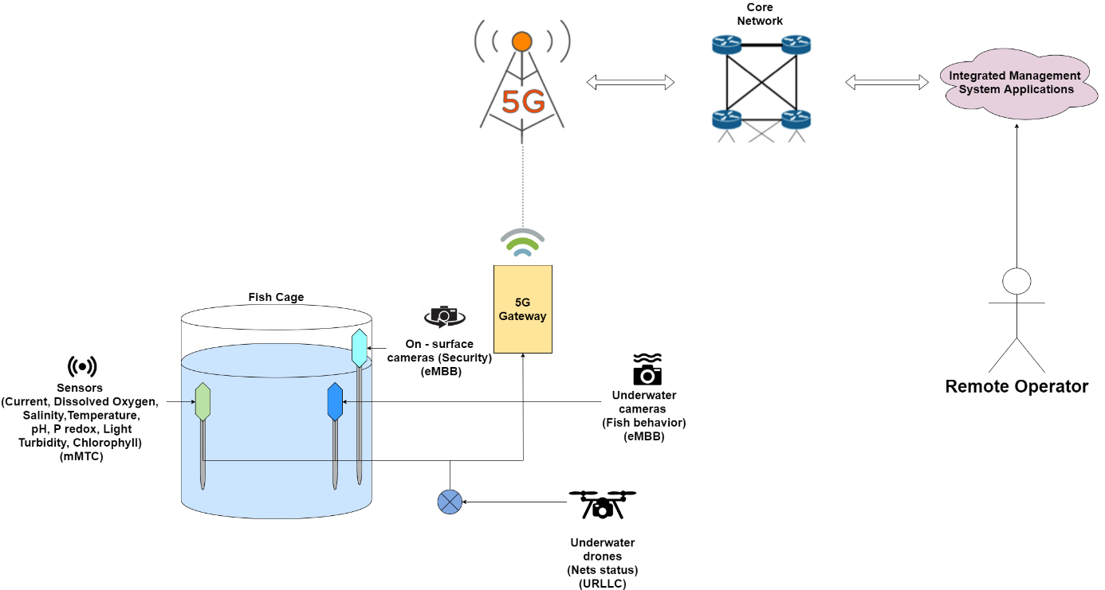
Figure 39: Aquaculture scenario architecture
Providing the installation of the equipment described, the connection to the 5G network is going to be implemented through a set of 5G gateways, able to upload the incoming traffic. The connection depends on the availability of a network base station that will provide the access point to the network.
The collected data are transmitted over the network to the cloud, where real-time machine learning and analytics algorithms analyse it to produce valuable observations facilitating the monitoring of the site. Additional operations such as site management functionalities allowing the transfer of operational data to the cloud as well as remote operations for the drone or for other actuation systems (feeding systems, lights and camera operations etc.) are available when using the aforementioned setup, while the exploitation of the 5G network services can guarantee the optimization of these operations.

Core Network KPIs Overview
A series of generic network KPIs are defined here:
- DL/UL throughput: corresponds to the 5%-percentile (5%) of the user throughput. User throughput (during active time) is defined as the size of a burst divided by the time between the arrival of the first packet of a burst and the reception of the last packet of the burst, and regards all types of data (video, voice, etc.).
- Broadband connectivity/peak data rate: corresponds to the highest theoretical data rate which is the received data bits assuming error-free (ideal) conditions assignable to a single mobile station, when all assignable radio resources for the corresponding link direction are tilizes (i.e., excluding radio resources that are used for physical layer tilizeszation, reference signals or pilots, guard bands and guard times).
- Latency requirements: corresponds to the time it takes from the instance a data packet is sent from the transmitting end to the instance it is received at the receiving end.
- Reliability: corresponds to the success probability of transmitting X bytes within a certain delay, which is the time it takes to deliver a small data packet from the radio protocol layer 2/3 SDU ingress point to the radio protocol layer 2/3 SDU egress point of the radio interface, at a certain channel quality (e.g., coverage-edge).
- Mobility: corresponds to the maximum user speed at which a defined QoS can be achieved.
- Location accuracy: corresponds to the accuracy with which location information is provided to the end device/user.
- Connection (device) density: corresponds to the total number of devices fulfilling a target QoS per unit area (per km²), where the target QoS is to ensure a system packet drop rate less than 1% under given packet arrival rate l and packet size S. Packet drop rate = (Number of packet in outage) / (number of generated packets), where a packet is in outage if this packet failed to be successfully received by destination receiver beyond packet dropping timer.
- Interactivity: corresponds to the ability to issue commands (or even send data/video) and requests and receive acknowledgement of execution and/or reaction (that can be in the form of data/video) within a very short period of time (in the msec order of magnitude).
- Area traffic capacity: corresponds to the total traffic throughput served per geographic area. Throughput can be defined as the number of correctly received bits, i.e., the number of bits contained in the SDUs delivered to Layer 3, over a certain period of time.
- Security/privacy: corresponds to the need to protect the usability and integrity of user data, equipment and network, as well as the Privacy of User Identity and Information.
- Energy efficiency (ITU-R M2410-0): Network energy efficiency is the capability of a RIT/SRIT to minimize the radio access network energy consumption in relation to the traffic capacity provided. Device energy efficiency is the capability of the RIT/SRIT to minimize the power consumed by the device modem in relation to the traffic characteristics.

KPI: Data/Video transmission

Definition
Video Transmission (UL): Indicates the user need to transmit video information of different formats and definitions/resolutions and frame rates (i.e. 4K or 8K or even 360o). This user requirement influences the upload bitrates to be provided in the Mobile Access Network. The indicative bitrates for different video formats are similar to the ones of the previous requirement (Video Reception).
Data Transmission (UL): Indicated the need to transmit different types of data (Upload – UL) from the user end device to the network and/or other users. Together with the Service/Traffic Type requirement (explained further below), this requirement guides the network planners to correctly size not only the uplink bandwidth but also the backhauling capacity of the network.
Related Definitions:
- Report ITU-R M.2410-0 (11/2017) defines KPIs specific to the radio interface. These include Peak data rate, User experienced data rate, Mobility, Latency – separately for user plane and control plane, Connection density, Reliability, Area traffic capacity, Peak spectral efficiency, 5th percentile user spectral efficiency, Average spectral efficiency, Energy efficiency, Mobility interruption time and Bandwidth.
- Multiple definitions referenced in ETSI TS 128 554 (05/19). A) Upstream throughput for network and network slice instance. B) This KPI describes the upstream throughput of one single network slice instance by computing the packet size for each successfully transmitted UL IP packet through the network slice instance during each observing granularity period and is used to evaluate integrity performance of the end-to-end network slice instance. C) This KPI is obtained by upstream throughput provided by N3 interface from NG-RAN to UPF which is related to the single network slice instance.

Mapping
This KPI maps to the following Network KPIs:
- UL throughput = Min { 5G-Core_Thr, Transport _Thr, Edge_Thr, 5G-Radio_Thr }
- Broadband connectivity / Peak data rate
- Reliability
- Latency requirements: Service_E2E-L = 5G-Core_L + Transport _L + Edge_L + 5G-Radio_L
- Mobility

Measurement
Video metric: It is a Boolean value. The expected response is Yes or No. If the answer is yes, then some explanation(s) can be expected in terms of the nature of the video stream (i.e. format) and the number of simultaneous streams/channels that are being transmitted. In case more details can be provided the indicative bitrates should be included.
Data metric: The value of this requirement is provided in a qualitative manner by selecting High/Medium/Low representing values of 1 Gbps / 100 Mbps / 10 Mbps (or less) respectively. If these values are not adequate, the vertical can also indicate Ultra High which represents a data stream of 10 Gbps.
Proposed reference values (E2E):
- Video: HD Video (up to 15 Mbps), 4K Video low frame rate (15-45 Mbps), 4K Video high frame rate (45-70 Mbps) – Video transmission takes into consideration also the number of streams
- Data: 100<high<=1.000 / 10<medium<=100 /low<=10 Mbps (Max for Ultra High is 10 Gbps)
Points of measurement (network):
- UL throughput: This network KPI is measured between the transport and the core, i.e. the N3 interface.
  - Low ≤ 1 Mbit/sec
  - 1 < Medium ≤ 10 Mbit/sec
  - 10 Mbit/sec < High
- Broadband connectivity / Peak data rate:
  - Low ≤ 100 Mbit/sec
  - 100 < Medium ≤ 1000 Mbit/sec
  - 1000 Mbit/sec < High ≤ 20 Gbit/sec
- Reliability
  - Low: 99.99%
  - Medium: 99.999%
  - High: 99.99999%
- Latency: This KPI is measured at the communication interface, i.e. between the UE and the N6 interface.
  - Low ≥ 25 msec
  - 5 ≤ Medium < 25 msec
  - High < 5 msec
- Mobility
  - Low ≤ 50 km/h
  - 50 < Medium ≤ 200 km/h
  - 200 < High ≤ 500 km/h

KPI: Fast response (Low Latency)

Definition
Fast Response (Low Latency): The time between issuing a request (i.e. change direction) or transmitting a piece of information (i.e. an alarm happened), and receiving a response should be as short as possible. Technology-wise this is the end-to-end Latency of a Telecommunication Network also referred to as round-trip-delay. A simple measurement of this is done via the ICMP protocol with the “ping” command.
Related Definitions:
- 5G-HEART: The time between issuing a request (i.e., change direction) or transmission of a piece of information (i.e. an alarm happened) and receiving a response should be as short as possible.
- Report ITU-R M.2410-0 (11/2017) defines KPIs specific to the radio interface. These include Peak data rate, User experienced data rate, Mobility, Latency – separately for user plane and control plane, Connection density, Reliability, Area traffic capacity, Peak spectral efficiency, 5th percentile user spectral efficiency, Average spectral efficiency, Energy efficiency, Mobility interruption time and Bandwidth.
- The time that takes to transfer a given piece of information from a source to a destination, measured at the communication interface, from the moment it is transmitted by the source to the moment it is successfully received at the destination. It is also referred to as one trip time (OTT) latency. Another latency measure is the round-trip time (RTT) latency which refers to the time from when a data packet is sent from the transmitting end until acknowledgements are received from the receiving entity. (5G MoNArch – D6.1)
- Two definitions referenced in ETSI TS 128 554 (05/19). A) This KPI describes the end to end packet transmission latency through the RAN, CN, and TN part of 5G network and is used to evaluate utilization performance of the end-to-end network. B) This KPI is the RTT end to end latency of UE IP packets transmitted from UE to the N6 interface in the 5G network. The N6 interface is the reference point between UPF and DN.

Mapping
This KPI maps to the following Network KPIs:
- Latency requirements: Service_E2E-L = 5G-Core_L + Transport _L + Edge_L + 5G-Radio_L

Measurement
Metric: The requirement can be defined as Slow/Fast and Very Fast representing network latencies around 100, 25 and 5 ms respectively.
Proposed reference values: slow>=100 / 25<=fast<100 / very fast<25 msec
Points of measurement (network):
- Latency: This KPI is measured at the communication interface, i.e. between the UE and the N6 interface.
  - Low ≥ 25 msec
  - 5 ≤ Medium < 25 msec
  - High < 5 msec

KPI: Space/area dependent interactivity

Definition
Space/Area Dependent Interactivity: This user requirement, is a measure of the spatial distribution of the end-users/devices. It indicates the ability to issue commands (or even send data/video) and requests and receive acknowledgement of execution and/or reaction (that can be in the form of data/video) within a very short period of time (in the msec order of magnitude) from a large number of “collocated” end user/devices etc. (example is gaming and or guidance for emergency evacuation, transaction stock/financial markets or the more common request for a Web Page).
Related Definitions:
- 5G-HEART (3GPP/ITU-R): Corresponds to the total number of devices fulfilling a target QoS per unit area (per km²), where the target QoS is to ensure a system packet drop rate less than 1% under given packet arrival rate l and packet size S.
Packet drop rate = (Number of packet in outage) / (number of generated packets), where a packet is in outage if this packet failed to be successfully received by destination receiver beyond packet dropping timer.
- Report ITU-R M.2410-0 (11/2017) defines KPIs specific to the radio interface. These include Peak data rate, User experienced data rate, Mobility, Latency – separately for user plane and control plane, Connection density, Reliability, Area traffic capacity, Peak spectral efficiency, 5th percentile user spectral efficiency, Average spectral efficiency, Energy efficiency, Mobility interruption time and Bandwidth.
- 5G-HEART (ITU-R): corresponds to the total traffic throughput served per geographic area. Throughput can be defined as the number of correctly received bits, i.e., the number of bits contained in the SDUs delivered to Layer 3, over a certain period of time.
Formula (Source: Report ITU-R M.2410-0 (11/2017))
We first define the average spectral efficiency:
$$SE_{avg}=\frac{\sum_{1}^{N}{R_{i}(T)}}{T W M}$$
where R_{i}(T) the number of successfully transmitted bits in a T period of time, W the channel bandwidth and M the number of TRxPs. Then the area traffic capacity C_{area} is defined as:
$$C_{area}=ρ W {SE}_{avg}$$

Mapping
This KPI maps to the following Network KPIs:
- Latency requirements: Service_E2E-L = 5G-Core_L + Transport _L + Edge_L + 5G-Radio_L
- Connection (device) density: CD = #devices / area
- Interactivity: #transactions / time
- Area traffic capacity: $C_{area}=ρ W {SE}_{avg}$

Measurement
Metric: According to the description of this requirement, the possible metrics are Sustained (continuous data traffic) / Bursty (traffic in bursts) and Sporadic (at regular or irregular intervals). Each data flow type can then be defined as High/Medium or Low and indicative values are i.e for sustained 1 Gbps / 100 Mbps and 10 Mbps (for high/medium and low) respectively.
Proposed reference values:
- Dense >1 UE/m2 and 100<high<=1,000 / 1<medium<=100 / low<=1 transactions/sec Medium Density High/Medium/Low
- 1 UE/25m2<=Medium<high<=1,000 / 1<medium<=100 / low<=1 transactions/sec Sparse High/Medium/Low
- Sparsity of < 1 UE/25m2 and 100<high<=1,000 / 1<medium<=100 / low<=1 transactions/sec
Points of measurement (network):
- Latency: This KPI is measured at the communication interface, i.e. between the UE and the N6 interface.
  - Low ≥ 25 msec
  - 5 ≤ Medium < 25 msec
  - High < 5 msec
- Connection (device) density:
  - Low ≤ 40×103 devices/km2, 40×103 ≤ Medium < 106 devices/ km2, High ≥ 106 devices/ km2
- Area traffic capacity:
  - max 10 Mbit/sec/m²
- Interactivity:
  - Low ≤ 1 transactions/sec
  - 1 < Medium ≤ 100 transactions/sec
  - 100 < High ≤ 1000 transactions/s

Vertical KPI definitions
In this section, the vertical KPIs for the Agriculture sector are defined per functionality:

Sensory data monitoring
Power consumption: Power/energy consumption measured for UE devices that connect to the 5G network in comparison to the corresponding 4G values. When measured, the corresponding overheads from the utilization of different equipment should be considered.

Camera data monitoring
Frame quality [15]: Video frames quality degradation caused from missing packets. Video frames can be reconstructed by powerful re-construction algorithms currently on play, which include an error deviation. This KPI is based on the difference between the original and the reconstructed frame. The metric of this difference can be the Euclidian distance or other metric depending on the application. Video resolution can be an important influence factor for the measurements.
Missing frames: Metric to evaluate the rate of missing frames. This can be a percentage or a more complex metric considering the frequency and density of lost frames. Frame rate (source) is a relevant factor that can influence the measurements.
$$MF= \frac{Number of missing frames}{Total number of transmitted frames}$$
Misclassification: Percentage of information-important frames lost. Consider information-important frames as the ones that can be used for classification of certain characteristics in comparison to the ones that don’t offer any special information.
$$MC= \frac{Number of missing information-important frames}{Total number of transmitted information-important frames}$$

Live monitoring, automation and actuation functionalities
Continuous operation: The (stochastic) maximum time of continuous unavailability of the operation service.
Service availability: The percentage of the operation service availability time.
Total reaction time: The time elapsing from an observation collection, to its transmission to the cloud, and the backwards transmission of a command based on this observation:
T = T_{UE1}+T_{Uplink}+T_{app1}+T_{human}+T_{app2}+T_{downlink}+T_{UE2}
Delay: The application latency measured during the transfer of a piece of information.
Live experience: The evaluated performance of the streaming service in terms of MOS (Mean Opinion Score). This relates to the video frame quality as well as the delay KPIs subjectively to the user.

Common
Device density: The number of connected devices per square kilometre.
Coverage: The percentage of the geographical area in which data transmission speed surpasses a given value for a set minimum period of time.

Core and Service KPIs Mapping
In this section, the vertical KPIs for the Agriculture sector are mapped to the corresponding network ones:
Vertical KPIs  vs  Network KPIs | Connection density | Area traffic capacity | Coverage | Interactivity | Packet loss | Energy efficiency | Bandwidth | Jitter | Throughput (UL) | Reliability | Availability | Latency
Device density | ✓ | ✓
Coverage |  |  | ✓ | ✓
Power |  |  |  |  |  | ✓
Frame quality |  |  |  |  | ✓ |  | ✓ | ✓ | ✓
Frame loss |  |  |  |  | ✓ |  |  | ✓
Misclassification |  |  |  |  | ✓ |  |  | ✓
Continuous operation |  |  |  |  |  |  |  |  |  | ✓ | ✓
Service availability |  |  |  |  |  |  |  |  |  | ✓ | ✓
Total reaction time |  |  |  |  |  |  |  |  |  |  |  | ✓
Delay |  |  |  |  |  |  |  |  |  |  |  | ✓
Live experience |  |  |  |  | ✓ |  | ✓ | ✓ | ✓ |  |  | ✓

Comments
Sensory data monitoring involves low demands considering almost all requirements, except for interactivity and connection density (which is also low, but in relation to other Aquaculture scenarios is more demanding). This is due to the fact that this functionality focuses on the continuous sensory data collection monitoring of the site, considering sensory data to monitor and analyse the performance of the farm. Parameters like dissolved oxygen, temperature, salinity, current velocity and meteorological data are frequently obtained to evaluate water quality and environmental conditions in order to ensure optimal conditions for the safe production of the fish. However, video transmission/ reception is not included, therefore the demands in user experienced DL and UL throughput are low.
Camera data monitoring involves the majority of the data transfers that are required for the operation of the fish farming sites regarding camera footage, and as such demonstrates a high UL throughput requirement. Specifically, data from security footage obtained from cameras located on-site will be considered, as well as image and real-time video footage from a 360° perspective and several underwater cameras for monitoring purposes including general fish health, feeding and feed waste management, behaviour analysis, etc. This real-time aspect of operation is what imposes the requirement for very low latency.
The Automation and actuation functionalities are principally characterised by high location accuracy and low latency. Both these requirements, as well as mobility, can be explained by the involved ROVs. In particular, this scenario concerns the implementation of a low-latency network infrastructure, which will be able to support automations in ROVs and deliver commands in minimal time allowing the remote operation of such devices in order to realise functionalities such as automatic feeding and monitoring of infrastructure integrity. The navigation and management of ROVs or underwater drones in a harsh environment with multiple obstacles, like the cage infrastructure, requires instant confrontation and resolution at real-time.

Smart (Air)ports

Introduction to the Vertical Industry
Ports are complex systems involving a wide number of stakeholders, such as port operators, authorities and shipping companies. As global trade is expanding, ship sizes and cargo volumes are increasing, placing additional pressure on ship berths and yards. Ports are therefore becoming increasingly interested in smart solutions to help optimise and improve their operational efficiency and reduce logistics costs.
Within the scope of the 5G-PPP project, the smart ports vertical has been addressed with two use cases in the 5G-SOLUTIONS project. The use cases are “Autonomous assets and logistics for smart port” and “Port safety – Monitor & detect irregular sounds”.

Use Cases Overview
SP_UC1: Autonomous assets and logistics for smart port
The purpose of this use case is to demonstrate the capabilities of 5G technology to support real-time operation and integration support for autonomous assets in a logistics hub. The autonomous test site includes the smart port, the logistics solution used in the cargo loading area as well as a dedicated autonomous vessel with autonomous land-based cargo handling assets. This UC will explore the enhanced service offering enabled by 5G technology.
The use case will validate the hypothesis that advanced 5G technology and communication protocols can enable the port’s autonomous infrastructure (cranes, carriers, energy infrastructure, etc.) to serve multiple (not pre-defined) assets with on-loading and offloading as well as fuelling / charging and basic maintenance. It will be of importance to understand if the accuracy of 5G positioning is sufficient to support autonomous operations, without additional GPS equipment. The assets would mainly be ships, but can potentially be expanded also to port vehicles. Safety, reliability and security are key priorities of this use case.
The use case consists of three (3) different scenarios.
- The first scenario is called “Digital Lean Container” (DLC) and intends to validate the usability of tablets within the smart port that update information in a datacenter hosted system. The architecture is displayed below in Figure 40:
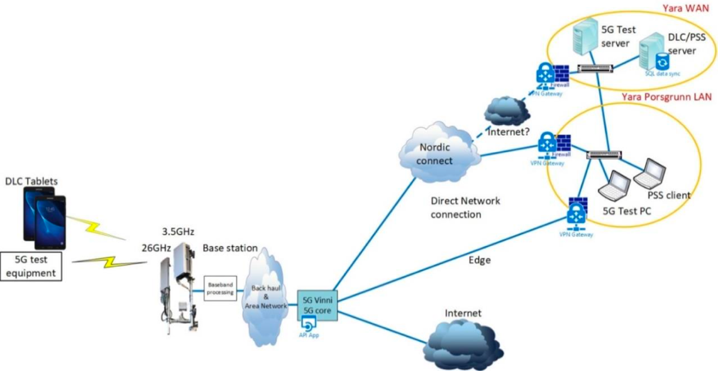
Figure 40: Smart Ports – Digital Lean Container Scenario

- The second scenario is called “Autonomy”. Its purpose is to support the autonomy of the various assets within the port. It will cover various aspects from simple performance checks to more complicated actions that require autonomy. The setup for this scenario is shown below in Figure 41:
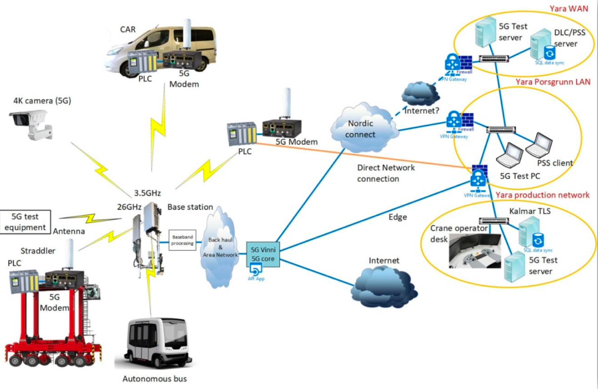
Figure 41: Smart Ports – Autonomy Scenario

- Finally, the last scenario called “High Speed Data Transfer”, plans to test the data transfer speed. More precisely, it will investigate whether the 26GHz band of the 5G system is capable of uploading large files used for diagnostics to a cloud service. The relevant architecture is shown below in Figure 42:
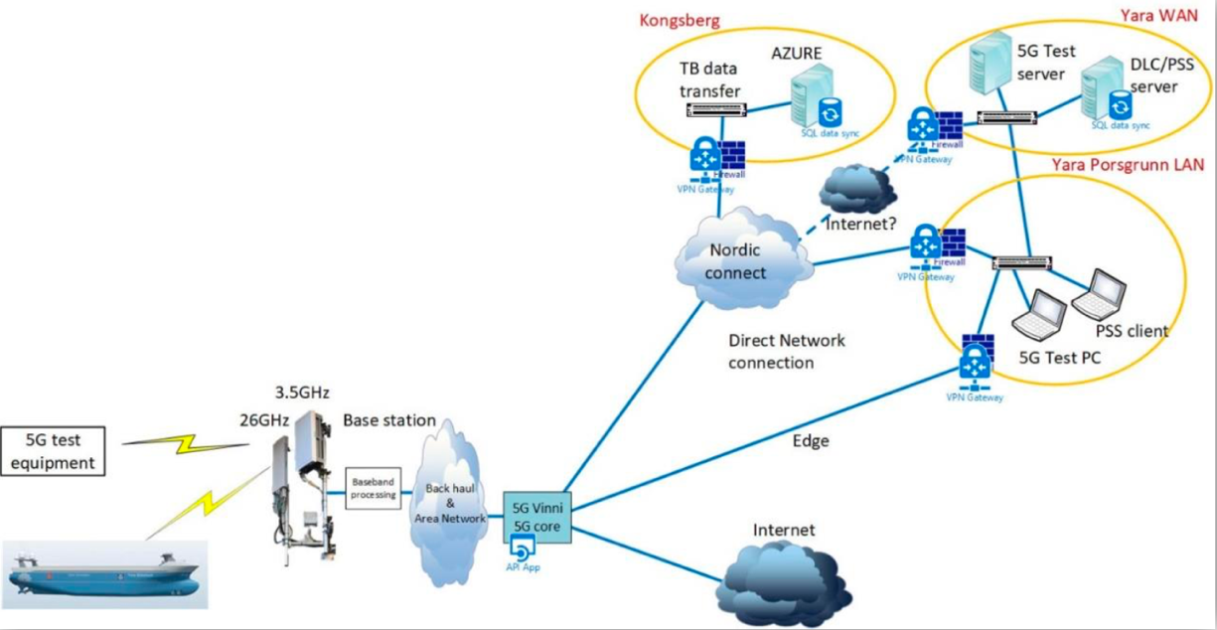
Figure 42: Smart Ports – High Speed Data Transfer Scenario

SP_UC2: Port safety – Monitor & detect irregular sounds
Safety and security within a port are of great importance thus they are a significant part of a smart port design. Through this use case, emphasis is given on the irregular noise and sound detection technology to assist in the security and safety measures. The deployment of such detection systems (e.g. sensitive microphones and UHD+ 360o CCTV (closed-circuit television) cameras) through the use of a reliable 5G network, transmitting real-time audio-visual information on events to the ports operations centre, is of utmost importance to port authorities by allowing them to act immediately and find out the exact location of the incident.
The use of machine learning algorithms is going to assist in detecting the abnormal sounds coming in from various points within the port. Marked data will be used to train the algorithms on the port sounds within a usual day. The machine learning algorithms will run on VNFs and gather outputs from the microphones and cameras distributed throughout the port. The objective is to get a precise location of the source of the abnormal sound.
This UC has not matured enough at this time to provide a final architecture or the measurement points. The planned system setup is displayed below:
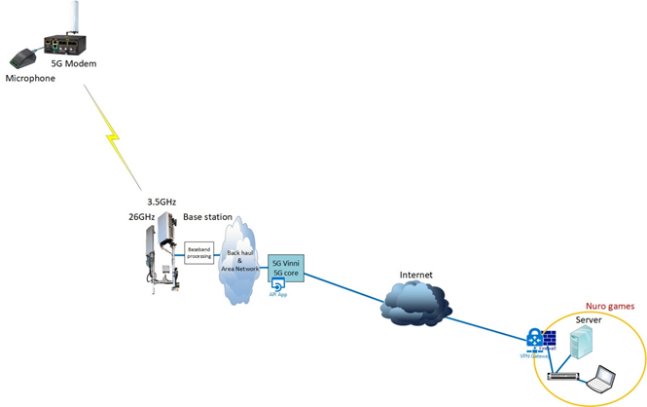
Figure 43: Smart Ports: Port safety – Monitor & Detect Irregular Sounds

Service KPI Overview
A complete list of KPIs planned to be measured within this vertical is listed below:
UC: Autonomous assets and logistics for smart port
Service KPIs | Target | Measurement Method | Justification
Data Rate | > DL: 100Mbps  > UL: 100Mbps  (per device) | Use 5G enabled test equipment | To be able to use 4k cameras in autonomy
High speed data rate (26.6 GHz) | > DL: 1000Mbps  > UL: 500Mbps  (per device) | 5G high speed measurement tools | To be able to upload diagnostics data from the vessel while loading it
Coverage | > 99.9% | Test device with GPS mapping | To be able to support autonomy
Reliability | > 99.99% | Statistical | To be able to support real time applications and autonomy
Positioning Accuracy | <0.5 m | Verify against a DGNSS | To be able to become an alternative for positioning of straddlers in autonomous operation
Density | >1 (devices/m2)
Mobility | <50 (km/h) | Use 5G enabled test equipment | To be able to support autonomy
Latency | < 10ms | Use 5G enabled test equipment | To be able to support real time applications and autonomy
Data quality | >99,99% | Statistical | To be able to support real time applications, data input and autonomy
Log quality |  | Subjective | To reduce downtime due to problem solving
Cyber security | Proven secure / not hackable | Subjective / penetration test | To not create a back door into the production network / to reduce downtime

UC: Port safety – Monitor & Detect Irregular Sounds
Service KPIs | Target | Measurement Method
Data Rate | > DL: 100Mbps  > UL: 100Mbps  (per device) | Throughput measurement at device
Coverage | > 99.9% | Data reception success rate when device in different locations (statistical sampling from >1000 measurements in different locations)
Reliability | > 99.99% | % of data delivered without data corruption
Positioning Accuracy | <10 m | Compare calculated position with actual parking location and parking available length
Density | >0.1 (devices/m2)
Mobility | <50 (km/h) | Vehicles will move at different speeds, while testing the service (statistical sampling)
Latency | < 10ms | Network + elaboration latency in normal operation mode
Service Provisioning time – (minutes)

Core Network KPI Research on Definitions
From the above KPIs, data rate, latency and mobility are the ones of interest within the smart ports vertical for the scope of this white paper. There are several different definitions of these KPIs in the bibliography. Some of them are:
Latency
- E2E Latency: Measures the duration between the transmission of a small data packet from the application layer at the source node and the successful reception at the application layer at the destination node plus the equivalent time needed to carry the response back. The E2E latency is the latency perceived by the end user [NGMN 5G WHITE PAPER: https://www.ngmn.org/wp-content/uploads/NGMN_5G_White_Paper_V1_0.pdf]
- User Plane Latency: User plane latency is the contribution of the radio network to the time from when the source sends a packet to when the destination receives it (in ms). It is defined as the one-way time it takes to successfully deliver an application layer packet/message from the radio protocol layer 2/3 SDU ingress point to the radio protocol layer 2/3 SDU egress point of the radio interface in either uplink or downlink in the network for a given service in unloaded conditions, assuming the mobile station is in the active state [Minimum requirements related to technical performance for IMT-2020 radio interface(s): https://www.itu.int/dms_pub/itu-r/opb/rep/R-REP-M.2410-2017-PDF-E.pdf]
- Control Plane Latency: Control plane latency refers to the transition time from a most “battery efficient” state (e.g. Idle state) to the start of continuous data transfer (e.g. Active state) [Minimum requirements related to technical performance for IMT-2020 radio interface(s): https://www.itu.int/dms_pub/itu-r/opb/rep/R-REP-M.2410-2017-PDF-E.pdf]
The proposed definition in the context of the Smart Ports vertical is the one proposed by the NGMN 5G White Paper. This is the actual latency perceived by the user as it covers the round-trip time (RTT) needed by the packets to be transmitted, travel, received and acknowledged back to the application source.
Data Rate
- User Experienced Data Rate: The achievable data rate that is available ubiquitously across the coverage area to a mobile user/device (in bps) [5G-MoNArch D6.1 :https://5g-monarch.eu/wp-content/uploads/2017/10/5G-MoNArch_761445_D6.1_Documentation_of_Requirements_and_KPIs_and_Definition_of_Suitable_Evaluation_Criteria_v1.0.pdf]
- Minimum Required Bit Rate: the minimum guaranteed bit rate that must be delivered to ensure an acceptable user experience for this service [5G-MoNArch D6.1 :https://5g-monarch.eu/wp-content/uploads/2017/10/5G-MoNArch_761445_D6.1_Documentation_of_Requirements_and_KPIs_and_Definition_of_Suitable_Evaluation_Criteria_v1.0.pdf]
- Peak Data Rate: Peak data rate is the maximum achievable data rate under ideal conditions (in bps), which is the received data bits assuming error-free conditions assignable to a single mobile station, when all assignable radio resources for the corresponding link direction are utilized (i.e. excluding radio resources that are used for physical layer synchronization, reference signals or pilots, guard bands and guard times) [Minimum requirements related to technical performance for IMT-2020 radio interface(s): https://www.itu.int/dms_pub/itu-r/opb/rep/R-REP-M.2410-2017-PDF-E.pdf]
The proposed definition in the context of the Smart Ports vertical is the User Experienced Data Rate.
Mobility
- Maximum user speed at which a defined QoS can be achieved (in km/h). [NGMN Recommendations (2016) Definition: [https://www.ngmn.org/wp-content/uploads/Publications/2016/160603_Annex_NGMN_Liaison_to_3GPP_RAN_72_v1_0.pdf]:

- Maximum user speed at which a defined QoS can be achieved (in km/h). This definition also offers a classification of the service based on the mobility speed. It presents 4 classes:

- Stationary: 0 km/h
- Pedestrian: 0-10 km/h
- Vehicular: 10-120 km/h
- High speed vehicular: 120-500 km/h
ITU-R M.2410-0 Report (2017) Definition (https://www.itu.int/dms_pub/itu-r/opb/rep/R-REP-M.2410-2017-MSW-E.docx)

Core and Service KPIs Mapping
Mobility Service KPI
To ensure accurate and on-time operations, the various components of a smart port must stay connected at any time and in any conditions. In order to support the port autonomy, mobility is a crucial aspect that must be ensured. Device mobility as a service KPI is dependent on the network availability, the network coverage as well as the radio signal quality and buffer occupancy. Service availability must be guaranteed at any time and in any location within the smart port logistics perimeter while elements are moving without degrading the performance and providing the agreed QoS.

Latency Service KPI
Vertical KPIs corresponding to the latency KPI are:
- Site latency: the latency within a specific site. The latency will be the difference between the latency measured over a 5G radio channel and the latency measured via fiber transmission. It will be measured in both directions to differentiate Upload and Download latency.
- Site-to-site latency: the E2E latency between 5G devices located in different sites. The two devices must be synchronized with an NTP server and compare with the timestamp sent within the data body.
The overall component on application and network level of the two use cases presented I seen below in Figure 44.
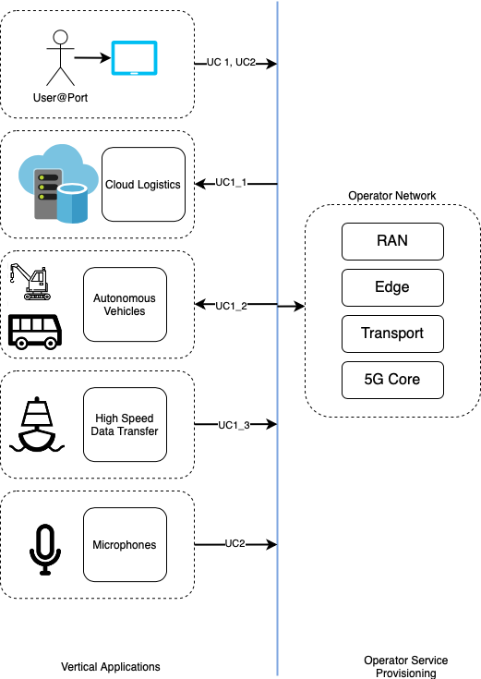
Figure 44: Smart Ports Architecture Elements
Ues
Latency on the Ues can occur from the transmission interface while transmitting the data, the microphones while receiving the actual noise, the actuator of the vehicles until they translate the signal to an action
Network
Network latency can occur on one of the four network components:
- Delay on the 5G Radio network component
- Delay on the 5G Edge network component
- Delay on the 5G Transport network component
- Delay on the 5G Core network component

E-health & Wellness

Introduction to the Vertical Indusrty
-

Use Cases Overview
The eHealth and wellness use cases are shown below:
- Use case HW_UC1 – “Remote interventional support” that explores the use of advanced, rich media communications in the context of remote monitoring, education and robotics in patient diagnostics and treatment.
- Use case HW_UC2 – “Remote polyp detection performed by AI in real-time”, which aims to test real-time transmission with feedback control of a pill camera (capsule video endoscopy), in order to improve diagnosis of cancer or precancerous pathology.
- Use case HW_UC3 – “Vital-sign patches with advanced geo-localisation”, whose objective is to explore direct-to-cloud disposable vital-sign patches to enable continuous monitoring of ambulatory patients, anytime and anywhere.

Use case HW_UC1 has four subcases:
- HW_UC1.1 – “Educational surgery” tilizes the evolution of 5G mobile connections that provide increased capacity, lower latency and improved reliability, and together with the latest high-quality video streaming technology and devices, it aims to support 4K-8K video or even 360° video for educational surgery purposes.
- HW_UC1.2 – “Remote ultrasound examination” considers the case, where expert (cardiac) sonographers perform remote ultrasound diagnostics of complex cases, even on patients from rural areas. Such tele-sonography solutions will enable an expert to guide a remote doctor or paramedic in performing ultrasound exams and ultrasound guided interventions. There are three different ways that the remote doctor can be guided to perform such interventions. One approach could be a Skype-like session to be set-up between a remote expert and a local doctor, while another one could be to enable a remote expert and a local doctor to step into the same augmented reality space (i.e., 3D) by wearing AR/VR headsets (glasses), coordinating the exam of the patient together. The last approach could constitute a robot-guided ultrasound examination (with fixed video) that brings the remote doctor into the driving seat of the examination by remotely controlling a robot arm with haptic feedback, manipulating the ultrasound probe touching the patient.
- HW_UC1.3 – “Paramedic support” deals with the case where a healthcare professional responds to medical emergencies (e.g., ambulance paramedic, nurse, emergency medical technician or other first responder) with remote senior support. This remote senior support will be the medical supervisor of the ambulance service, or a medical expert located at a hospital, first responder call centre or other medical facility.
- HW_UC1.4 – “Critical health event”, four distinct clinical cases (i.e., mass casualty supervisor support, chronically ill child, cancer drug follow-up at home, paramedic to paramedic for drug delivery support) were identified with different types of pain points which could potentially be solved using paramedic wearable video.

Use case HW_UC3 has two subcases:
- HW_UC3.1 – “Vital-sign patch prototype” tilizes a direct-to-cloud vital-sign patch that measures heart rate and breathing rate, constituting a paradigm of classical mMTC deployments.
- HW_UC3.2 – “Localizable tag” deals with the problem of validation of the narrowband radio-localization approach with real signals and in a realistic environment (outdoor/indoor, rural/urban).

Service KPIs Overview
Use-case scenarios of HW_UC1.1 “Educational surgery”, HW_UC1.2 “Remote ultrasound Examination”, and HW_UC1.3 “Paramedic support” gives the highest demands for video and data transmission and reception. For the purposes of the scenario HW_UC1.2, 3-4 channels of 15 Mbps each for HD video reception and transmission are needed. Scenario HW_UC1.1 poses further needs for streaming of 4K-8K video or even 360-degrees video, leading up to 200 Mbps throughput in the uplink.
As far as voice communication is concerned, most of the eHealth use-case scenarios need to have real-time full-duplex voice communication to supplement the video and data perception, due to the urgency and criticality of such scenarios.
For scenarios HW_UC1.3 and HW_UC1.4 “Critical health event”, there is a need to receive high definition Video (4K, 8K) on his/her device, TV/monitor or VR/AR end device, as well as, a need to receive ‘Good’ quality video (640x480, 720p – 1080p, 25/30 frames per second) on a mobile tablet in the supervisor vehicle (Wearable) and a requirement for a Mean Opinion Score (MOS) of 4 and 5. Furthermore, regarding video transmission for HW_UC1.3 and HW_UC1.4 apart from the need to transmit high definition (4K or 8K or even 360-degree video) Video once again there is need to transmit Good quality video (640x480, 720p – 1080p, 25/30 frames per second) from an Android access device (Wearable). These scenarios also demand duplex audio to accompany video with a MOS value of 5.
Although, for most of the use-case scenarios the need for mobility is restricted to stationary and walking-running speed, the HW_UC3.2 “Localizable Patch” scenario requires a medium speed up to 130 km/h. On the other hand, there is always significant need to provide accurate location of the end device, and thus, a medium location information requirement is imposed from scenarios HW_UC1.4 and HW_UC3.2. In order to perform complex calculations and retrieve a large amount of information with the least possible delay, several of the scenarios pose the need for (either combined or not) edge computing and storage. This need can be further justified by considering the stringent fast response requirement of 1-2 msec defined by HW_UC2 “Remote polyp detection performed by AI in real-time” use-case scenario.
Regarding the traffic type resulting from the eHealth services, it can be characterized as sustained high for the majority of the scenarios, while a value of 100 Mbps sustained traffic is especially defined for the HW_UC1.2 scenario. At the same time, the scenarios of HW_UC3.2 and HW_UC3.1 “Vital-sign patch prototype” constitute an exception to other healthcare services, resulting to a sporadic low traffic type.
Finally, high reliability is needed by all scenarios besides HW_UC1.1 and HW_UC1.2, whereas a high-medical degree security is required for the purposes of the whole eHealth vertical, in order to provide services without interruptions and protect the usability and integrity of user data.

Core Network KPIs Overview
The definition and explanation of the derived network KPIs for the 5G-HEART use cases are given below. In their majority, the definitions provided follow those discussed during 3GPP standardisation efforts (3GPP TR 38.913 version 15.0.0).
- DL/UL throughput: corresponds to the 5%-percentile (5%) of the user throughput. User throughput (during active time) is defined as the size of a burst divided by the time between the arrival of the first packet of a burst and the reception of the last packet of the burst, and regards all types of data (video, voice, etc.).
- Broadband connectivity/peak data rate: corresponds to the highest theoretical data rate which is the received data bits assuming error-free (ideal) conditions assignable to a single mobile station, when all assignable radio resources for the corresponding link direction are utilized (i.e., excluding radio resources that are used for physical layer synchronization, reference signals or pilots, guard bands and guard times).
- Latency: corresponds to the time it takes from the instance a data packet is sent from the transmitting end to the instance it is received at the receiving end.
- Reliability: corresponds to the success probability of transmitting X bytes within a certain delay, which is the time it takes to deliver a small data packet from the radio protocol layer 2/3 SDU ingress point to the radio protocol layer 2/3 SDU egress point of the radio interface, at a certain channel quality (e.g., coverage-edge).
- Mobility: corresponds to the maximum user speed at which a defined QoS can be achieved.
- Location accuracy: corresponds to the accuracy with which location information is provided to the end device/user.
- Connection (device) density: corresponds to the total number of devices fulfilling a target QoS per unit area (per km²), where the target QoS is to ensure a system packet drop rate less than 1% under given packet arrival rate l and packet size S. Packet drop rate = (Number of packet in outage) / (number of generated packets), where a packet is in outage if this packet failed to be successfully received by destination receiver beyond packet dropping timer.
- Interactivity: corresponds to the ability to issue commands (or even send data/video) and requests and receive acknowledgement of execution and/or reaction (that can be in the form of data/video) within a very short period of time (in the msec order of magnitude).
- Area traffic capacity: corresponds to the total traffic throughput served per geographic area. Throughput can be defined as the number of correctly received bits, i.e., the number of bits contained in the SDUs delivered to Layer 3, over a certain period of time.
- Security/privacy: corresponds to the need to protect the usability and integrity of user data, equipment and network, as well as the Privacy of User Identity and Information.

Core and Service KPIs Mapping
The network KPIs are determined by the vertical KPIs in the following way:
- User experienced DL/UL throughput
Is determined by the video transmission and data transmission requirements, and the service /traffic types.
- Broadband connectivity/peak data rate
Is determined by the use cases’ video and data transmission/reception requirements.
- Latency
Is determined by the use cases’ Fast Response, Voice Communication, Service/ Traffic type, Space Area Dependent Interactivity, and video and data reception and transmission requirements.
- Reliability
Is determined by the reliability requirements for voice communication, and video and data reception and transmission.
- Mobility
Is determined by the mobility requirements for video transmission/reception, data transmission/reception, service/traffic type, and location information.
- Location accuracy
Is determined by the requirements for Location Information, and for the Mobility
- Connection (device) density
Is determined by the use cases’ Space/Area Dependent Interactivity requirements.
- Interactivity
Is determined by the use cases’ Space/Area Dependent Interactivity requirements.
- Area traffic capacity
Is determined by the use cases’ Space/Area Dependent Interactivity requirements.
- Security/privacy
Is determined by the Security/privacy of the use cases.

To illustrate the mapping between vertical and network KPIs, consider the architecture for use case H1B “Robotic-assisted ultrasound examination” shown in Figure 45.
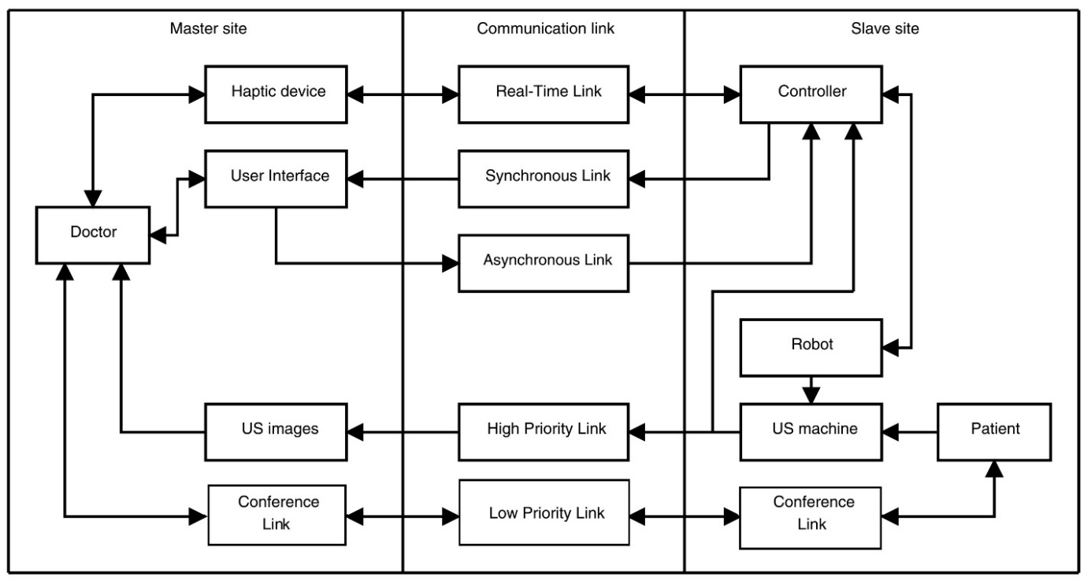
Figure 45: System architecture of long-distance teleoperation system

The communication link in the architecture must support following types of data:

- Real-time control data:
In a bilateral network-based teleoperation system, depending on the architecture, the control loop or part of the control loop of the system passes through the communication link. Sensory information such as forces, torques and velocities should transmit over the real-time control data channel with low jitter and with the delay being below an allowed maximum. It means that hard-real time and reliability requirements must be met in this link.
- High-level management data:
This data link covers data from the slave site to the master site, such as setting the control loop’s mode and reading the status information of the slave robot which needs to be displayed at the master site user interface. This link has a lower priority than the one of the real-time control data and therefore needs to be a separate link. This link has a soft-real time requirement. This means that the system will still be working if some data-packets are lost due to phenomena like multipath propagation, the Doppler effect, and noise. Sensory information from the slave manipulator, which is needed to be displayed to the user interface at the master site, is sent through a synchronous link. The user interface enables the expert at the master site to change the mode and the parameters of the system at the slave site. This management data is sent through the asynchronous link and is processed as it arrives in the slave robot controller.

- Medical video streaming:
The ultrasound video is vital for the cardiologist, and therefore this video must be sent over a high priority link.

- Ambient video streaming:
In a remote tele-operation setting, it is important for the cardiologist to be able to communicate with the patient. Therefore, a video conference link is needed between the sites.

Conclusions

This white paper summarized the progress and several key findings produced by 5G PPP projects on the methods to measure the Service performance for Verical Industries over 5G experimental networks, in order to prove and validate that the 5G technology can provide prominent industry verticals with ubiquitous access to a wide range of forward-looking services. This work’s scope is to better understand the correlation and formal associations of the core 5G KPIs with respect to technical service KPIs, for a plethora of Vertical Indusrties.
5G PPP has the capability to demonstrate the feasibility for Vertical Industries to develop and deploy 5G innovative solutions in vertical markets. This will eventually allow an increasing number of Verticals to follow a similar path, ultimately increasing the European market share on a global scale. This will strengthen the prospects for European Vertical Industries to achieve sustainable growth and become key players in the new business environment created by the 5G paradigm, considering that “the rising demand from various (vertical) applications has been recognized as the major drivers for the 5G infrastructure market growth.”
SKPIs identify the business and operational-oriented benchmarks and figures of merit that must be met in order to certify that the vertical services, once implemented, are fully functional (i.e., they work as expected to satisfy the demanded vertical requirements and agreed SLAs). In a nutshell, the SKPIs are the promises that the underlying management institutions make to the verticals. Each service's set of SKPIs is a list of observable, measurable, and quantifiable parameters that are only important and meaningful for that service. As a result, even if both coexist and are carried out over a similar (computing and network) infrastructure, the collection of SKPIs for a given service may not be relevant to other vertical services.
The latter then creates a collection of CKPIs that are connected to the computing and networking resources which will be allocated to support the vertical service. Remember that CKPIs are measurable performance parameters associated with the network and computing infrastructure that supports the vertical service's functions, applications, connectivity, etc. As a result, an indisputable relationship is established between a vertical service's SKPI and its determined set of CKPIs. These CKPIs can be measured, collected, and analyzed through a range of locations (e.g., edge DC, terminal, etc.), data and control interfaces, functions, systems, and devices that are all part of the deployed vertical service.

Abbreviations and Acronyms

3GPP | 3rd Generation Partnership Project
5G PPP | 5G Public Private Partnership
AF | Application Function
ATO | Automatic Train Operation
CMM | Coordinate-Measuring Machine
CCTV | Closed-Circuit Television
CDN | Content delivery network
CKPI | Core KPI
CPE | Customer Premises Equipment
eMBB | enhanced Mobile Broadband
FR | Functional Requirements
FRMCS | Future Railway Mobile Communication System
GIS | Geographic Information System
GPS | Global Positioning System
GSM-R | Global System for Mobile Communications – Railway
HL | High-Level
HTTP | Hypertext Transfer Protocol
IoT | Internet of Things
ITU | International Telecommunication Union
KPI | Key Performance Indicator
M2M | Machine-to-Machine
MCPTT | Mission Critical Push to Talk
MCM | Manoeuvre Coordination Messages
mMTC | massive Machine Type Communications
NB-IoT | NarrowBand IoT
NR | New Radio
PoC | Proof of Concept
QoS | Quality of Service
QoE | Quality of Experience
RAN | Radio Access Network
RSU | Road Side Units
RTT | Round trip TIme
SKPI | Service KPI
TCO | Total Cost of Ownership
UC | Use Case
UE | User Equipment
URLLC | Ultra-reliable low-latency communication
V2I | Vehicle-to-Infrastructure
V2V | Vehicle-to-Vehicle
V2X | Vehicle-to-everything
VNF | Virtual Network Function
VOU | Vehicular Onboard Unit
ZDM | Zero Defect Manufacturing

Contributing 5GPPP Projects

 | 
 | 
 | 
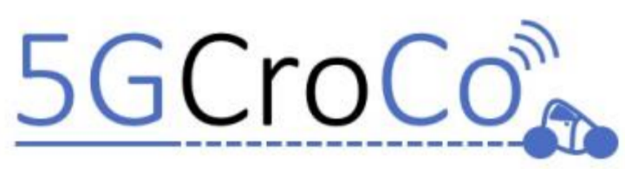 | 

List of authors

Ioannis Markopoulos | 5G-SOLUTIONS
Luka Valcarenghi | 5GROWTH
Ioanna Mesogiti | 5G-VICTORI
Manfred Taferner | 5G-VICTORI
Patrice Boleguin | 5G-SOLUTIONS
Faouzi Bouali | 5G-HEART
Kostis Tzanettis | 5G-SOLUTIONS
Ioannis Tzanettis | 5G-HEART
Dirk Hetzer | 5G-CROCO
Ilkka Känsälä | 5G-DRONES
Ole Grondalen | 5G-HEART
Anastasius Gavras | 5G-VINNI
Konstantinos Katsaros | 5G-MOBIX
Konstantinos Trichias | 5G-MOBIX
Peter Lundh | 5G-VICTORI
Gokul Srinivasan | 5G!Drones
Alexandros Kaloxylos | 5G-PPP TB
Andrea Cattoni | 5G-PPP TMV

References
- Setting the Scene for 5G: Opportunities & Challenges. https://www.itu.int/en/ITUD/Documents/ITU_5G_REPORT-2018.pdf
- 5G; Service requirements for cyber-physical control applications in vertical domains https://www.etsi.org/deliver/etsi_ts/122100_122199/122104/16.05.00_60/ts_122104v160500p.pdf
- 5G-SOLUTIONS ICT-41 Project https://www.5gsolutionsproject.eu/
- 5G; Management and orchestration; 5G end to end Key Performance Indicators (KPI) (3GPP TS 28.554 version 15.4.0 Release 15) https://www.etsi.org/deliver/etsi_ts/128500_128599/128554/15.04.00_60/ts_128554v150400p.pdf
- 3GPP Portal https://www.3gpp.org/DynaReport/23501.htm
- NGMN 5G Whitepaper [17-2-2015] https://www.ngmn.org/wp-content/uploads/NGMN_5G_White_Paper_V1_0.pdf
- 5G; Service requirements for next generation new services andmarkets (3GPP TS 22.261 version 15.5.0 Release 15) https://www.etsi.org/deliver/etsi_ts/122200_122299/122261/15.05.00_60/ts_122261v150500p.pdf
- Report ITU-R M.2410-0 (11/2017) Minimum requirements related to technical performance for IMT-2020 radio interface(s) https://www.itu.int/dms_pub/itu-r/opb/rep/R-REP-M.2410-2017-PDF-E.pdf
- 3GPP TS 22.186 V16.1.0 (2018-12). 3rd Generation Partnership Project; Technical Specification Group Services and System Aspects; Enhancement of 3GPP support for V2X scenarios; Stage 1 (Release 16)
- In SAE Level 4, an automated system can both conduct the task of driving and monitoring the environment, without the need for a human driver to take back control. Operation of the system is limited to certain environments and conditions. See also: "Automated Driving – Levels of Driving Automation are Defined in New SAE International Standard J3016". SAE International. 2014.
- Cisco Annual Internet Report (2018–2023) White Paper https://www.cisco.com/c/en/us/solutions/collateral/service-provider/visual-networking-index-vni/mobile-white-paper-c11-520862.pdf
- Definition of the Testing Framework for the NGMN 5G pre-commercial Networks Trials https://www.ngmn.org/wp-content/uploads/Publications/2019/190111_NGMN_PreCommTrials_Framework_definition_v2_small.pdf
- 3GPP TS 26.501 V16.2.0 (2019-12) 3rd Generation Partnership Project; Technical Specification Group Services and System Aspects; 5G Media Streaming (5GMS); General description and architecture (Release 16) - Section 4: Media Streaming General Service Architecture https://www.3gpp.org/ftp/Specs/archive/26_series/26.501/26501-g20.zip
- 5G-PPP White Paper - View on 5G Architecture V3.0 https://5g-ppp.eu/wp-content/uploads/2019/07/5G-PPP-5G-Architecture-White-Paper_v3.0_PublicConsultation.pdf
- No-Reference Video Quality Assessment Model for Distortion Caused by Packet Loss in the Real-Time Mobile Video Services https://www.researchgate.net/publication/287027344_No-Reference_Video_Quality_Assessment_Model_for_Distortion_Caused_by_Packet_Loss_in_the_Real-Time_Mobile_Video_Services
- Setting the Scene for 5G: Opportunities & Challenges. https://www.itu.int/en/ITUD/Documents/ITU_5G_REPORT-2018.pdf
- 5G; Service requirements for cyber-physical control applications in vertical domains https://www.etsi.org/deliver/etsi_ts/122100_122199/122104/16.05.00_60/ts_122104v160500p.pdf
- Setting the Scene for 5G: Opportunities & Challenges. https://www.itu.int/en/ITU-D/Documents/ITU_5G_REPORT-2018.pdf
- 5G; Service requirements for cyber-physical control applications in vertical domains https://www.etsi.org/deliver/etsi_ts/122100_122199/122104/16.05.00_60/ts_122104v160500p.pdf
- The 5G infrastructure Public Private Partnership (5G PPP), [Online] https://5g-ppp.eu
- Future Railway Mobile Communication System, UIC, International Union of Railways, [Online, Dec. 2020] https://uic.org/rail-system/frmcs/
- 3GPP TR 22.889, “Study on Future Railway Mobile Communication System; Stage 1”, Rel. 17, [Online, Dec. 2020]
- 3GPP TS 22.289, “Mobile Communication System for Railways; Stage 1”, Rel. 17, [Online, Dec. 2020]
- UIC, International Union of Railways, Future Railway Mobile Communication System User Requirements Specification v5.0, February 2020, [Online, Dec. 2020] https://uic.org/IMG/pdf/frmcs_user_requirements_specification-fu_7100-v5.0.0.pdf
- 5G-VICTORI, EU funded project, 5G-PPP ICT-19, https://www.5g-victori-project.eu/
- 5G-VINNI, EU funded project, 5G-PPP ICT-17, https://www.5g-vinni.eu/
- 3GPP TS 22.289, "Mobile communication system for railways" Phase 1, Rel 16
- 3GPP TR 22.989, “Study on Future Railway Mobile Communication System”, Rel 15
- 3GPP TR 22.889, “Study on Future Railway Mobile Communication System (FRMCS)”, Rel 15
- 3GPP TR 22.890, “Study on supporting railway smart station services”, Rel 17

Video processing will be the main cause of latency
Also considered in other UCCs, see next.
Also considered in other UCCs, see next.

